Check Your Understanding of the Moon /30
Curricular Competencies: Interpret and Apply
Fill in the blank. Each term may be used only once. Some terms may not be used: apogee, perigee, revolution, axis, rotation
- The moon is at_______________________ when it is farthest from Earth.
- The moon appears to rise and set at Earth’s horizon because of Earth’s rotation on its _______________________.
- The moon completes a ______________________on its axis only once during each orbit around Earth.
Short Answer:

- Describe what the moon looks like when at its perigee.

- Describe the temperature on the moon and explain why it varies so much.

- Why do observers on Earth always see the same side of the moon?

- Why does the moon shine?
- because it reflects light from Earth
- because its surface is molten
- because it reflects light from the sun
- because it reflects light from all the planets

- Phases of the moon are caused by
- change in seasons.
- revolution of Earth on its axis.
- revolution of the moon on its axis.
- changing positions of the sun, moon, and Earth.

- The period from one new moon to the next is
- 27.3 days.
- 30 days.
- 29.5 days.
- 31 days.

- The phase of the moon you see depends on
- where you are on Earth’s surface
- how much of the sunlit side of the moon faces Earth.
- how much of the moon’s surface is lit by the sun.
- whether or not an eclipse is occurring.

- During what phase of the moon is the near side dark, and no lighted area is visible on Earth?
- dark moon
- new moon
- near moon
- full moon

- The waxing phases of the moon are:
- waxing, growing, completing.
- crescent, half, whole.
- first quarter, second quarter, third quarter
- waxing crescent, first quarter, waxing gibbous.

- At what stage is the entire near side of the moon illuminated by the sun, because Earth is between the sun and moon?
- whole moon
- luminous moon
- new moon
- full moon

- When the lighted part of the near side of the moon appears to decrease in size, the moon is
- waxing.
- shrinking.
- waning.
- decreasing

Use the moon phases below to answer questions 15-19
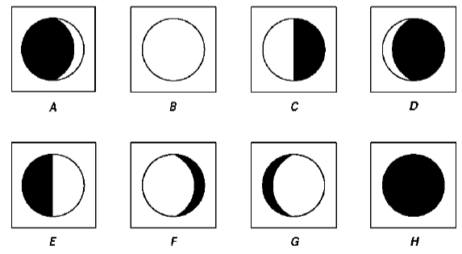
- What is the name for phase C?
- What is the name for phase F?
- Is E getting bigger or smaller?
- Approximately how much time passes between H and B?
- Which two phases are gibbous moons?

Use the diagram below to answer the next two questions.
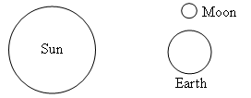

- What is the name of the phase of the moon?
- What tide would this produce?

- Tides are caused mainly by
- Earth’s rotation on its axis, which causes water to move.
- differences in how much the sun pulls on different parts of Earth.
- strong winds blowing water onto coasts.
- differences in how much the moon and the sun pull on different parts of Earth.

- What is the difference between Neap and Spring tide?

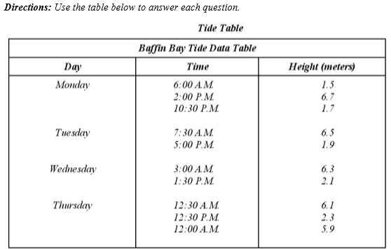
- Describe how the height of the tides changes from Monday to Thursday.
- How many tides will occur on Monday? How many are high tides? How many are low tides?
- Are the tides approaching a spring tide or a neap tide? Explain.
- Challenge: Explain why does water on the side of Earth farthest from the moon bulge away from Earth in the opposite direction?

