Cellular Respiration Interactive Assignment
- Go to: https://biomanbio.com/video/video-landing-page.html
- Find the Cellular Respiration video series:
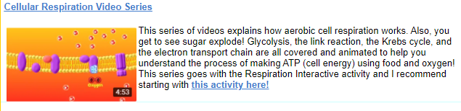

- Click on “this activity here” OR cut and pastes this link:
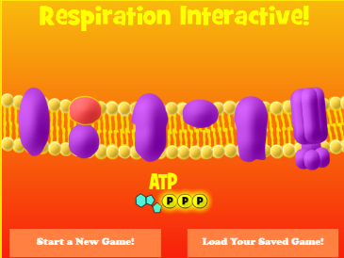
https://biomanbio.com/HTML5GamesandLabs/PhotoRespgames/respiration-interactive-page.html
- Click on “Start New Game”

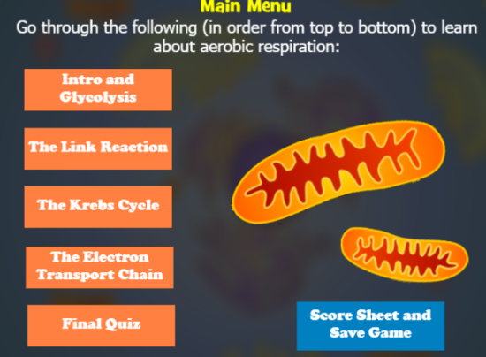
- Intro and Glycolysis
- Watch the video, then do the interactive.

- Return to Main Menu to repeat the process by watching the remaining videos and performing the tasks.

- After watching all 4 videos and trying the interactions, do the “Final Quiz” when you are ready. Watch the videos again if you need to. You only get one chance to take the quiz as you must enter your name before you start. the end of the quiz, there will be a screen shot option.

- UPLOAD YOUR SCREEN SHOT TO TEAMS. (If you are not happy with your quiz score, you may enter a new name and take it again, upload to TEAMS).

What was the purpose of the explosion demonstration?
- To show energy contained in sugar
- To show the energy contained in protiens
- To show that fire is edible
- To set off a chain reaction
- To show the energy contained in lipids
- Why do living things perform respiration?
- To cuase cells to combust
- To burn the ATP in cells and ukse for energy
- To gradually release the energy in food to make ATP
- To create sugars that cells need for energy.
- What gets oxidized and broken down during glycolysis?
- Pyruvate
- NADH
- ATP
- Glucose
- All of these
- What are the products of glycolysis
- Water and carbon dioxide
- Glucose and oxygen
- 2 pyruvates, 2 NADH, and 2ATP
- 2 NAD+, 1 glucose, 2 CO2
- All of these
- Which of the following is a true statement about glycolysis?
- ATP gets made when a phosphate is transferred to ADP
- Electrons and hydrogens get transferred to NAD+, making NADH
- Electrons and hydrogens get removed from glucose whenit gets oxidized.
- A 6-Carbon glucose splits to make 2 pyruvates with 3 carbons each
- All of these
- What is the purpose of the NADH made during glycolysis?
- It breaks down ATP
- It transports pyruvate around the cell
- It makes sugar more likely to explode
- It carries electrons and hydrogens to the electron transpot chain.
- All of these
- Where in the cell does glycolysis happen?
- Cytoplasm
- Mitochondria
- Chloroplasts
- At ribosomes
- In the golgi
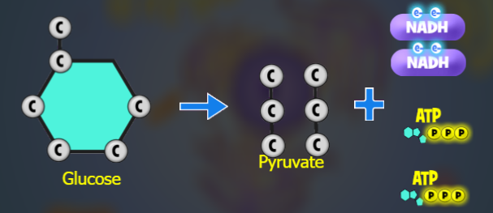

Or Main page:
https://biomanbio.com/HTML5GamesandLabs/PhotoRespgames/photoresp.html
select Respiration Interactive
Start New Game. Click on “Intro and Glycolysis”
Watch video, answer quiz

Back to Main menu to finish the rest
https://biomanbio.com/HTML5GamesandLabs/PhotoRespgames/respiration-interactive-page.html
Electron transport chain
https://www.youtube.com/watch?v=zJNx1DDqIVo
