Sci 8 Gummy Bear and Osmosis Lab Name:
(Skills: Predicting, Identifying variables, Explaining) Partner:
Question: How does tonicity affect a Gummy Bear?
Hypothesis A: If a Gummy Bear is placed in a solution containing only water then water will flow __________ the gummy bear because _________________________________ ___________________________________________________________________
Hypothesis B: If a Gummy Bear is placed in a solution containing salt water then water will flow __________ the gummy bear because _________________________________ ___________________________________________________________________
Independent Variable (what will be manipulated): ____________________________
Dependent Variable (what is being measured): ______________________________
Control Variables (what stays the same): __________________________________
Materials: gummy bears, tap water, salt water, plastic cups, ruler, scale, tape
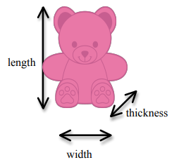
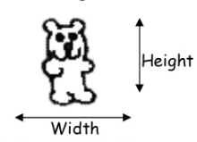
Procedure: DAY 1
- Obtain 2 Gummy Bears of the same colour.
- Measure length, width, and depth of each. Record your measurements in “Day 1 Observations” Data Table
- Measure mass of each gummy bear and record in same table.
- Obtain two 100ml beakers. Label both beakers with your group name and block number. Label one beaker “distilled water”, and the other “salt water”.
- Add 80ml distilled water to the distilled water beaker. Add 80ml salt water to the other beaker.
- Place ONE Gummy Bear in EACH beaker. Set aside.
DAY 2
- Observe each gummy bear in the beakers. Record your observations.
- Carefully pour off the water and slip gummy bear onto paper towel. Record measurements in data table.
- Calculate percent change in volume and mass of each gummy.
- Clean up and put everything away.
Observations
Qualitative Tap Water Gummy Observations:

Measurements
 | Length | Width | Height | Volume (mm³) =  Length x Width x Height
Day 1
Tap Water Gummy
Day 1
Salt Water Gummy

Day 2 Observations:
 | Observations (size, colour, texture) | Volume = Length x Width x Height (mm³)
Tap Water
Salt Water

Calculate Percent change in volume:
% change in Volume =
(Day 2 volume – Day 1 volume) X 100 =
Day 1 volume
Tap Water | Show your work:
Salt Water | Show your work:

Analysis:
- Why was it necessary to record measurements of your Gummy Bears before beginning the experiment?

- Use CER to explain what happened to the Water Gummy.
CLAIM : In the tap water gummy, water moved _____________________________
The EVIDENCE is: __________________________________________________
The REASONING is: (use concepts like concentration and osmosis) ______________ ________________________________________________________________

- Using terms like tonicity and concentration, explain why your Salt Gummy was smaller than the Water Gummy.

- Predict what would happen if the Salt Gummy bear from day 2 was placed in fresh water overnight. Explain your reasoning.

- Predict what would happen to the Water Gummy from day 2 if you placed it in salt water. Explain your reasoning.

- EVALLUATE: What would improve the accuracy of this experiment?

- Do you think sugar from the Gummy moved out of the bear? Why? Is there any evidence? How could you test this?

