6-1 Photosynthesis Reading Check (113-117)
- In your own words, briefly describe the experiments that contributed to the understanding of photosynthesis
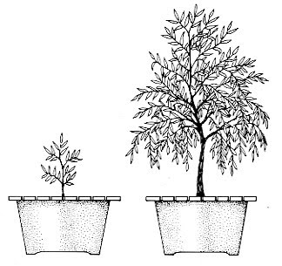
Jan Van Helmont Experiment:

Conclusion:

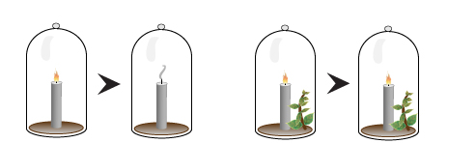
Joseph Priestly Experiment:

What was his conclusion?

Fill in the blanks:
- _______________________ are organisms that can make their own food.
- An organism that obtains energy by eating food: _____________________
- A green pigment that is involved in light absorption for photosynthesis: ____________________
- ______________________ performed an experiment that showed that plants produce a gas that allows a candle to burn.
- The most important energy-storing compound is _________________.
- Explain how ATP stores and release energy.

6-2 Reading Check (p118-123)

- Production of NADPH and ATP requires sunlight. The series of reactions that produces there energy-storing compounds are known as the ___________________.
- The second stage of photosynthesis does not require light and is therefore called _________________________.
- This 2nd stage uses the energy stored in NADPH and ATP to produce _____________. Why is this substance produced? __________________________________________ _____________________________________________________________________

- Light Reactions can be divided into four basic processes:
_____________________________ _____________________________

_____________________________ _____________________________

- The ______________________ take place within saclike _________________ that are located inside an organelle called ________________________ .

- Sunlight is capture by clusters of pigment molecules called __________________ that contain serval hundred ___________________ molecules as well as a number of accessory pigments.

- Electrons are passed from one _______________________ to the next during the process of ________________________.

- _____________________________ is “split” to produce hydrogen ions, ____________________ gas, and ___________________________ that replace those lost by chlorophyll.

- An enzyme uses the energy created by a difference in charges across a membrane to add a (an) ____________________ group to ADP to form ____________________

- The light reactions use _____________________, ____________________________ and ____________________ and produce ______________________, _________________________, and ___________________.
- In the _______________________, or Calvin Cycle, the energy from the ____________________ and _____________________ produced in the light reactions is used to make ________________________ into PGAL and other biologically important molecules.
- In the first reaction of the Calvin cycle, which is catalyzed aby the enzyme ____________________, a 5-carbon sugar combines with _____________________.

- Compare light and dark reactions in terms of substances used, products made and where they occur.
 | Light | Dark
Light requirement
Reactants
Products
Where they occur

- Write out the balanced chemical equation for photosynthesis.

- If molecules have equal numbers of protons and electrons, how can a molecule of chlorophyll continue to exist in the photosynthetic membrane if chlorophyll molecules continually lose high-energy electrons to the electron transport chain? (Hint: look at the reactants in the basic equation)

