Diabetes for Dummies
What is diabetes and what causes it? We’ve all heard about but probably don’t know much about it unless we know someone affected. For this assignment you will create a clear, easy to interpret comic strip describing diabetes. Your target audience is around 12-14 years old.
In your comic you will include:
- Brief definitions of Diabetes I and Diabetes II. (Do not worry about terms mellitus and insipidus).
- What is glucose and where does glucose come from?
- What is insulin, and what does it do?
Where does insulin come from? When is it produced?
- Why is high glucose levels in your blood bad? What are the long term complications?
(Pathology: How is the body affected by the disease? Explain in detail the cells, organs, organ systems affected by this disease)
- What are the symptoms of Diabetes Type 2?
- What are some Risk Factors for Diabetes type 2?: How/why does it happen, what brings it on? (how is diet a contributor) Can it be avoided?
- How many people in are Canada affected? Is there a certain population that is more susceptible?
- Living with Diabetes: Is there a cure? What is the treatment? Foods to avoid. Read labels: names of some natural and artificial sweeteners added to packaged foods.
- YOU WILL DRAW (cartoon) images with captions illustrating your points.
- Use colour.
- Include a title page.
- Be CONCISE
- MUST BE IN YOUR OWN WORDS.
- MUST BE DONE IN CLASS.
- No Wikipedia, Prezi, Weebly
- Start: Go to School Webpage, Select Library Tab – Learning Commons. Select Britannica Online, World Book
- See other helpful links on next page
- Enter main points onto planning sheet

Other Helpful Links:

https://www.cdc.gov/
https://www.diabetes.ca/
https://www.niddk.nih.gov/health-information
https://www.mayoclinic.org/
https://www.idf.org/
https://my.clevelandclinic.org/

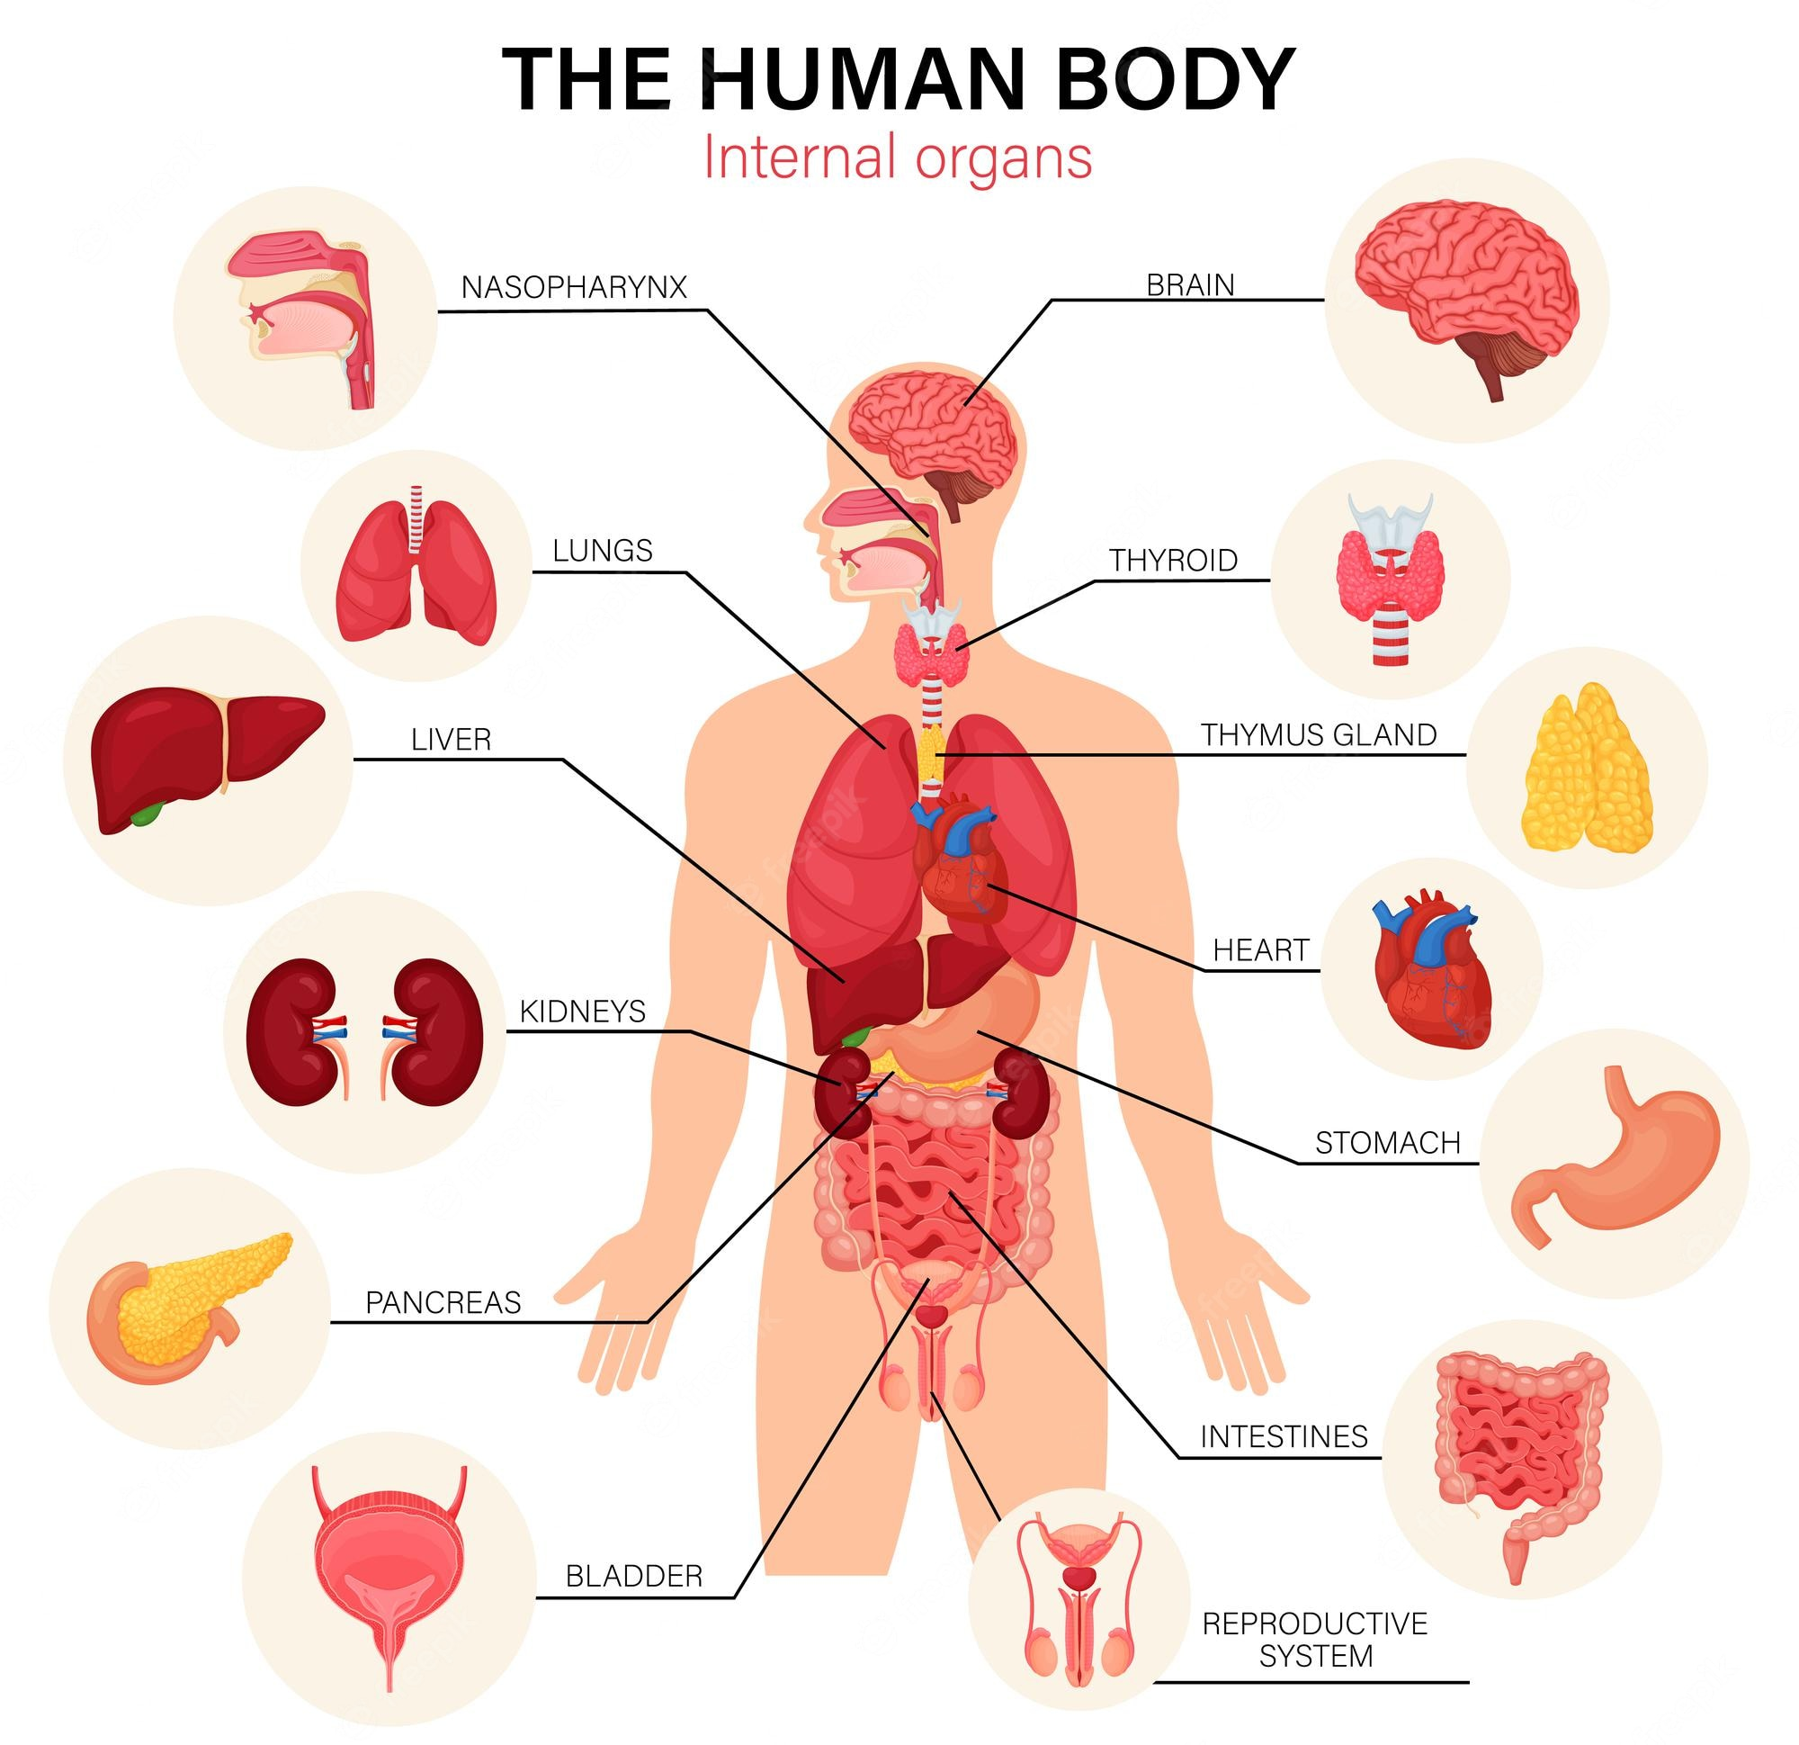

Planning Sheet
Brief description of Diabetes type 1 | Diabetes type 2
What is glucose? Where does it come from?

What is insulin? What does it do?

Why is high blood sugar bad?

What are some long-term complications?

Symptoms of Diabetes

Risk Factors of diabetes type 2.

How many people in are Canada affected? What population is more susceptible?

Living with Diabetes:
Is there a cure?

What is the treatment?

Foods to avoid.

Why should we read labels?

Extending: What are some sweeteners that are added to foods so they can claim “no sugar added”?

What is Gestational Diabetes? Can the baby get it?

