MEASUREMENT UNIT REVIEW
Unit Conversions
  - The distance to the moon is 238,855 miles. How many meters is this? (1mi = 1610m)

  - Speed of sound, 740 miles per hour, in kilometers per hour and meters/sec.

  - Length of a C-C bond in diamond, 1.54452 Å (angstrom), in cm and m.
Metric System:
  - What is the multiplier for Mega?

  - What is the symbol for micro?

  - Conversions: Show all your unit conversions like this:
6.2 kL = _____mL

6.2 kL x 1000 L x 1000 mL = 6.2 x 10⁶ mL
1kL 1L

- 3s = ____ ms
- 3125 L = ____kL
- 7.8 g/mL = ____ kg/L
- 16 cm/s = ____km/ks
- 51 kg/hr = _____g/s
- ____nm² = 89700000m²
- ____mm³ = 1.876 m³
- 4 Mm = _________ cm

Scientific Notation
  - Perform the indicated operations and express your answer in scientific notation.
- (1.81 x 10⁻³) (1.06 x 10 ²⁰) =
- (5.77 x 10 ^{–4}) /( 1.71 x 10 ^{–11}) =
- 1.17 x 10⁴ - 3.57 x 10² =
- 1.34 x 10²⁴ – 2.22 x 10² =

Uncertainty, Precision, Accuracy:
  - Define Precision
  - Define Accuracy
  - Give the correct measurement in cm:

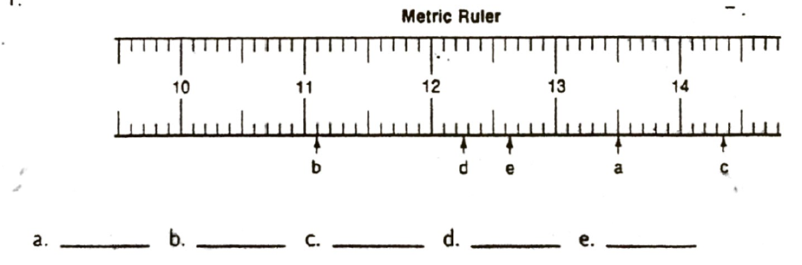
Significant Figures
  - How many Sig Figs?

- 46.37
- 0.00872
- 15.285
- 15.285
- 150 000 000
- 870 000
- 0.00960
- 4.59 x 10⁻⁵

  - Round off to the indicated number of Sig Figs:

- 195.259 (4) e. 0.014625 (3)
- 24.603197 (4) f. 52196.942 (3)
- 0.00000439 (2) h. 60000. (3)
- 216.452 (1) i. 4356 (2)

  - Calculate and give answers to the correct number of significant figures

a. 16.7205 b. 12.112 c. 167 = d. 0.0000004120 =
3.84 - 2.9 - 27.3 0.0000012785
+12.709

- 4.2 x 1.7 = f. 14 x 0.05 = g. 165 x 12 =

- 9.34 x 0.07146 – 6.88 x 0.081 15 =

- 0.341 x (18.64 – 6.00) x 3.176 =

Graphing:
  - What is a best fit line?
  - What is slope?
  - What are two ways to calculate slope?

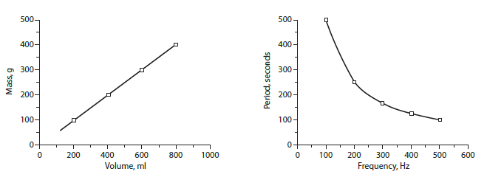
  - Define the two types graphing relationships one the right.

  - Which is the independent variable on the graph below?
