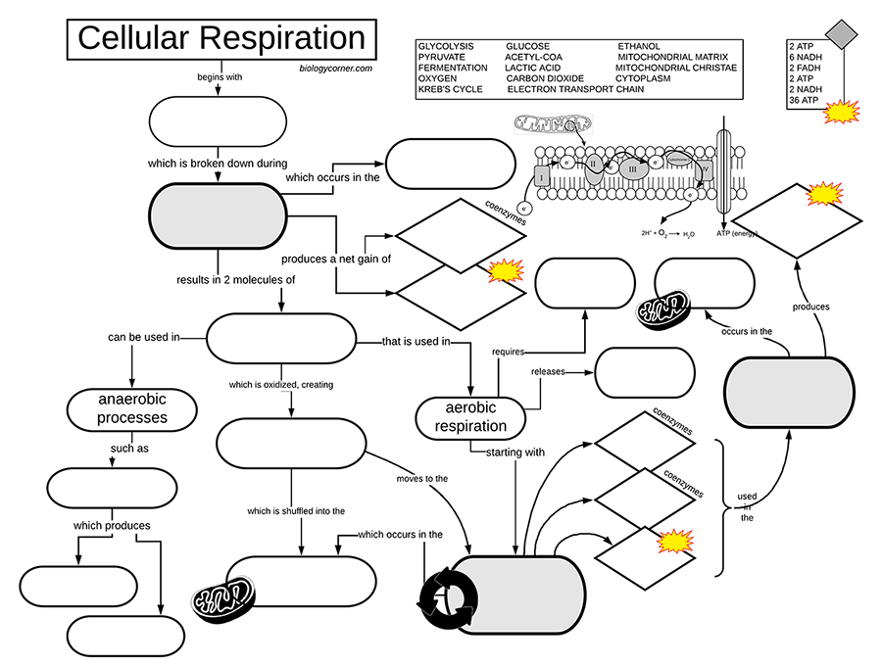
Follow-Up Questions:
- Define cellular respiration in words.

- What materials are required for this process? What materials are produced?

- Where in the cell does glycolysis occur and where does the Kreb’s Cycle occur?

- What is the difference between aerobic and anaerobic respiration?

- Compared to other types of energy conversions, how efficient is cellular respiration?

- Explain the connection between photosynthesis and cellular respiration. Include the summary equations and what each does.

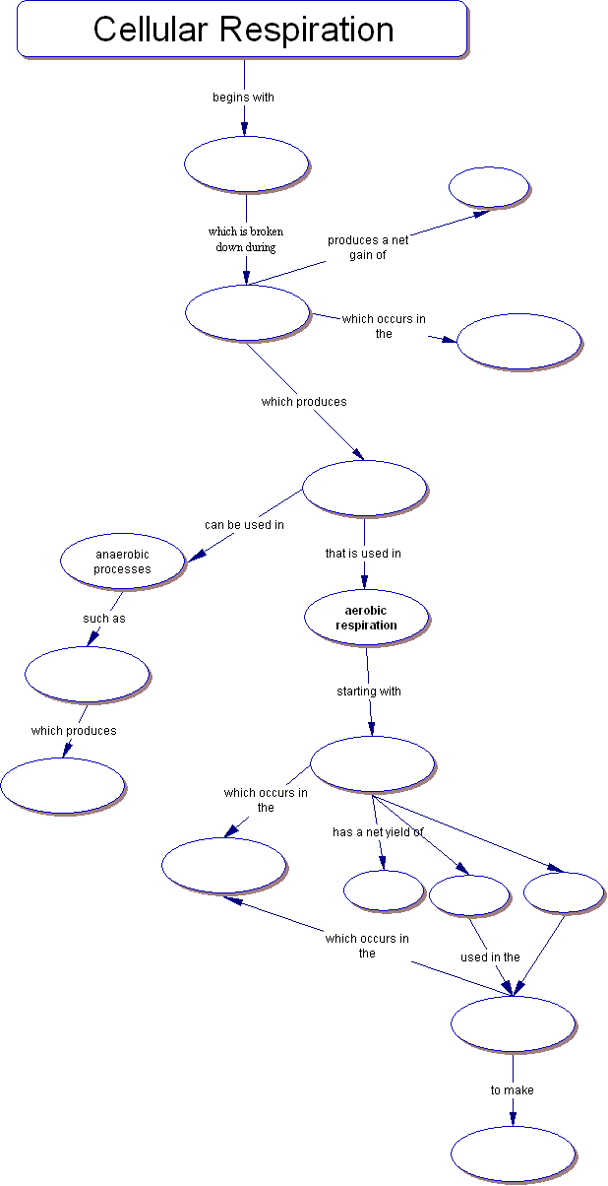

WORD BANK:

2 ATP, 2 ATP, 36 ATP, 6 NADH, 2 FADH, Electron transport chain, Mitochondrion, Cytoplasm, Fermentation, Glycolysis, Glucose, Pyruvate, Lactic acid, Kreb's Cycle

There is a newer version of this graphic organizer at https://www.biologycorner.com/2018/11/10/cellular-respiration-graphic/
