Cellular Respiration Worksheet Name: ___________
Read p123 – 129 to answer the following questions
- In your own words explain what glycolysis means.
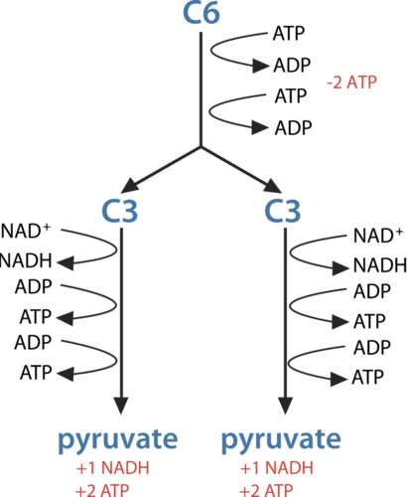
- Where in the cell does glycolysis occur?

- What is needed at the start of glycolysis to split the glucose molecule?

- What are the products of glycolysis?

- How many ATP in total are produced from glycolysis? What happens to the first two?

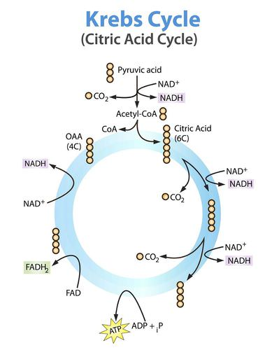
- In your own words define respiration.

- What type of organisms use respiration?

- What does aerobic mean?

- How is respiration similar to breathing?

- The Krebs cycle is the __________ set of reactions in ________________.

- Where in the cell does the Krebs cycle occur?

- What is the first reactant in the Krebs Cycle? Where does it come from?

- What is the first product of the Krebs cycle?

- Explain why two turns of the Krebs cycle are needed for each molecule of glucose.

- Most organisms don’t eat straight glucose, so where does the glucose come from?

- None of the steps of the Krebs cycle involves oxygen. However, the Krebs cycle is considered to be an aerobic process. Explain why.

