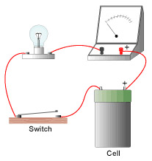
MEASURING CURRENT – PART I
Skill focus: observing, predicting, measuring
Goal: In this activity, you will measure currents in a simple circuit using an ammeter.
Materials: light, electric cells in holders, switch connecting wires, ammeter
Procedure:
1. Connect the light bulb to the electric cells in series. Insert an ammeter between the bulb and the cell. (See picture to left).
2. Draw a circuit diagram of your circuit. Draw an arrow on your diagram to indicate the direction of electron flow.

3. Close the switch. Measure the current entering the light bulb.
Record it:
4. Open the switch. Remove the ammeter and place it on the other side of the light bulb. Make a prediction about how the current on this side of the light bulb will compare with the current on the other side.
Prediction:

5. Close the switch and measure the current leaving the light bulb.
Record it:
Analysis: How does the current entering the light bulb compare with the current leaving the bulb? Draw a conclusion about what happens to electrons when entering and leaving the bulb.

MEASURING CURRENT – PART II

Add a second bulb. What happens to the current if you add a second light bulb?

Add a third bulb. What happens to the current if you add a third light bulb?

Take out the extra bulbs. Add a second battery. What happens to the current when you add a second battery?

Add a third battery. What happens to the current when you add a third battery?

How would you make a circuit that had the brightest light possible? TEST IT.

