Sci 8 Microbe Research Project 25 pt Name:

Alone or in pairs, you will research ONE species of a type of microbe and discuss how it is important to us (good or bad) in one of the following:
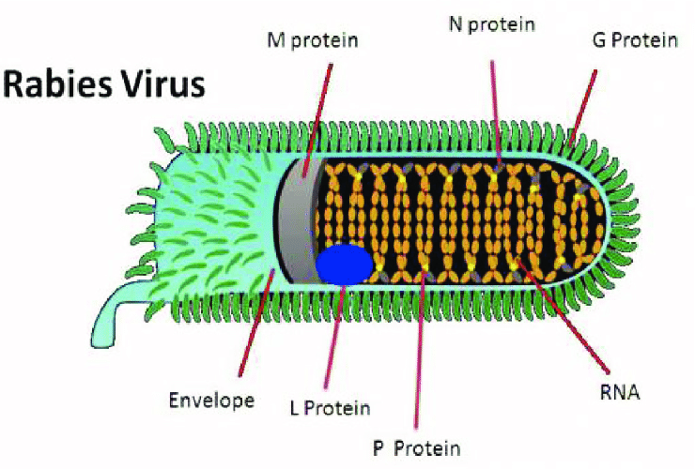
- Cycling of Nutrients
- Food production
- Medicine
- Gut bacteria
- Disease,
- Bioremediation (Cleaning up chemical spills)
- Use in waste management

Your project will include:
- Title, name, partner, date, block (1pt)
- Scientific and Common Name of ONE organism (1pt)
- Description of organism: Shape, size, Type (bacteria, virus, yeast), Habitat (where normally found) (4pt)
- Labeled Image/drawing of the organism (1pt)
- Discussion of your topic: Importance, How does your microbe function? Affects: Benefits/harm Use prompts. (10 pt)
- Cite your work. Minimum of three sources. Wikipedia does not count. (1pt)
- Project must be in your own words. No cut and paste (2pt).
- Well organized, no spelling mistakes, visually appealing, effort (5pt)
- You may include other images to support your presentation. Images must also be cited.
- Can be poster, power point, comic strip or written report.

Partner: _____________________

Microbe topic: __________________________

There are many different species of algae, protozoa, bacteria, fungi, and viruses. Discuss ONE and what it does.
Eg. Pseudomonas putida is a gram-negative soil bacterium that is involved in the bioremediation of toluene, a component of paint thinner. It breaks down toluene by ….This is important because …
Eg. Bacteria and cycling of nutrients: Nitrosomonas europaea is a bacteria that lives on the nodules of ….plants. this bacteria cycles nitrogen in the ecosystem in a process called nitrification, where ammonium is oxidized to nitrite …Nitrogen cycling is important because most nitrogen in the atmosphere is not in a useable for plants and animals. Nitrogen is a major component in chlorophyll, a pigment needed for photosynthesis. Without nitrogen fixing bacteria plants would die.
Eg. Candida albicans is a type of yeast (which is a type of fungi) that normally lives in the human gut. This particular yeast can cause candidiasis, a yeast infection in the vagina. This can happen when…..Symptoms of an infection include…It can be treated…

