Sci 8 Microbe Research Project 25 pt Name:

Introduction:
Microbes are microscopic organisms and are found all around us. They can be classified into 4 main groups: Bacteria, Viruses, Fungi, and Protists (parasites):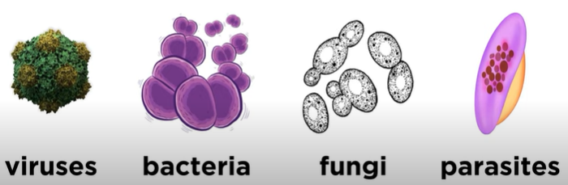

Microbe are important to us as they are responsible for both negative and positive interactions such as:

- Cycling of Nutrients
- Food production
- Used to make Medicine
- Gut bacteria
- Disease
- Bioremediation (Cleaning up chemical spills)
- Used in waste management

What to do:
Alone or in pairs, you will research ONE species of a type of microbe and discuss how it is important to us (either good or bad) in one of the following:

Your project will include:
- Title, name, partner, date, block (1pt)
- Scientific and Common Name of ONE organism (1pt). Scientific name consists of TWO names in italics (eg Escherica coli )
- Image and Description of organism: Shape, Size, Type (bacteria, virus, fungus, protist), Eukaryotic or prokaryotic? Uni- or Multicellular? Habitat (where normally found). (4pt).
- Discussion of your topic: How does your microbe do the thing that impacts us? (3pt)
- Discuss Impact on Humans: Does it have a Positive (good) or Negative (bad) impact on humans/plants/ society? Discuss this importance. How many people are/were affected? Use the prompts that came with your assigned microbe. (6 pt)
- Reflection: Share something that you learned or that surprised you about your topic. (1pt)
Things to be aware of:
- You should include relevant images to support each topic. Images must also be cited.
- Cite your work. Minimum of three RELIABLE sources. No Wiki, Prezi, Weebly. (1pt)
- Project must be in your own words. No cut and paste (5pt).
- Well organized, no spelling mistakes, visually appealing, effort (3pt)
- Can be poster, power point, comic strip or written report.
- You will share your project to small groups of peers.
- You will peer review your peer’s presentations.
- Minimum 6 slides if presenting a powerpoint
Intro to microbes: https://www.youtube.com/watch?v=ycO-oWYvaQI
Topic List

- Food Poisoning – pick ONE microbe that can cause food poisoning, what type of food would you find it in? How does it get there? What happens to our bodies when we eat it? What steps can we take to prevent this microbe from poisoning us? Discuss the overall toll on the general population if this microbe was widespread.

- Parasite – Pick a microscopic parasite. Where does this microbe normally live? Show its life cycle. What is the host (list all if more than one). At what stage in life cycle does it infect the host? How long does it stay in the host? How does it get in? If it does, how does it get out? Or what part of life cycle gets out? What are the symptoms? Is it treatable? Curable? How can you prevent getting it? What countries is it most common?

- Disease – Pick a microbe that causes a particular disease. How do you catch it? What are the symptoms? Does the disease kill? How long does it last? How do you cure/treat it? How can you prevent it? Is there a certain population that is more vulnerable? What countries is it most common in?

- Food Production – pick ONE microbe or family that is used to make food. What type of food? Discuss the process in which this microbe helps make the food. What requirements does this microbe have to do its job?

- Gut bacteria – Name ONE (beneficial) bacteria species that normally lives in out gut and what it does for us. How did it get there? What can decrease the population? Could we live without that one species? Are there other species that could take its place? How can we replenish this population if we lose it?

- Medicine – Pick ONE microbe that is used to make a particular medicine/protein/vaccine. (eg. Penicillin, insulin). How is the medicine taken? How does it help? Does it prevent growth, prevent, cure or treat a disease/illness?

- Cycling of Nutrients – pick ONE specific microbe that is useful the cycling of ONE nutrient (eg. Nitrogen). Briefly discuss nitrogen cycle and what your microbe does in this cycle. How does it do this? Where does it live? What do you think would happen if a disease wiped out all these microbes? Are there any particular requirements for this microbe to do its job? What hampers it? Discuss how does it benefits the general population.

- GMO/Agriculture – Pick a microbe that is used in the process of Genetic Engineering. What part of the microbe is used? How is it used? You may want to include a diagram to support the process. What other organism is involved? What is the benefit for the new organism? How does it benefit the general population?

- Bioremediation - Pick ONE microbe that is used in cleaning up chemical spills (oil spills, agricultural waste). How does it do this? Are there any particular requirements for this microbe to do its job? What hampers it? Discuss how does it benefits the general population.

- Waste Management Pick ONE microbe that is used to purify water. How does it do this? Are there any particular requirements for this microbe to do its job? What hampers it? Do all countries use this technology? Discuss how does it benefits the general population (compare to other countries that do not have this technology).

- Microbes in clothing.....why do they use microbes in clothing?

- Food Spoilage that causes illness – Pick one organism that spoils our food ( you may need to pick a particular type of food). Why does it spoil our food (is it breaking down the food into something it can use?) how does it do this? What enzymes does it use? What is the result? How do we slow/stop this process? What can be the symptoms.

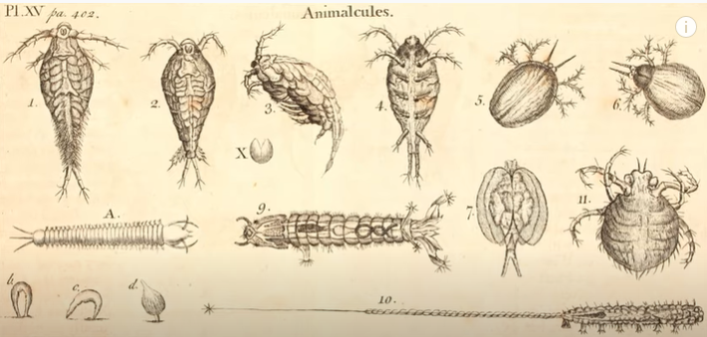
- REMOVE: Vaccine – Pick one microbe that is used in the creation of a vaccine. What disease/illness is it used for? Does it fully prevent or just reduce the effects of the disease? At what age do you get the shot? Is a booster required? Is the vaccine live, killed, or weakened? Is the vaccine available world wide or only some countries? Is it free? What would happen if you did not get the vaccine? Give some reasons why some people DO NOT/CAN NOT receive the vaccine. Discuss how this vaccine benefits the general population.

