Sci 8 Microbe WS Name:
Block:
- How small does an organism need to be to be considered a microbe?

- Name at least three places where microbes can live.

- Name four categories of microbes.

- Describe three characteristics that microbes share with other living things.

- Name two types of fungi that are microbes and one that is not.

- Name three positive interactions we have with microbes.

- Name three negative interactions we have with microbes.

- Bacteria can consume some chemicals that would make humans very ill. This makes them very useful for waste management and disaster recovery (bioremediation). Describe the role bacteria play in addressing these two issues.

- Name some methods that people have used to prevent or lessen microbes from spoiling food.

- The statements below are related to handing food safely. Explain the reason behind each statement. Be specific.
- Frozen meat should be thawed in the refrigerator, not on a counter at room temperature.

- Cutting boards and dishcloths need to be disinfected after each use.

- People should wash their hands before and after handling and preparing food.

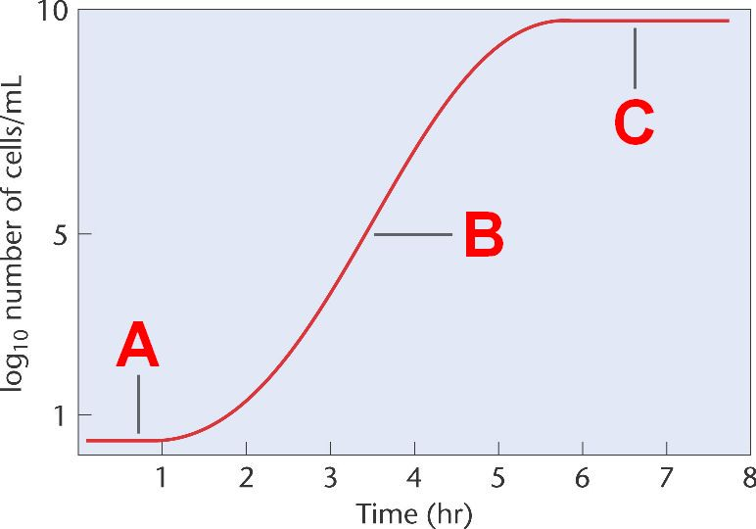
- The graph below shows how a population of bacteria increase in a bowl of broth over 8hr.

- Interpret what is happening to the population between 0 and 1 hour; and between 6 and 8 hours.

- After 8 hours the graph begins to decline sharply. Infer what is happening and give your reasoning.

- Assume the temperature of the broth was 25C. Predict what the graph would look like if the temperature of the broth were 4C. Explain your prediction.

- Some medicine people take to treat an infection also kill bacteria that are naturally found in the intestines. Why is this a concern?

