Name:___________________________________Date:______________

Cell Cycle Labeling
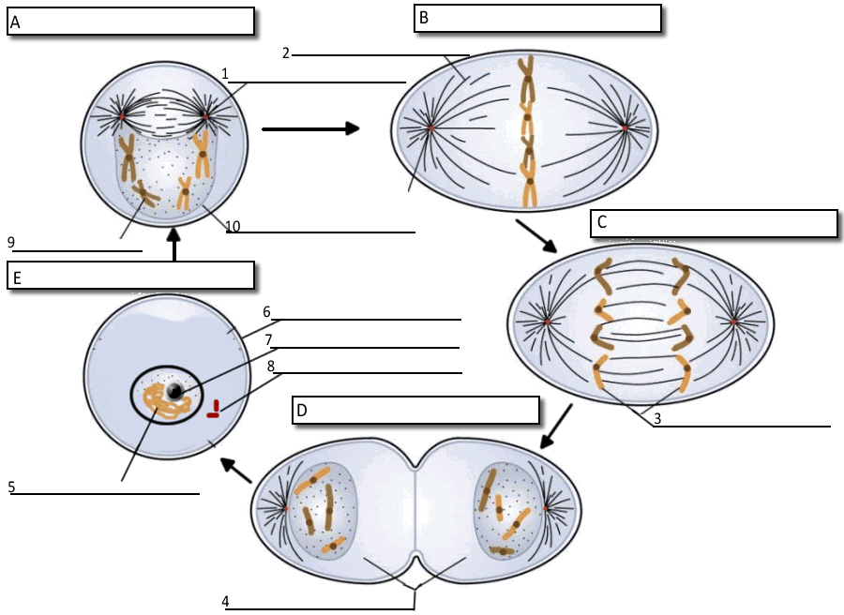
11. What moves the chromatids during mitosis? ___________________________________
12. What anchors the spindle? ________________________________________
13. What are the four phases of mitosis? ___________________________________________________
14. How many daughter cells are created from mitosis and cytokinesis? ___________________________
15. During what phase does cytokinesis begin? ________________________________________
16. If a human cell has 46 chromosomes, how many chromosomes will be in each daughter cell? _________
17. If a dog cell has 72 chromosomes, how many daughter cells will be created during a single cell cycle? ______
.....Each of these daughter cells will have how many chromosomes? ____________
18. The nuclear membrane dissolves during what phase? ________________________
19. In the cell pictured above, how many chromosomes are present during prophase? ________________
20. What structure holds the individual chromatids together? ______________________________

