Biology Unit Review Name__________________________

1. List the 7 Characteristics of Living Things and give an example of each:

|  |  |
| --- | --- |
| Characteristic: All Living things…. | Example |
|  |  |
|  |  |
|  |  |
|  |  |
|  |  |
|  |  |
|  |  |

1. What is the difference between a producer and a consumer?
2. What is a stimulus?
3. Give an example of an internal stimulus and an external stimulus.
4. List the 3 parts of CELL THEORY:

a)

b)

c)

1. What are the differences between a prokaryotic cell and a eukaryotic cell? Give detail.

|  |  |
| --- | --- |
| Prokaryotic Cell  Example: | Eukaryotic Cell  Example: |

1. What are the differences between bacteria and viruses? – Not covered this term.
2. Label the parts of the plant and animal cell.

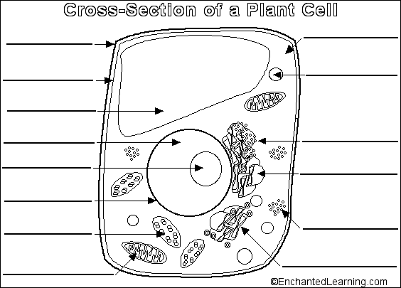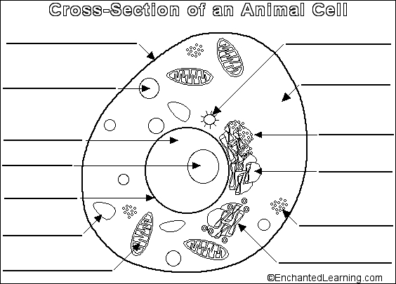

1. What are three main differences between a plant cell and an animal cell?

|  |  |
| --- | --- |
| Structure/Organelle | **Description/function** |
| 1. Cell membrane | Thin skin-like structure which surrounds the cell. Regulates movement of materials in/out of the cell. |
| 1. cytoplasm | Jelly-like environment in which the organelles are sitting in. |
| 1. cell wall |  |
|  | Large, often round structure that contains genetic material, controls all cellular activities. |
| 1. Ribosomes |  |
|  | Post- office of the cell. Piles of flattened sacs that *sort* and *repackage* proteins. Makes vesicles. |
|  | Network of membrane-covered **channels** that transport materials throughout the cell. |
|  | Captures energy from the sun to produce sugars (food) for the cell through a process called ___________________________________ |
|  | Releases energy from food molecules through cellular respiration. |
|  | Small sacs located in the cytoplasm used and transport units. |
|  | Larger sacs used to store water, nutrients, wastes. |
|  | Larger sac that contains enzymes to break down material |

|  |  |
| --- | --- |
| Define **photosynthesis** and complete the equation showing the reactants and products  Energy!!! | Products  Reactants  Light +__________________ +__________________ 🡪_________________ + ____________ |
| Define **cellular respiration** and complete the equation showing the reactants and products | Reactants  Products  Sugar + _________________ 🡪 ________________+_________________+_______________ |
| What pattern do you see when you compare photosynthesis and cellular respiration? |  |

Label the parts of the microscope:

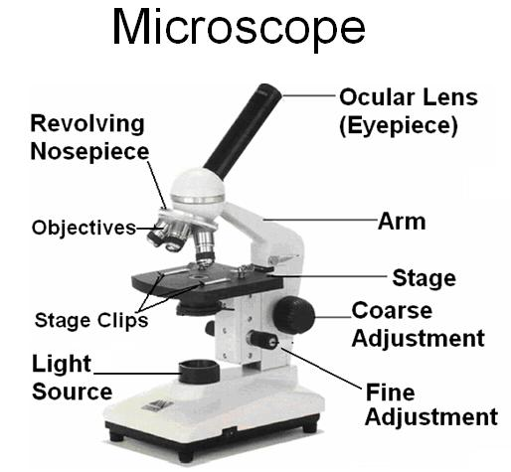

How is the image in a microscope different form the specimen on your slide?

How do you find TOTAL MAGNIFICATION?

What is the Field of View?

What happens to the FOV when the magnification INCREASES?

Compare DIFFUSION and OSMOSIS.

What does selectively permeable mean?

What does tonicity mean?

A hypertonic solution means it has a _______________ (Higher or lower) concentration of particles than the cell.

A cell is placed in a Hypertonic solution. The cells membrane is selectively permeable. Which way will the water move?