Sci 8 Determining Mass Lab using the Triple Beam Balance Name: _____________
Partner: ____________
Purposes:
- To become familiar with the operation of the triple beam balance.
- To determine the masses of several samples using the balance.

Part A: Label the diagram below using the labels: pan, beams, weights, adjustment screw, pointer
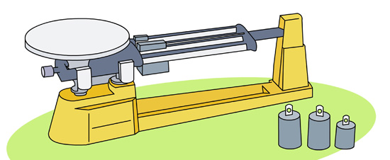

Part B: Determine the Mass (in grams) of the solid objects:
 | Rubber stopper | Wood Block | Marble | Your Choice:
Top Rider (Biggest weight)
Middle Rider
Bottom Rider
Total Mass

Part C: Determine the mass of 50ml of sand using a beaker.
Step 1. Measure mass of empty beaker, record in table.
Step 2. Measure 50ml of sand with graduated cylinder. Pour into empty beaker.
Step 3. Measure mass of beaker + sand.
Step 4. Calculate mass of sand by subtracting mass of beaker from beaker + sand.
Mass of Empty beaker | Mass of Beaker + Sand | Mass of Sand
Part D: Determine the mass of 50ml of tap water using a beaker.
Follow same steps as in Part C.
Mass of Empty beaker | Mass of Beaker + water | Mass of 50 ml of water

Part E: Compare masses of similar looking solutions.
Measure 20ml of each solution using a graduated cylinder. Return liquids to their containers.
Substance (20ml) | Mass of Empty beaker | Mass of Beaker + Solution | Mass of 20 ml of solution
Tap Water
Salt Water
Sugar Water

Questions
- What is the definition of Mass?

- Other than grams, what other units is mass measured in?

- What units would we use to measure mass of a pumpkin?

- How many milligrams in a gram?

- How many grams in a kilogram?

- Compare the mass of 50ml of sand to 50ml of water. Which has more mass?

- Compare the masses of the liquids in part E. Why do you think they all have different masses?

