Mass Lab Name: _____________
Partner: ____________
Purpose:
- To practice making accurate measurements using the centigram/ triple beam balance.

Materials: Triple beam balance, rubber stopper, marble, sand, tap water, salt water, small beaker, 25 ml graduated cylinder.
Part A: Determine the Mass (in grams) of the solid objects:
 | 1 Marble | Rubber stopper | Your Choice:
Mass

Part B: Determine the Mass of 20ml of sand using a beaker.
- Step 1. Measure mass of empty beaker, record in table.
- Step 2. Measure 20ml of sand with graduated cylinder. Pour into empty beaker.
- Step 3. Measure mass of beaker + sand.
- Step 4. Calculate mass of sand by subtracting mass of beaker from beaker + sand.

Mass of Empty beaker | Mass of Beaker + Sand | Mass of Sand only  (Beaker+Sand) - Beaker

Part C: Compare Masses of similar looking solutions.
Measure 20ml of each solution using a graduated cylinder.
Substance (20ml) | Mass of Empty beaker | Mass of Beaker + Solution | Mass of 20 ml of solution
Tap Water
Salt Water

Part D: Label the diagram below using the labels: pan, beams, riders, adjustment screw, pointer

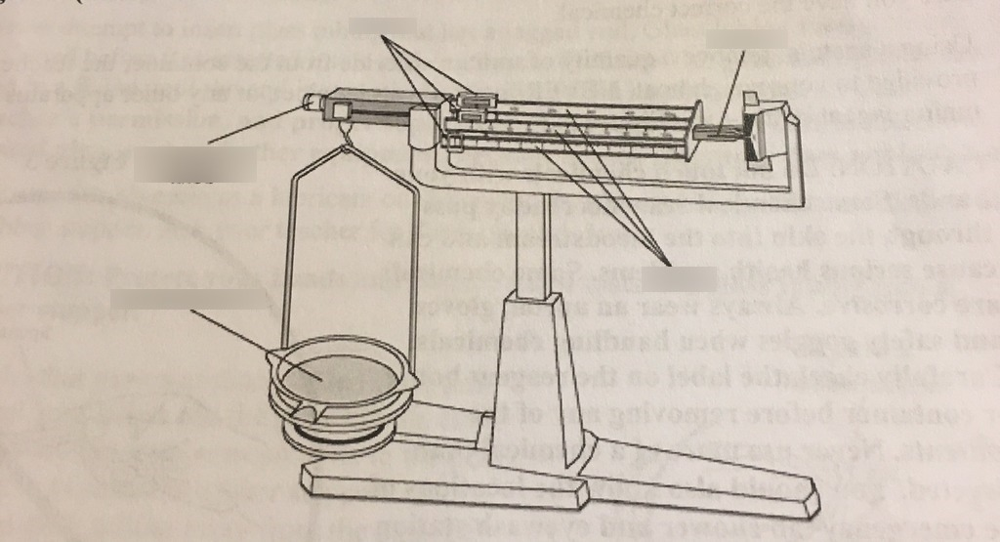

Questions
- What is the definition of Mass?

- What units would we use to measure mass of a candy bar? A person?

- How many milligrams in ONE gram? 4. How many grams in ONE kilogram?

- Convert: 23g to ______ mg convert 450 g = ________ kg

- Compare the mass of 20ml of sand (Part B) to 20ml of water (Part C). Which weighs more? Why do you think this is?

Rate yourself:
Planning and Conducting | Emerging | Developing | Proficient
I can handle the triple beam balance properly
I can take accurate measurements

- Other than grams, what other units is mass measured in?

- Which weighs more, a kilogram of feathers or kilogram of steel? Justify your answer.

