**Cell Division and Asexual Reproduction (pg. 57-59)**

1. Complete the table below to compare **sexual** and **asexual** reproduction.

|  |  |  |
| --- | --- | --- |
|  | **Sexual** | Asexual |
| # of new cells formed |  |  |
| # of parent cells |  |  |
| Genetically identical? (Y/N) |  |  |

2. What is cloning? Why are all of the offspring of asexual reproduction called clone?

_____________________________________________________________________

3. Identify the method of asexual reproduction in each of the following:

i. A new tree begins to grow from the root of another tree. ________________________

ii) A single celled bacteria pinches into two. _________________________

iii) Mushrooms release many small cells which grow into new mushrooms. __________

4) a) What is the difference between binary fission and budding? __________________

______________________________________________________________________

b) How are these processes similar? ________________________________________

______________________________________________________________________

5) What is **spore formation**? ______________________________________________

______________________________________________________________________

6) a) Explain the difference between fragmentation and regeneration. ______________

______________________________________________________________________

b) Give an example of an animal that can do both. _____________________________

7) What are the three characteristics of asexual reproduction?

a) ______________________________________________________________

b) ______________________________________________________________

c) ______________________________________________________________

Use your notes and pages 57-59 of your text to briefly describe the different forms of Asexual Reproduction and draw an image demonstrating the method using the minion image below for each.

|  |  |
| --- | --- |
| Binary Fission  Description:  Image result for minion image cartoon  Eg. Bacteria | Budding  Description  Image result for minion image cartoon  Eg. |
| Fragmentation  Description  Image result for minion image cartoon  Eg. | Spore Formation  Description  Image result for minion image cartoon  Eg. |

In 1952, tadpoles were first cloned. Dolly the sheep was the first mammal to be successfully cloned. It was accomplished by taking the nucleus from a body cell of an adult female sheep and fusing it with a denucleated egg cell from another adult female sheep. The resulting embryo was placed inside the womb of a third sheep.

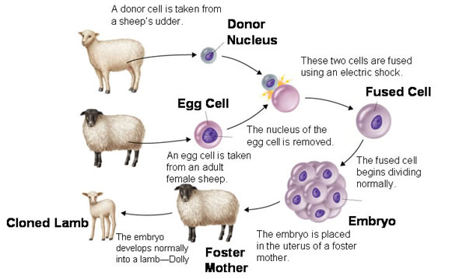

Read pages 61-62 to answer the questions about cloning.

1. If we can clone large mammals like Dolly the sheep, do you think cloning humans is possible?
2. Do you think scientists should clone mammals? Read the arguments in the chart on page 63 to support your response.