Latitude and Longitude Worksheet
Use the map to answer the following questions about latitude and longitude.
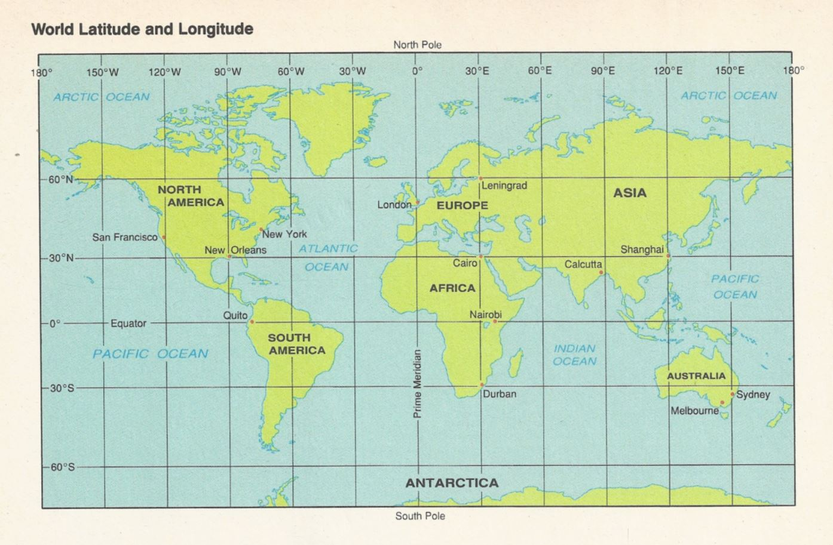
- In what ocean does the Prime Meridian cross the equator?
- Atlantic b. Pacific c. Indian d. Artic

- What two continents does the equator cross?
- North America and South America c. Africa and Europe
- Africa and South America d. Australia

- Which one of these continents lies completely in the Southern Hemisphere?
- North America c. South America
- Asia d. Australia

- What continent lies completely north of the equator and east of the Prime Meridian?
a. Europe b. Asia c. Africa d. North America

- On what continent would you find the place with a latitude of 20° N and a longitude of 0°?
a. Europe b. Asia c. Africa d. South America

- On what continent would you find each of the following locations?

  - 60°N, 100°W _________________
  - 60°N, 100°E ________________
  - 20°S, 60°W ________________
  - 20°N, 20°E ________________

- Identify the city and lies closest to each pair of coordinates.

  - 30°N, 90°W __________________
  - 30°N, 30°E __________________

- Give the coordinates for each city.

  - Shanghai, China ______________
  - Durban, South Africa ____________

- Identify the city with each pair of coordinates.
  - 0°, 78°W ____________________________________
  - 51°N, 0° ____________________________________
  - 38°S, 145°E ____________________________________

- Estimate the coordinates for each city to the nearest degree.
  - Calcutta, India __________________________________
  - Nairobi, Kenya __________________________________
  - New York, New York _____________________________

- Calculate the distance in km of 25° latitude ______________________

- Name the three types of map projections, their primary use, and a disadvantage of each.

- Calculate the antipode of Burnaby, BC (49° N, 122° W)?

