1. Define the following terms:
2. Current:
3. Voltage:
4. Resistance:

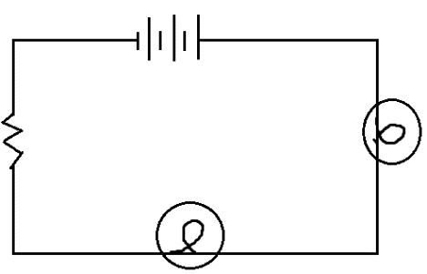

1. Circuit Diagrams: Be able to draw a circuit diagram using correct symbols.

a) Describe the circuit below with as many terms as you can:

1. On the circuit draw how you would attach an ammeter. What does it measure? ____________________
2. On the circuit, draw how you would attach a voltmeter to the 3rd light. What does it measure? _______________________
3. Be able to read an ammeter from an image:
4. Be able to Calculate Current, Charge, or time in seconds from a word problem. Eg What is the charge flowing through a 5 Amp radio over 5 minutes?
5. Be able to convert units within the metric system, such as kilocoulombs or milliamps and minutes to seconds, etc. Eg. How many seconds in 2 hr? How many amps in 250 mA?
6. Be able to use Ohm’s Law to calculate Current, Voltage, Resistance from both a word problem or circuit diagram.
7. Fill in the table below

|  |  |  |  |
| --- | --- | --- | --- |
| **Variable Name** | **Formula** | **Unit (& symbol)** | **Symbol** |
| Current |  |  |  |
|  |  |  | V |
|  | R = V/I |  |  |

1. Only 0.025 A of current pass through a portable CD player. If the CD player is operated by a 9V battery, what is the resistance in the circuit?
2. A clothes dryer uses a 220V power source. The coils of the heater provide an average resistance of 12Ω. What amount of current is flowing through the heating coils? (USE GUESA!)
3. Understand how current and voltage behave in both series and parallel circuits.
4. If you measure the **current** before and after a lightbulb, the current will ___________________

(increase, decrease or stay the same)

1. If you measure the **voltage** around a battery and compare it the voltage around a lightbulb, the voltage will ______________________ (increase, decrease or stay the same)
2. If you increase the **voltage**, the **current** will ____________________ and the lightbulb will __________________________ (increase, decrease or stay the same) (get dimmer, brighter or stay the same)
3. If you add more lightbulbs to a series circuit, the bulbs get _____________________

(dimmer, brighter or stay the same)

1. If no current runs through a load, does it receive any energy? Explain.
2. What is the purpose of adding a resistor in a circuit?

