ES 11 Mapping Review
- Are lines of latitude horizontal (side-side) or vertical (up and down)?
- What is another name for lines of latitude?
- What is the reference line for latitude?
- What is the highest latitude you can reach?
- Are lines of longitude horizontal (side-side) or vertical (up and down)?
- What is another name for lines of longitude?
- What is the reference line for longitude?
- What is the highest longitude you can reach?
- How are lines of latitude and longitude labelled and divided?
- Discuss each map projection.
Projection | Use | Disadvantage
Mercator
Polyconic
Gnonomic

- What is an antipode?
- How do you calculate the antipode of a coordinate?
- How many time zones do we have?
- If the map distance between 2 villages is 2.3 cm and the scale is 1:500, what would be the actual driving distance?

- If a sailing ship is 145 m long and the model of the ship in a bottle is 22 cm long, what would be the scale?

- A painting of a tree is 7 cm tall. The scale is 1: 45. What would be the height of the actual tree?

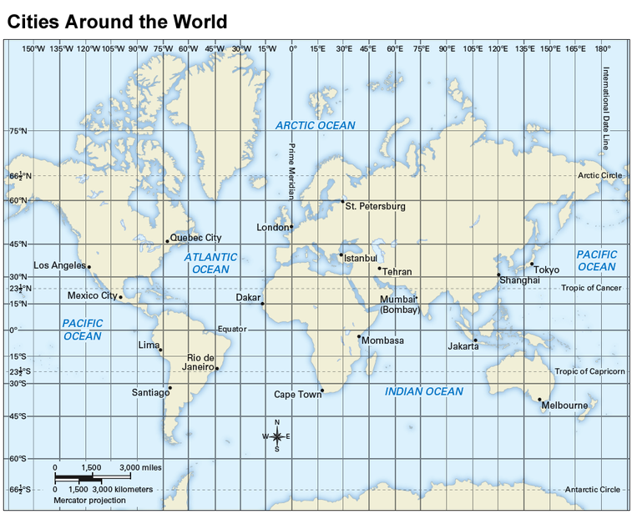
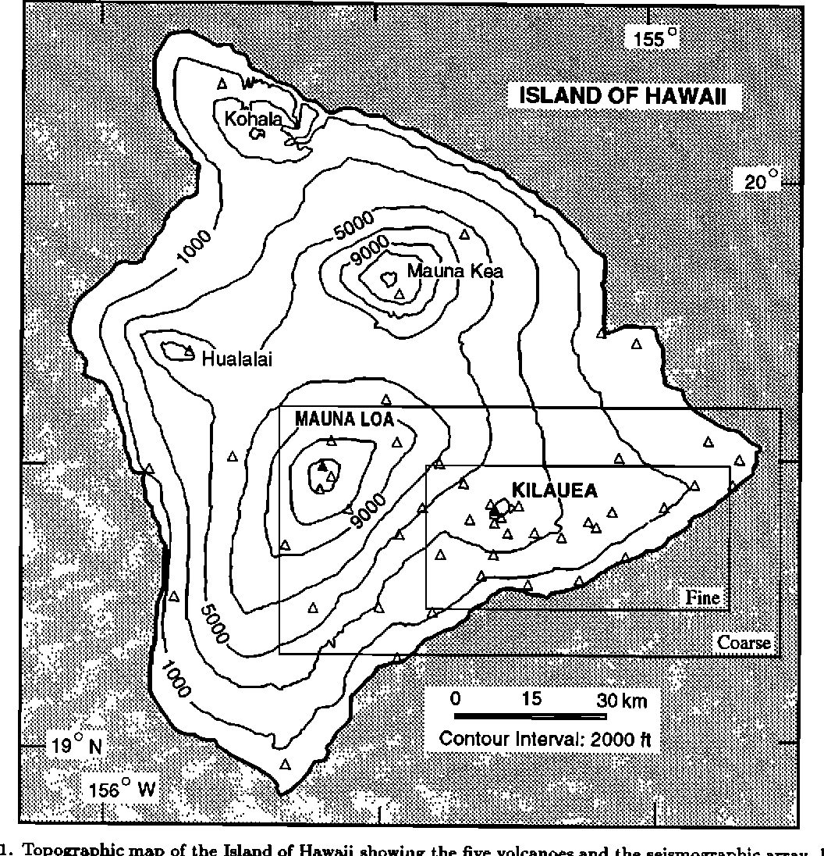
- What is the latitude and Longitude location of Quebec City on the map below?

- On the map below, what city is located at 33 ° S, 70° W?

- What do contour lines on a topographic map show?

- What is the contour interval of the topographic map on the right?

- What is the elevation of the highest point of Mauna Loa?

- What is the gradient between the black triangle of Mauna Loa and the black triangle of Kilauea?

