ES 11 Weather Forecasting Assignment /35pts
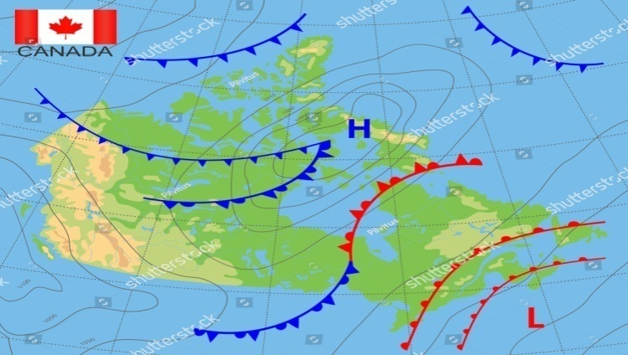
Demonstrate you learning of weather by creating a weather report across Canada. You will discuss at least two different weather systems expected at least 2 different cities (in different provinces or territory).
What to do:
Part I (25pt)
- Decide location of two cities (in different provinces/territories) and the weather each city is to expect. Then decide appropriate symbols for pressure, front, wind, precipitation, clouds, and temperature for that system.
- Print/Trace/Draw the blank map of Canada (see second attachment) on a full, plain sheet of paper.
- Label at least 2 different air masses on your map and indicate the direction they are moving. These air masses will dictate what fronts will be arriving to which cities and the weather they will bring and for how long. Keep in mind where the masses originate (over land vs water and latitude) will dictate the temperature and moisture content. (4 pt)
- Draw at least 2 different fronts. The location and direction should correlate with your air masses. These fronts should be approaching your cities. (4pt)
- Draw and label at least 10 different isobars covering the country. Include at least ONE HIGH pressure system and ONE LOW pressure system. These would be approaching, over, or leaving your cites. (3pt)
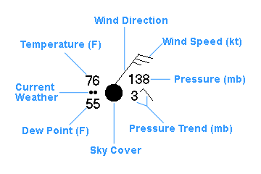
- Apply station symbols at your two cities (each in a different province or territory). Your station symbols will include: wind direction and speed, temperature in degrees Celsius, precipitation, sky cover, pressure (does not need to be exact but does need to correspond to isobars). You do not need to apply all the symbols in the example on the right, just those stated above. (10pt)
- Draw at least 2 different types of cloud symbols (see below for cloud symbols) next to the cities with weather symbols. The clouds should correspond to the current weather for that city. (2pt)
- Include at least one type of precipitation for one of your cities. It must correspond to your clouds. (2pt).
- Take a picture of your map and upload to Office 365 account. Make sure all labels are clearly readable on your picture. Name your file “Forecasting Assignment - Map”, and your first and last name.
You may use examples on this page as a guide but your map must be unique.
- Check: Does the moisture content and temperature of your air masses correspond to their origin?
- Do your wind speeds and direction correspond to your isobars (wind blows from .. to ..). Remember, the higher the pressure difference, the faster the wind.
- Do your clouds correspond to the precipitation that city is having?
Part II (10 pt)
- Next, type out your weather forecaster’s script for your two cities describing each item you illustrated on the map (what each cloud is and means, weather symbol, air mass, pressure system, and front means and what type of weather it will bring). This proves to me you know what each symbol means.
- Save as a word doc with appropriate title (Forecast Script, your name), upload to Office 365 account and submit through TEAMS.

In the end you will have submitted 2 pieces to me for this assignment: Map with symbols, and your script.
