Acceleration Summary
- Acceleration is the rate of change of velocity.
- Change in velocity can be due to either change in speed, direction, or both
- If acceleration is is same direction of motion, object is speeding up.
- If acceleration is is opposite direction of motion, object is slowing down.
- Slope on Velocity Time Graph is Acceleration:

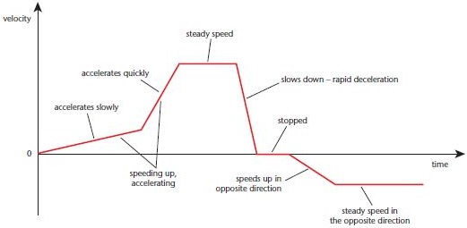
- Acceleration due to gravity is ALWAYS DOWNWARD and therefore NEGATIVE. 9.8m/s²
- Acceleration due to gravity applies to anything FALLING or THROWN UPWARD.
- Formula for calculating acceleration is always:

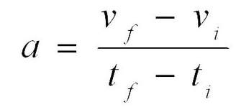
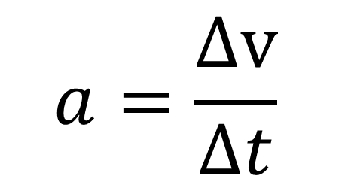 or

- Where units for acceleration is m/s2
- Units for velocity is m/s
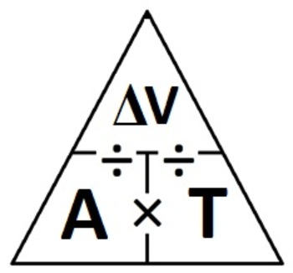
- Time is in seconds.

