Apoptosis vs Necrosis

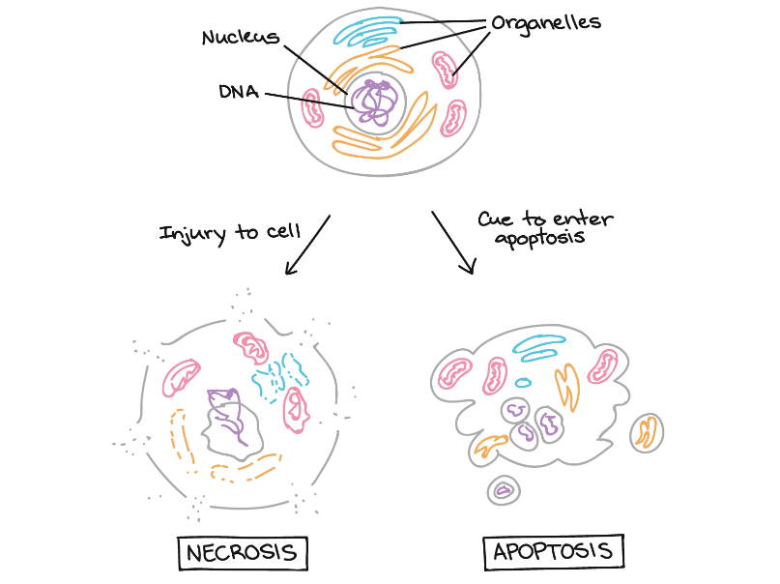
Why would cells need to undergo apoptosis?
- Some cells need to be “deleted” during development – for instance, to whittle an intricate structure like a hand out of a larger block of tissue.
- Some cells are abnormal and could hurt the rest of the organism if they survive, such as cells with viral infections or DNA damage.
- Cells in an adult organism may be eliminated to maintain balance – to make way for new cells or remove cells needed only for temporary tasks.

