What is Cancer?
- Uncontrolled growth
- Neoplasm (a new and abnormal growth of tissue in some part of the body, especially as a characteristic of cancer.)
- Tumours can be either benign (non-cancerous) or malignant (cancerous).
- Benign tumour cells stay in one place, do not spread usually not life-threatening.
- Malignant tumour cells are able to invade nearby tissues and spread to other parts of the body (metastases).
- malignant tumors consist of undifferentiated, or unspecialized, cells that show an atypical cell structure and do not function like the normal cells from the organ from which they derive.
- lack contact inhibition; cancer cells growing in laboratory tissue culture do not stop growing when they touch each other on a glass or other solid surface but grow in masses several layers deep.
- secondary effects, pressure on surrounding tissue
- telomerase, an enzyme that alters the telomere gene and allows the cell to continue to divide.
- competes with normal tissue for nutrients, eventually killing normal cells by nutritional deprivation.
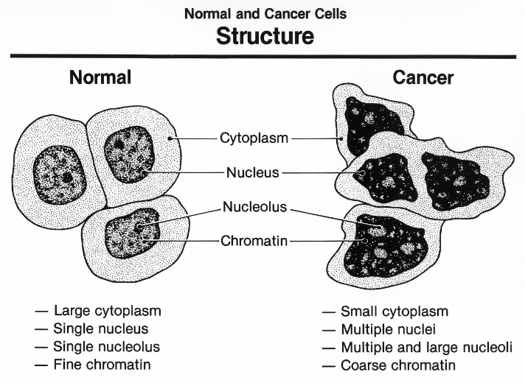
Cancer cells behave differently from normal cells because they don’t:
- stop dividing
- obey signals from other normal cells
- stick together very well and can spread to other parts of the body
- specialize into mature cells (differentiate) but stay immature
Cancer cells usually can’t enter G₀ and therefore begin to divide uncontrollably.

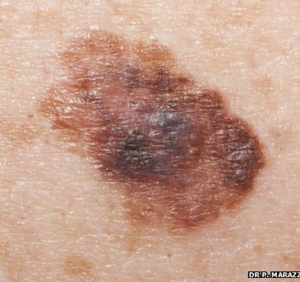
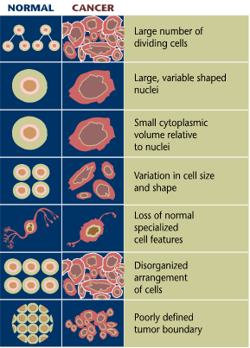

A – asymmetry
B – border irregularity
C – colour
D – diameter

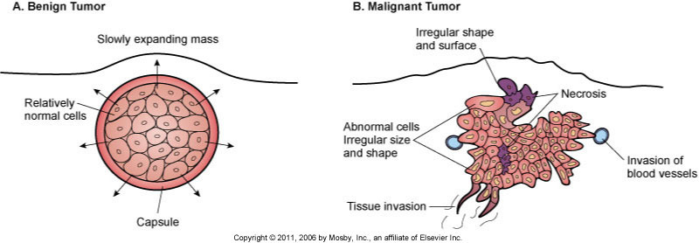

Main Categories named for site of origin
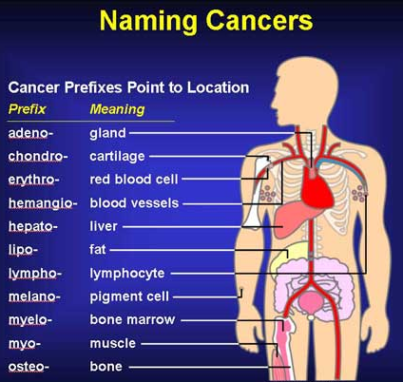
- Carcinoma – begins in the skin or in tissues that line or cover internal organs.
- Adenocarcinoma, basal cell carcinoma, squamous cell carcinoma, and transitional cell carcinoma
- Sarcoma – begins in the connective or supportive tissues such as bone, cartilage, fat, muscle, or blood vessels
- Leukaemia – starts in blood forming tissue such as the bone marrow and causes large numbers of abnormal blood cells to be produced and go into the blood
- Lymphoma and myeloma – begin in the cells of the immune system
lung cancer that has spread to the brain is called metastatic lung cancer,
Carcinoma in situ refers to a cancer that has not spread.

Most Common Causes of Cancer
Cumulative
- gene mutation
  - inherited or acquired (caused by repeated exposure carcinogens):
- Smoking
- Diet - high fat, low fibre diet, lacking in fruits and veg (antioxidants)
- excessive alcohol consumption
- Radiation - leukemia in Hiroshima and Nagasaki
    - thyroid cancer after the Chernobyl nuclear disaster
    - ultraviolet radiation of sunlight.
- Chemicals from occupational hazards.
  - asbestos lung and colon cancer

Susceptibilities
- dose of carcinogens
- biologic susceptibility:
  - age,
  - sex,
  - immune status,
  - nutritional status,
  - genetics - 5% thought to be inherited genetic mutations.
  - BRCA1 and BRCA2 genes that increase breast cancer risk and the
  - HNPCC gene that is linked with colon cancer
  - ethnicity - African Americans have comparatively higher cancer rates and cancer mortality rates.
Types of cancer genes (3) the main causes of cancer-related mutations,
which may make them more likely to develop a particular type of cancer.

Oncogenes
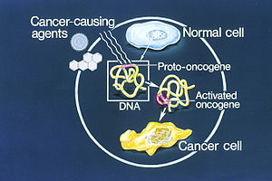
- damaged versions of normal genes called proto-oncogenes,
- activated by a mutagen
- Most normal cells will undergo a programmed form of rapid cell death (apoptosis) when critical functions are altered.
- Activated oncogenes cause those cells designated for apoptosis to survive and proliferate instead
- Oncogenes produce growth factors, signalling cell to grow and divide

Tumour suppressor genes
- genes that normally protect against cancer
- Eg. p16, p53, and BRCA1 genes normally produce a negative growth factor that tells a cell when to stop dividing.
- If they get damaged, cell growth, cell division and cell death (apoptosis) may not be controlled.
- TP53 is a tumour suppressor gene that triggers cell death, commonly damaged or missing in many types of cancer.

DNA repair genes
- responsible for repairing damaged genes.
- fix mistakes (mutations) that commonly occur when DNA is being copied.
- When damaged, mutations may not be repaired and will build up.
- may also be considered a type of tumour suppressor gene.
Tumor development
- There is usually a latency period of years or decades between exposure to a carcinogen and the appearance of cancer.
- Initiation
  - gene mutations
  - translocations
    - cell must spot these mutations and either fix them or undergo
    - failure to do so may result in cancer
  - Initiators - carcinogens, such as chemicals, smoking or radiation
- Promotion
  - Further and repeated damage needs to occur before cancer develops.
  - Promoters (hormones or some drugs)
  - repeated insults eventually result in mutations or altered gene expression in oncogenes and tumor-suppressor genes
- Progression
  - The change (transformation) in a normal cell causes it to behave, grow and function differently and turn into a cancer cell.
  - Cell keeps growing and reproducing itself.
- some develop their own blood vessels (angiogenesis) and begin to grow and spread
Staging
- based on location of the primary tumor, size, number, spread to nearby lymph nodes.

Tumour Grading
- Based on appearance and behavior
- Well-differentiated - look and behave like the normal
  - slow growing and less aggressive.
- Undifferentiated or poorly differentiated - look and behave quite differently from normal cells in the tissue they started to grow in.
  - look immature or undeveloped
  - often do not resemble the tissue of origin at all.
- depends on the type of cancer.
- 1, 2, 3, or 4, depending on the amount of abnormality.
- Grade 1 tumors, cells and the organization appear close to normal.
  - grow and spread slowly.
- Grade 3 and Grade 4 tumors do not look like normal cells and tissue.
  - grow rapidly and spread faster than tumors with a lower grade.
Grading an Unspecified tumor:
- GX: Grade cannot be assessed (undetermined grade)
- G1: Well differentiated (low grade)
- G2: Moderately differentiated (intermediate grade)
- G3: Poorly differentiated (high grade)
- G4: undifferentiated (high grade)

