The Cell Cycle: Growth and Division
Why Divide?
- Growth of organism- from fertilized egg to multi-celled organism
- Repair of damaged tissues and organs- replace cells that die from normal wear & tear or from injury
- Maintenance to replace dying/dead cells
- Some cells like skin cells divide continuously.
- Skeletal muscle and nerve cells do not.
Two Stages of the Cell Cycle:
- When not dividing cells reside in a period called interphase
- Cells divide in mitosis
- Once cells enter the cell cycle they are committed
- Cells not in the cell cycle (dividing) are in the G0 phase
  - Neurons are permanently in the G0 phase – not dividing
  - Stem cells of bone marrow may never enter the G0 phase -continuously divide

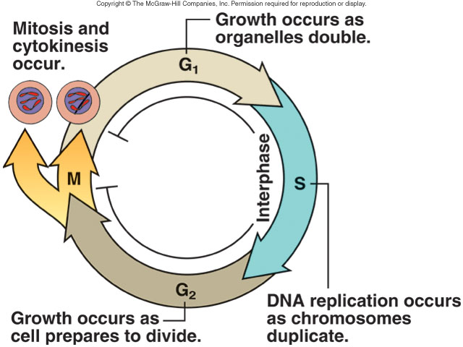
Interphase:
- Cell grows and develops, duplicates DNA, and prepares for division.
- nucleus and nucleolus, are easily seen
- DNA loosely packed
- 3 phases: G1, S, G2
G1 (Growth 1) | - Major growth period of cell  - Gap phase  - Cell synthesizes new molecules in preparation for next phase in cell cycle  - mRNA and proteins synthesized in preparation  - organelles duplicate
S (Synthesis) | - DNA Synthesis  - DNA exists in uncondensed fibres called chromatin  - Cells that complete this phase enter G2  - DNA synthesis occurs, and DNA replication results in duplicated chromosomes
G2 (Growth 2) | - 2nd Gap/growth phase  - Prepares for division  - Cell grows more  - safety gap: check if DNA and other intracellular components properly duplicated.  - cell forms the materials that make up the spindle.  Late Interphase  - before the start of mitosis, duplicated chromatin is condenses into chromosomes,  - centrosomes have duplicated in preparation for mitosis.
Mitotic Phase (M stage - includes mitosis and cytokinesis).
Mitosis:
https://www.youtube.com/watch?v=C6hn3sA0ip0
http://www.sumanasinc.com/webcontent/animations/content/mitosis.html
- Process of nuclear division that produces two daughter nuclei, each with the same number and kinds of chromosomes as the parent nucleus.
Mitosis has four phases: prophase, metaphase, anaphase, and telophase.
Interphase prophase pro-metaphase
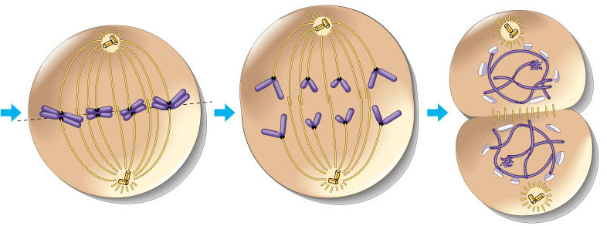
Metaphase anaphase telophase
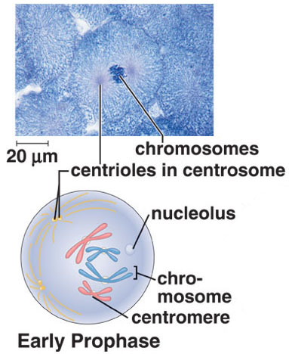
PROPHASE:
- chromatin condense into visible chromosomes
- Each DNA contains 2 copies –sister chromatids (because of replication in interphase) held together at a centromere.
- Nuclear membrane breaks down
- Nucleolus disappears
- Spindle fibres form between centrosomes as they move to opposite sides of cell.
Protein fibers cross cell to form mitotic spindle

How do Chromosomes Move?
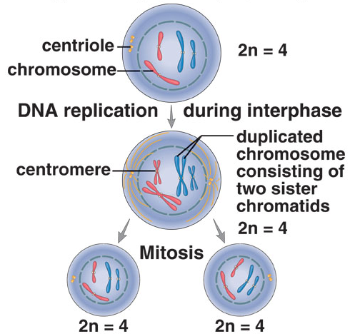
- Each centrosome contains a pair of barrel-shaped organelles called centrioles and an aster, which is an array of short microtubules that radiate from the centrosome.
- Centrosomes divide during interphase, and organize the spindle.
- The spindle contains fibers made of microtubules
- The spindle distributes the chromosomes to each daughter cell
- Plant cells lack centrioles; thus centrioles are not required for spindle formation.
    - coordinates movement of chromosomes
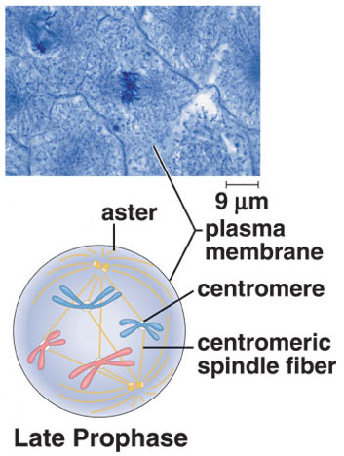
LATE PROPHASE:
- Chromosomes become attached to the spindle fibres.
- Centromeres attach to centromeric (or kinteochore) fibers.
- chromosomes have no particular orientation as yet.
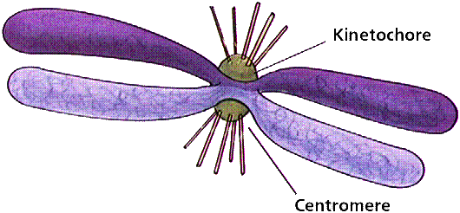
chromosomes begin moving

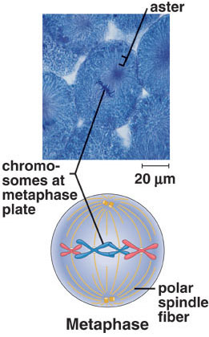
METAPHASE:
- fully formed spindle consists of poles, asters, and fibers.
- metaphase plate is a plane perpendicular to the axis of the spindle and equidistant from the poles
- Spindle fibres reach opposite sides of cell, attach to centromere of each chromosome
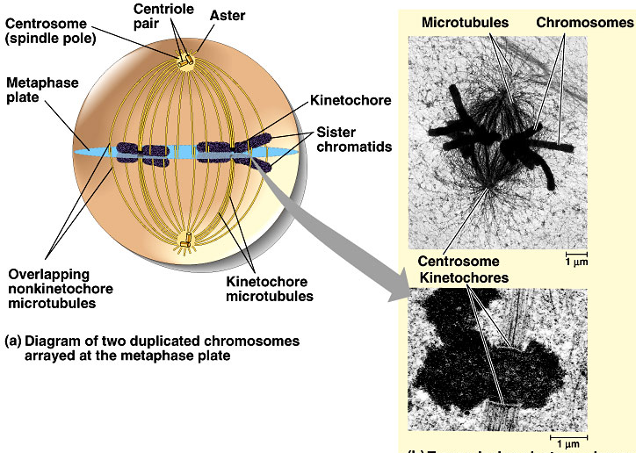
- chromosomes attached to the centromeric spindle fibers line up at the metaphase plate (meta = middle)

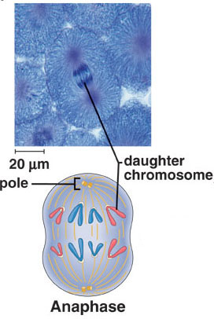
ANAPHASE:
- Centromere splits apart
- Spindle fibres shorten, pull sister chromatids to opposite sides
  - pulled by motor proteins “walking”along microtubules
- Separated sister chromatids now chromosomes
- daughter chromosomes have a centromere and a single chromatid.
- microtubule shortens by dismantling at kinetochore (chromosome) end

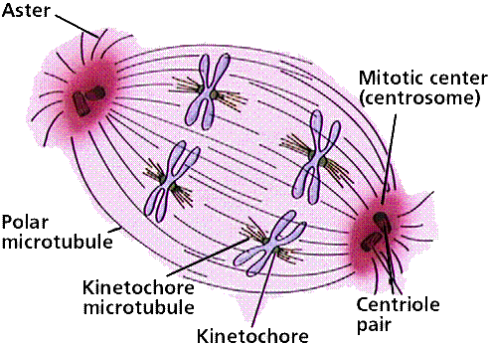
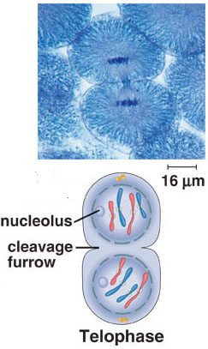
TELOPHASE:
- Chromosomes have reached opposite poles of cell
- Chromosomes start to unwind into less visible chromatin
- Spindle fibres break down
- Nuclear membrane forms around new set of chromosomes
- Nucleolus reforms within each nucleus.
- Spindle fibers disperse
- Cytokinesis: Begins near end of mitosis, involves division of cell cytoplasm + creation of new cell.
- Cycle checkpoints monitor growth
  - Ensure that cycle continues when it should
  - If something interferes with signals = uncontrolled growth
  - Eg: Cancer = uncontrolled , cancerous cells keep dividing = mass cells = tumour
Cytokinesis:
- Division of cytoplasm or cytoplasmic cleavage
- Indentation forms in cell membrane along equator of cell.
  - Deepens until cell pinched in 2
  - Cytoplasm divides equally
  - Ends with separation of 2 genetically identical daughter cells
  - Daughter cells are now in G1 of interphase
  - Cleavage of the cytoplasm begins in anaphase, but is not completed until just before the next interphase.
What can halt cell cycle?
The cell cycle is controlled at three checkpoints:
- During G1 prior to the S stage
- During G2 prior to the M stage
- During the M stage prior to the end of mitosis

  - At the G1 checkpoint, DNA is checked for damage before getting replicated. apoptosis can occur if DNA is damaged. In mammalian cells, the p53 protein stops the cycle at the G1 checkpoint when DNA is damaged. It attempts repair, but will initiate apoptosis when repair is not possible. Many kinds of tumors lack an active p53 gene.
- Signaling protein, cyclin, increases and decreases as the cell cycle continues.
- Cyclin must be present for cell to proceed from from the G1 S stage and from G2 M stage
Cyclins, cyclin dependent kinase
P53 – stops cell in the cycle to give ethe cell time to fix DNA or diee by apapotosis if eerrors cant’ be fixed.
  - At the G2/M checkpoint, checks for replication erros and cell size
mitosis will not occur if DNA is damaged or not replicated.
  - At the M checkpoint, mitosis stops if chromosomes are not properly aligned.
- Apoptosis is programmed cell death.
- Apoptosis occurs because of two sets of enzymes called capsases.
- The first set, the “initiators” receive a signal to activate the second set, the “executioners”.
- The second set of capsases activate enzymes that tear apart the cell and its DNA.
    - http://www.nobelprize.org/educational/medicine/2001/cellcycle.html

