Cell Cycle Regulation: Checkpoints and Regulators
Cells move forward through the cell cycle due to:
- external cues (like molecular signals) and
- internal cues (like DNA damage).
- Cdks, cyclins, and the APC/C are direct regulators of cell cycle transitions,
- respond to cues from inside and outside the cell.
- Positive cues, like growth factors, typically increase activity of Cdks and cyclins, negative cues, like DNA damage, typically decrease or block activity.
  - Example, DNA damage halts the cell cycle in G1:
  - Cells deal with this damage by either fixing it or preventing cell division.

Core cell cycle regulators:
- proteins called cyclins,
- enzymes called Cdks (cyclin dependent kinases),
- enzyme complex called the APC/C (anaphase promoting complex).

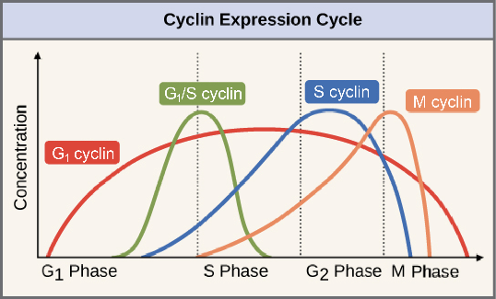
Cyclins
- Cyclins are among the most important core cell cycle regulators.
- activate or inactivate target proteins inside cell.
- bind to and activate Cdks forming a cyclin-Cdk complex signals cell to pass to the next phase,
- cyclin degrades, deactivating the Cdksignals cell to exit a particular phase.
- each cyclin is associated with a particular phase,
  - eg. M cyclin promotes the events of M phase, such as nuclear envelope breakdown and chromosome condensation

Cyclin-dependent kinases (Cdk)
- Cdks are kinases - enzymes that phosphorylate (attach phosphate groups to) specific target proteins
- attached phosphate group acts like a switch, activating/deactivating target protein
- Cdk on its own is inactive, but is activated when cyclin binds to it.
- When a cyclin attaches to a Cdk
  - it activates the Cdk,
  - and directs the Cdk to a specific set of target proteins, ones appropriate to the cell cycle period controlled by the cyclin.
Example:
- G1/S cyclins send Cdks to S phase targets (e.g., promoting DNA replication),
- M cyclins send Cdks to M phase targets (e.g., making the nuclear membrane break down).

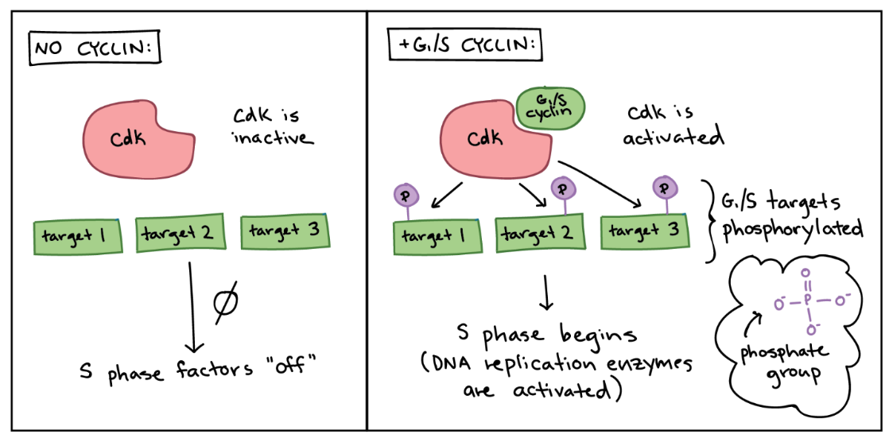

Left panel (no cyclin): no cyclin is present, Cdk is in active, and targets specific to the G1/S transition are not phosphorylated. Nothing happens, and S phase factors remain "off."
Right panel (+G1/S cyclin): the G1/S cyclin is present and binds to the Cdk. The Cdk is now active and phosphorylates various targets specific to the G1/S transition. The phosphorylated targets cause the activation of DNA replication enzymes, and S phase begins.

Maturation-promoting factor (MPF)
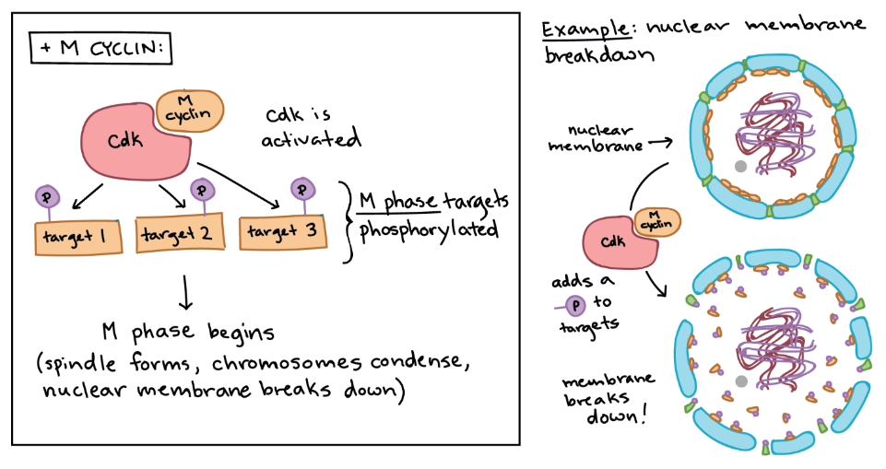
- drives events of M phase
How Cdk and M cyclin combine to form MPF:
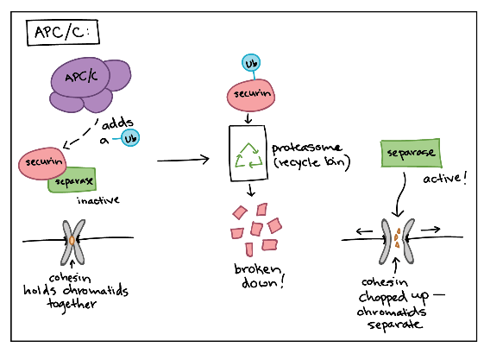
Left panel: The MPF complex phosphorylates various targets specific to M phase, and the phosphorylated targets cause spindle formation, chromosome condensation, nuclear membrane breakdown, and other events of early M phase.
Right panel: Specific example of MPF triggering nuclear envelope breakdown. The MPF complex phosphorylates proteins in the nuclear envelope, resulting in the fragmentation of the nuclear membrane into vesicles (and release of some of the proteins from the membrane).

p53
- TP53 or tumor protein
- tumor suppressor
- the guardian of the genome
- p53 ensures that cells do not pass on their damaged DNA through cell division:
  - stops the cell cycle at G1 checkpoint by triggering production of Cdk inhibitor (CKI) proteins. The CKI proteins bind to Cdk-cyclin complexes and block their activity, buying time for DNA repair.
  - activate DNA repair enzymes.
  - if DNA not fixabletriggers apoptosis (programmed cell death) so damaged DNA is not passed on.
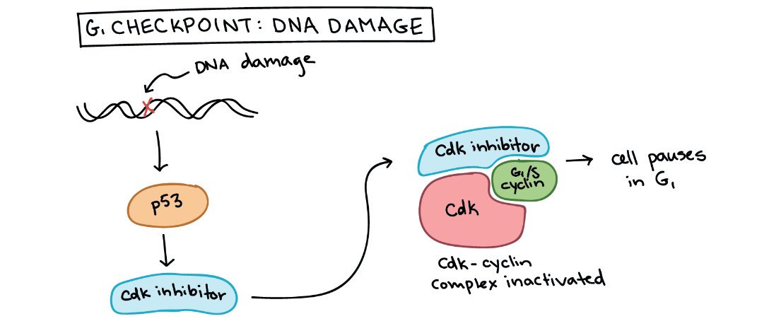
p53 halts the cell cycle at the G1/S checkpoint: p53 is activated by DNA damage and causes production of a Cdk inhibitor, which binds to the Cdk-G1/S cyclin complex and inactivates it. This halts the cell in G1 and prevents it from entering S phase, allowing time for the DNA damage to be fixed.

- p53 prevents mutations (changes in DNA) from being passed on by halting cycle. When p53 is defective or missing, mutations can accumulate quickly, potentially leading to cancer. Indeed, out of all the entire human genome, p53 is the single gene most often mutated in cancers.
What class of molecules are responsible for regulating the cell cycle?
What are the two classes of regulatory proteins discussed in this section?
Why do cyclins have their name?
Fill in the blanks: _________ binds to cyclin-dependent protein kinases (Cdks) to activate them. Once activated, Cdks signal progression through the cell cycle through _________, a process in which phosphate groups are added to other molecules.
What is the name of the complex formed when mitotic cyclins bind to Cdks and what is the role of this complex?

Interactive:
http://www.nobelprize.org/educational/medicine/2001/cellcycle.html

