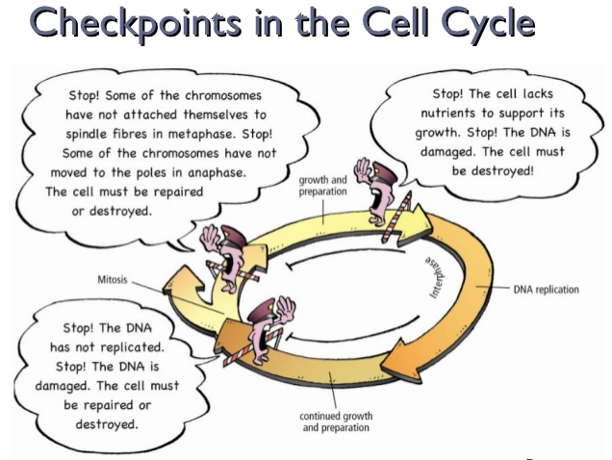
What can halt cell cycle?
The cell cycle is controlled at three checkpoints:
- During G1 prior to the S stage
- During G2 prior to the M stage
- During the M stage prior to the end of mitosis

At the G1 checkpoint:
  - DNA is checked for damage before getting replicated.
  - p53 protein stops the cycle at the G1 checkpoint when DNA is damaged.
  - It attempts repair, but will initiate apoptosis when repair is not possible. Many kinds of tumors lack an active p53 gene.
  - Signaling protein, cyclin, increases and decreases as the cell cycle continues.
  - Cyclin must be present for cell to proceed from the G1 S stage and from G2 M stage
At the G2/M checkpoint:
- checks for replication errors and cell size
- mitosis will not occur if DNA is damaged or not replicated.
At the M checkpoint:
- mitosis stops if chromosomes are not properly aligned.
- Apoptosis is programmed cell death.
- Apoptosis occurs because of two sets of enzymes called capsases.
- The first set, the “initiators” receive a signal to activate the second set, the “executioners”.
- The second set of capsases activate enzymes that tear apart the cell and its DNA.
Cdk (cyclin dependent kinase, adds phosphate to a protein), along with cyclins, are major control switches for the cell cycle, causing the cell to move from G1 to S or G2 to M.
MPF (Maturation Promoting Factor) includes the CdK and cyclins that triggers progression through the cell cycle.
p53 is a protein that functions to block the cell cycle if the DNA is damaged. If the damage is severe this protein can cause apoptosis (cell death).
- p53 levels are increased in damaged cells. This allows time to repair DNA by blocking the cell cycle.
- A p53 mutation is the most frequent mutation leading to cancer. An extreme case of this is Li Fraumeni syndrome, where a genetic a defect in p53 leads to a high frequency of cancer in affected individuals.
p27 is a protein that binds to cyclin and cdk blocking entry into S phase. Recent research suggests that breast cancer prognosis is determined by p27 levels. Reduced levels of p27 predict a poor outcome for breast cancer patients

