CYU p 223

5. When an atom forms an ion, its outer shell becomes full by either losing or gaining an electron.
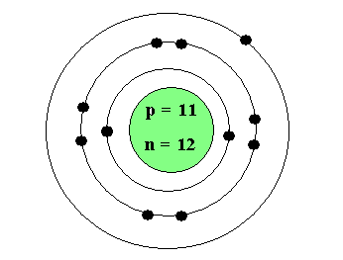
8. Noble gases do NOT normally form ions because their valence shells are already full, making them stable. They do not need to gain or lose electrons.
10. Bohr Diagram of sodium

11. a) number of protons in Be is 4, N 3- has 7 protons
b) Be has 4 electrons, N3- has 10 electrons
c) Fig 11 represents Be , Fig 12 represents Nitrogen .
d) Fig 11 represents Be ATOM, Fig 12 represents Nitrogen ION .

14. Aluminum sulfide is formed from atoms of aluminum and sulfur:
Al3+ S-2
Need two atoms Aluminum and 3 atoms of Sulfur.
Total of 6 electrons are transferred.
Aluminum gives up to Sulfur
15. sodium is more reactive than magnesium because sodium only has one valence electron which is easier to give away than magnesium’s two. The lower the electronegativity, the higher the reactivity.

