Unit H Review #1 KEY

H-1
- Metabolism is the amount of energy consumed by the total of all the anabolic (endergonic) and catabolic (exergonic) reactions that take place in your cells.

- An enzyme speeds up a chemical reaction by lowering how much "activation energy" is required for that given reaction.
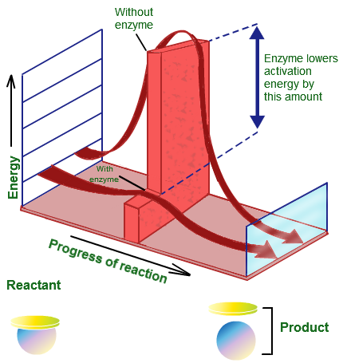
- An enzyme (holoenzyme) consists of a Protein portion (apoenzyme) and a non-protein portion (coenzyme/cofactor).
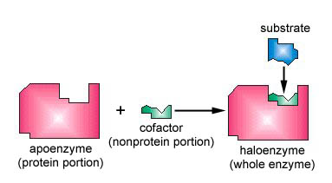
- The Protein portion bears the ACTIVE SITE.
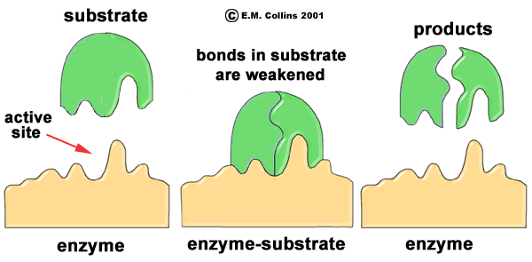
- The non-protein portion can be an inorganic element (mineral) then it is called a cofactor. If the non-protein portion is organic then it is called the co-enzyme (usually a vitamin).

- Activation energy is the specific amount of kinetic energy that must be put into the reactant molecules to allow them to collide and react.
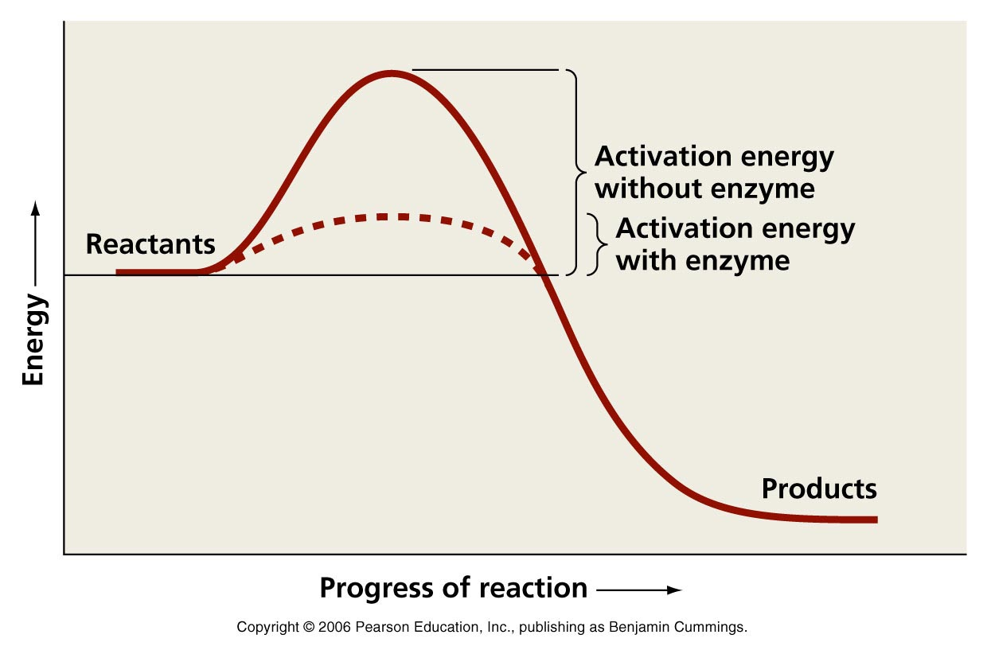
- Cellular respiration is Exothermic/Exergonic (energy release) and Catabolic (breaking down to release energy) - B
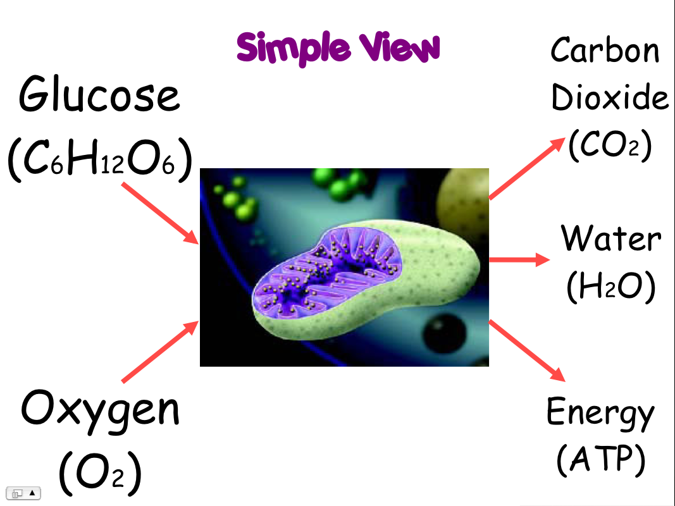

- ENDERGONIC/ENDOTHERMIC

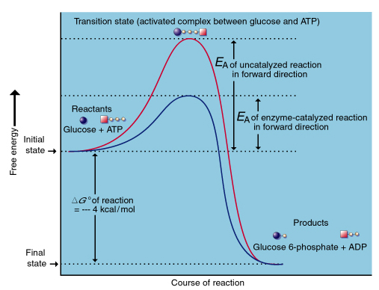
H-3
- The substrates must collide with one another with enough kinetic energy to force them to react.

- According to the "Lock and Key" theory. An enzyme's active site has the perfect complimentary shape for the specific substrate.
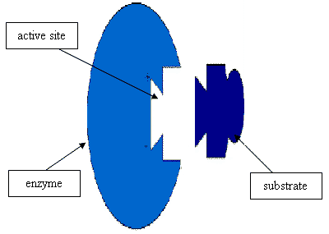
- The more current "Induced Fit" theory suggests that the active site will slightly transform its shape to grab the given substrate and run the rxn.
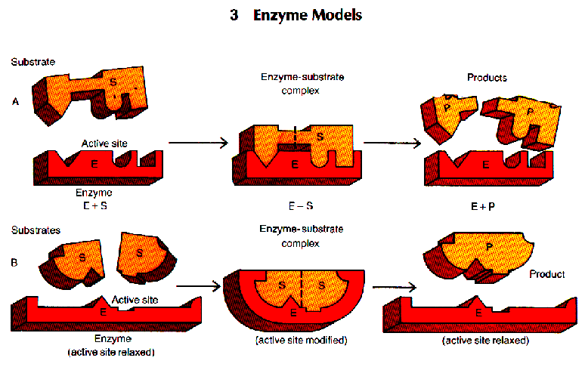
- Enzyme Substrate Complex is the temporary structure that forms when the substrate is bound into the enzymes active site.
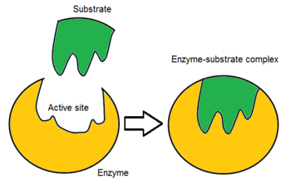
- The enzyme is unchanged after a reaction and it is able to take on more substrate.
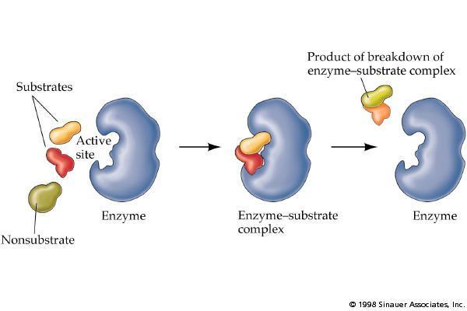
____9. On the diagram below label the following terms

1. SUBSTRATE A
3.PRODUCT A

2. SUBSTRATE B

5. PRODUCT B
4. ACTIVE SITE
COFACTOR (mineral) or COENZYME (Vitamin)
6.
_______________
7.APOENZYME

8.HOLOENZYME

PRACTICE QUIZ:
- B

- D

- B

- B

- B

- D

- A

- B

- C

- B

- B

- C

