Biology 12 Homework Booklet - Circulation Name: ___________

Heart Structure
Use your textbook to help you label the following diagram of the heart. (Box of terms to use is on the backside)

Colour the superior vena cave, the right atrium, the right ventricle, the inferior vena cava and the pulmonary artery BLUE to represent DEOXYGENATED blood that is being transported.

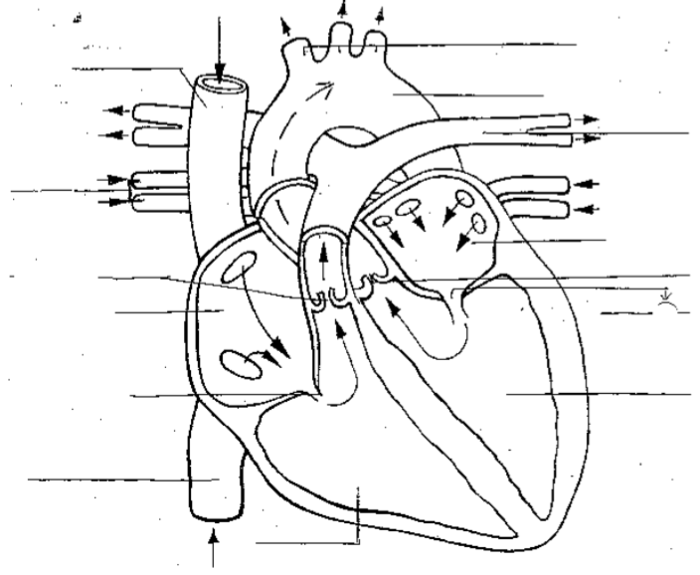
Colour the arteries, the aorta, the veins from the lungs, the left atrium, and the left ventricle RED to represent OXYGENATED blood that is being transported.
atria | coronary arteries | pericardial sac | tricuspid valves
atrioventricular  valves | coronary veins | pericardium | valves
bicuspid valve | endocardium | semilunar valves | ventricles
chordae tendinae | myocardium | septum

Match the parts of the heart with the description.

- _____________________ cardiac muscle.
- _____________________ lining of the inner surface of the heart
- _____________________ covers the outside of the heart
- _____________________ sac surrounding the heart that contains a fluid to lubricate the heart
- _____________________ blood vessels embedded in the heart muscle that deliver oxygen and nutrients to the heart muscle cells
- _____________________ blood vessels embedded in the heart muscle that return blood carrying carbon dioxide and wastes to the right side of the heart
- _____________________ divides the left and right sides of the heart
- _____________________ two upper thin-walled chambers, which receive blood
- _____________________ two lower thick-walled, more muscular chambers which propel blood out of the heart
- _____________________ prevent back flow of blood
- _____________________ valves that lie between the atria and ventricles
- _____________________ strong fibrous strings that support the A.V. valves
- _____________________ the A.V. valve with three flaps that lies between the right atrium and ventricle
- _____________________ the A.V. valve with two flaps that lies between the left atrium and ventricle
- _____________________ located between the ventricles and their attached vessels. They each have two flaps

Why is the left side of the heart more muscular than the right?

Why are valves important to separate the heart chambers? Name the valves and their location within the heart on the table below.

Valve | # flaps | Location in the heart (connects which two parts)

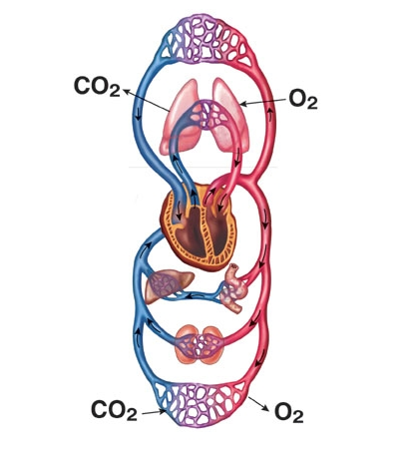
The Cardiac Cycle

Label and explain the diagram to the right.
Think: the flow of blood through the body, O2 vs CO2 in the blood, notice the arrows and the organ systems, notice the “webs” between larger vessels

Describe the path that blood moves through the circulatory system starting from the right atrium, through the heart, lungs, heart, body and back to the right atrium. Note when the blood is oxygenated or deoxygenated.

What is unique about the pulmonary arteries and pulmonary veins when comparing them to other blood vessels?

Explain what would happen if the coronary arteries became clogged. Is there a procedure that could help out in this situation?

Your friend wonders how taking someone’s pulse is directly related to one’s heartbeat. Explain the process to them.

Why is the SA node also known as the pacemaker? What happens if the SA node is not functioning properly?

Compare and contrast intrinsic and extrinsic control of the heartbeat using a Venn diagram.

________________________ _________________________

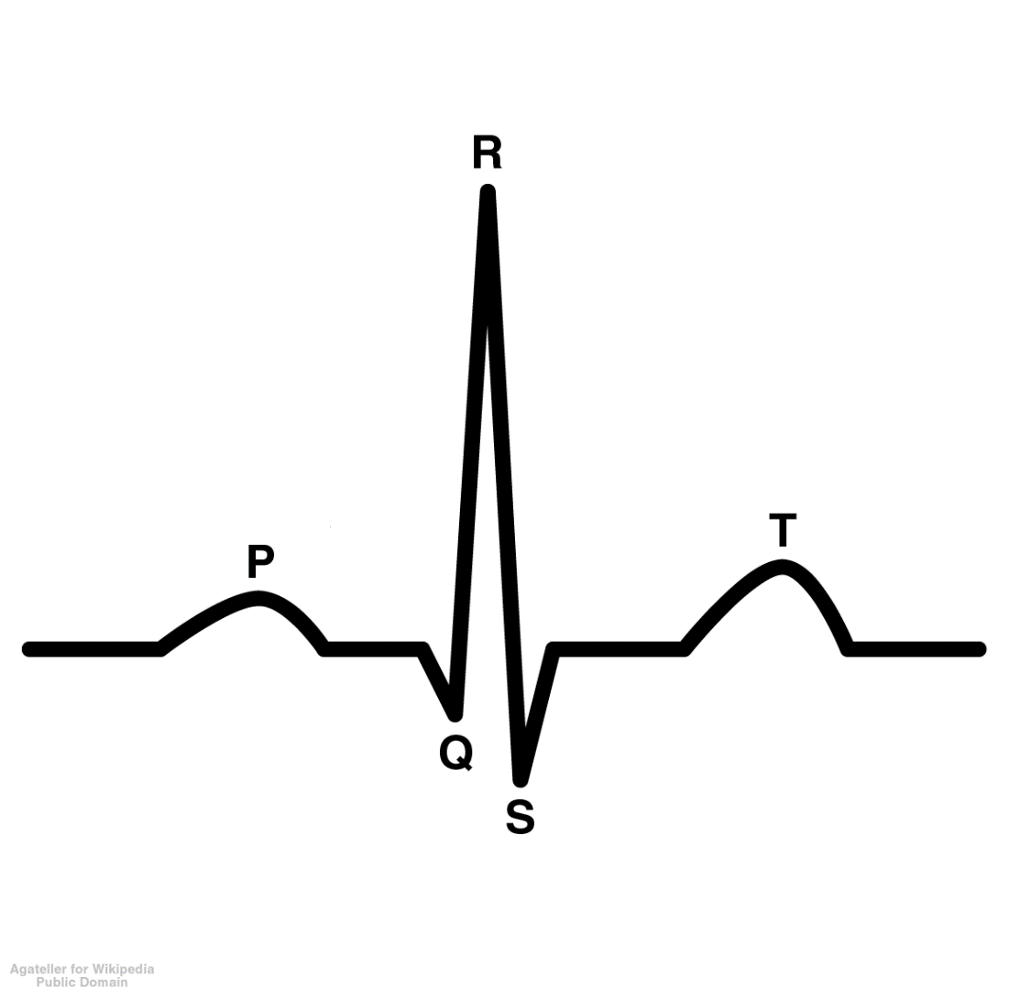
Explain the diagram of an ECG to the right. What events happen during each of the waves?

If a person had high blood pressure, how would you expect their ECG reading to look? Why?

What choices can you make now to minimize your risk of having a heart attack?

Blood Vessels & Blood Pressure
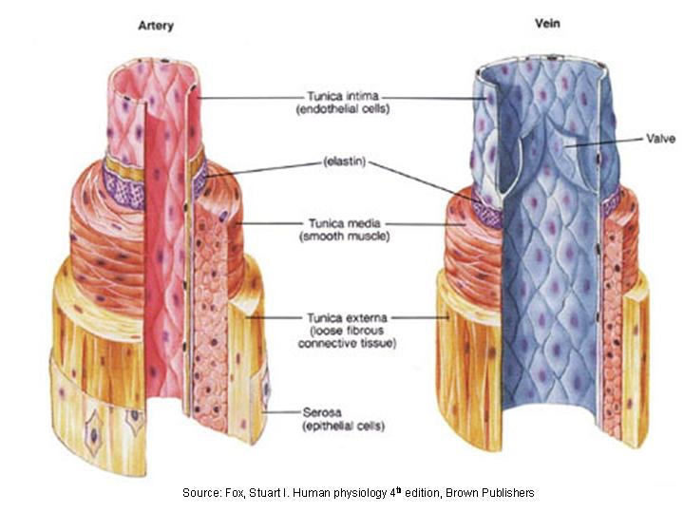
Colour the layers of the artery and the vein. Please colour the epithelial cells, loose fibrous connective tissue, smooth muscle, elastin, and endothelial cells the same colour in the different pictures. This will allow you to compare the different sizes more clearly.

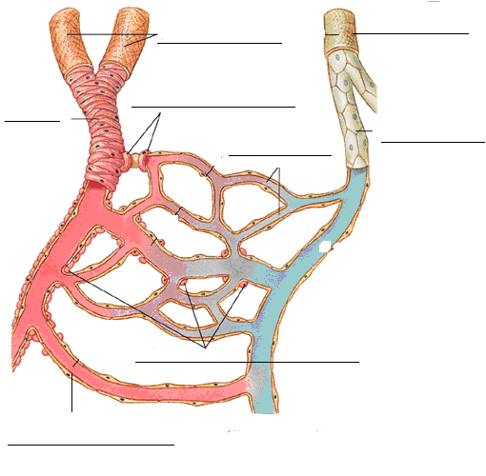
Colour and label the following diagram of the capillary bed: arteries, veins, arteriole, venule, capillaries, precapillary sphincter (twice) and the arteriovenous shunt.
Complete the table based on blood vessels: Use a red pen, blue pen, and pencil to indicate which blood vessels contain oxygen, carbon dioxide, and site of both.
Blood vessel | Thickness (diameter) | Direction of blood flow | Unique features / characteristics

We know that capillaries are only one cell thick. Why would thicker capillaries be a problem?

What is the difference between systolic pressure and diastolic pressure?

Why is blood pressure minimal in venules and veins?

Explain why fainting occurs.

Compare and contrast blood velocity among arteries, capillaries, and veins.

Why is it crucial that blood flows slowly in capillaries?

Blood Components
Fill out the following table about the four components of blood.
Blood component | Proportion in a 100g sample of blood | Function

White blood cells are categorized based on different structures. What are the two structures? Describe each one and provide examples.

Describe the structure of hemoglobin.

A young girl is experiencing fatigue and her doctor suggests she may have anemia. Explain what is happening.

Why is living with hemophilia a reason for someone to be continuously carful?

Explain why a person with type A+ blood would not be able to receive blood from a type B+ donor.

Which blood type would you like to be? Why?

Why is it potentially dangerous for a pregnant mother of Rh- red blood cells to carry a baby with Rh+ red blood cells? Is this more dangerous for the mother or the child? What preventative and/or reactive measures are there?

What are the major differences between the heart of a fetus (in the womb) vs. the heart of an adult?

