Biology 12 Homework Booklet - Reproductive System Name: _____________

- Label and briefly describe the function of the male reproductive structures on the diagram provided.

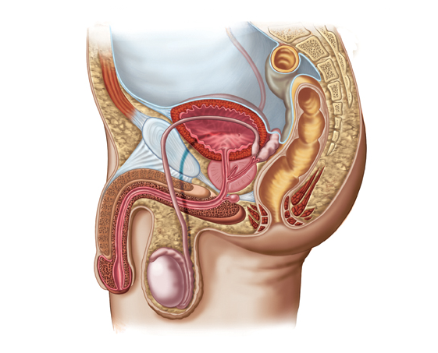

- Describe the pathway of sperm from the seminiferous tubules to the urethral opening. Trace this pathway on the diagram.

- What are the three reproductive accessory glands. Provide a brief explanation of each structure.

- What are the three functions of seminal fluid?

- Sperm is produced in the testes. Where do the sperm mature?

- Can a male release urine and semen simultaneously? Explain.

- Create an engaging PG13 summary story “Stewart the Sperm” and explain the maturation process, and the pathway Stewie must travel. Include the “friends” he meets along the way who accompany him during his journey.

- Label and briefly describe the function of the female reproductive structures on the diagram provided.

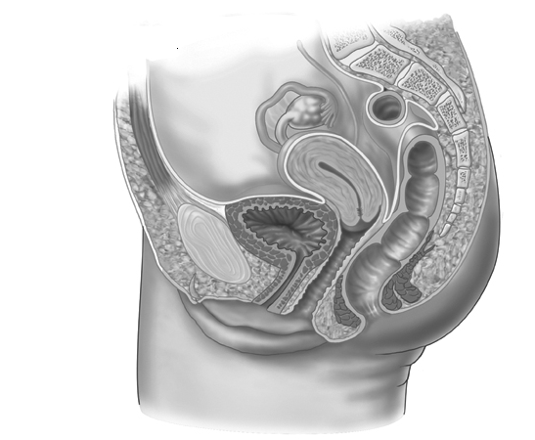

- Explain the pathway of an egg and a sperm before fertilization takes place. Mark an “X” at the location where the sperm meets the egg.

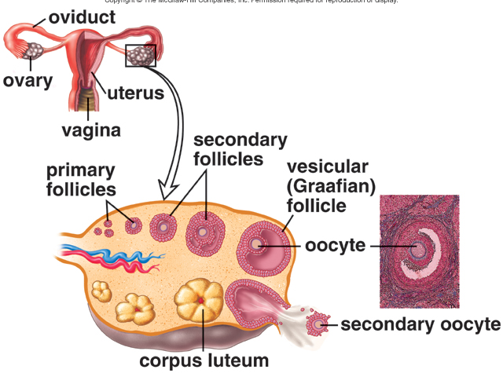

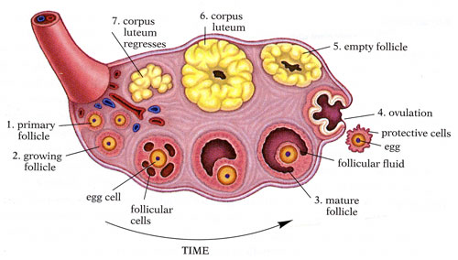

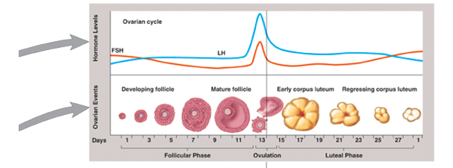

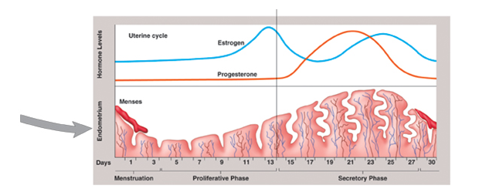

- Why does a woman know that she is not pregnant when she has a menstrual cycle?

- What is PMS and how can you help to ease symptoms?

- What are the two major phases of the uterine cycle? Briefly describe each phase.

- What is meant by feedback control with respect to the female hormone control? Explain.

- Explain what is happening with the increase/decrease of FSH and LH during follicular development (see “ovarian cycle” diagram on previous page).

- Explain what is happening with the increase/decrease of FSH and LH during the development of the endometrium lining (see “uterine cycle” diagram on previous page).

- What are the phases involved in the ovarian/uterine cycle? Briefly explain what happens in each phase.

- Complete the two tables that highlight the role of hormones in the male and female reproductive system.

Male Reproductive Hormones
Hormone Name(s) | Where, when/why and how is it produced | Function
GnRH
FSH
LH
Testosterone

Female Reproductive Hormones
Hormone Name(s) | Where, when/why and how is it produced | Function
GnRH
FSH
LH
Estrogen
Progesterone
Prolactin

