Immune System Concept Map Assignment Name: __________

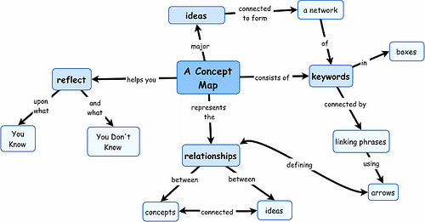
Demonstrate your understanding of the Immune System by creating a Concept Map
What to do:
- Write IMMUNE SYSTEM” in the middle of the page
- Draw arrows to related topics or descriptions
- Use LINKING words like “consists of” or “is characterized by” along the arrows.
- Using ALL the words in the word bank.
- You may use colour and shape to show relationships.
Remember:
A. A concept map is not linear; it should have interconnections.
B. Place each of the key terms below in its own separate “bubble.”
C. Each line of Defense should have a different "Bubble" shape
Assessment: You will be graded on:
Content:
- all words/concepts from word bank are used
Knowledge:
- Connections are correctly described
- Linking words used and demonstrate understanding
Organization:
- Words are neat and easy to read
- Concepts are clear and easy to follow

WORD BANK:

- IMMUNE SYSTEM
- Skin
- Stomach Acid
- Sweat
- Oils
- Cilia
- Ear wax
- B Cells
- Mucus
- Eyes
- Mouth
- Break in skin
- Pain
- Redness
- Swelling
- Heat
- Fever
- Tears
- physical barrier
- protects the body
- Phagocytes
- Helper T-cells
- White Blood Cells (Lymphocytes)
- B Cells
- Memory Cells
- Plasma Cells
- Antigen
- Pathogen
- Activates
- Inflammation
- Is characterized by
- Antibodies
- Innate
- Acquired
- General
- Specific
- Fast
- Slow
- Immunity
- Recognizes
- Activates
- Presents
- Engulfs
- Is a type of
- Examples include
- Can enter body through
- 1st Line of Defense- Barriers That Keep
- 2nd Line of Defense- The Inflammatory Response
- 3rd Line of Defense- The Immune Response

- Bacteria (eg. )
- Virus (eg. )
- Parasite (eg. )
- Direct Contact (eg. )
- Indirect contact (eg. )
- Ingestion (eating/drinking contaminated food/liquid) (eg. )
- Vectors (eg. )

