**Name: ______________**

**Partner: ______________**

**Determining the pH of Various Household Substances**

**Background Reading: What are acids and bases?** Many common pure substances can be classified according to whether they are acids or bases. Acids produce **hydrogen ions** (H+) and bases produce **hydroxide ions** (OH–) when dissolved in solution. The **concentration of hydrogen ions refers to the number of hydrogen ions in a specific volume of solution.** Solutions with a high concentration of hydrogen ions are highly acidic. Similarly, solutions with a high concentration of hydroxide ions are highly basic. When an acidic solution is mixed with a basic solution, the solutions can **neutralize** each other, which means that the acidic and basic properties are in balance.

**What is pH?** Testing the pH of a solution is a way of measuring its concentration of hydrogen ions, H+(aq). The **pH scale** is a number scale that indicates how acidic or basic a solution is. **Acids** have a pH below 7 and **bases** have a pH above 7. Neutral solutions have a pH of 7. On the pH scale, one unit of change represents a **10-fold change** in the degree of acidity or basicity. For example, a two unit drop in pH is a 102 or 100 times increase in acidity.

**What are pH indicators? pH indicators** are chemicals that change colour depending on the pH of a solution.

**PreLab Questions**

1. Describe the difference between the chemical nature of an **acid** and a **base.**
2. Describe the pH scale and what it measures.
3. What is the pH of a ***neutral solution***? *Explain,* in terms of ion concentration.
4. The pH scale is a ***base 10 scale***. Explain what this means in terms of the degree of acidity or basicity as the values increase from 0 to 14 on the scale.
5. Consider a change in pH from pH=3 *(grapes)* to pH=5 *(banana)*. This means a banana is ________X more acidic than a grape.

**Practice**

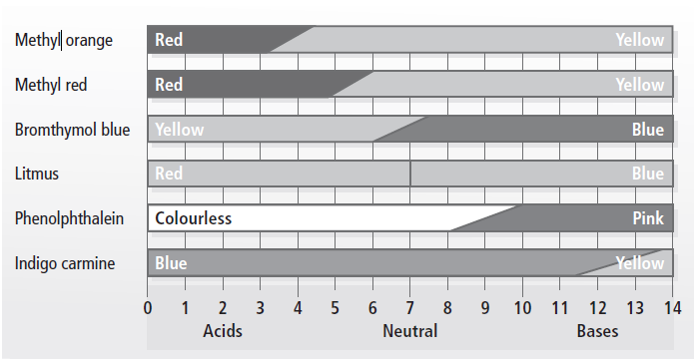



**Predictions:** Before starting the lab, predict if each solution will be acidic, basic or neutral.

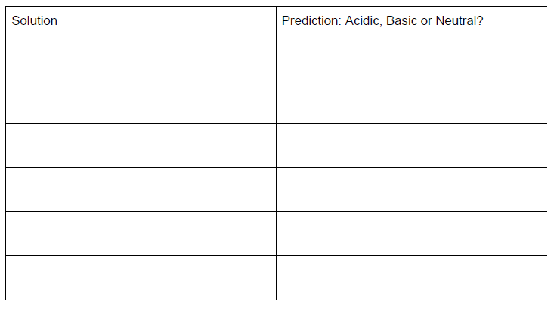

**Purpose:** In this lab, you will be testing a variety of household products with pH indicators to establish accurate pH ranges for each solution.

**Materials:** 6 small beakers with a small amount of each substance, dropper, 2 spot plates. Various pH indicators. 1 piece of blank paper.

**Procedure:**

1. Collect two spot plates. Rinse both thoroughly with tap water and dry thoroughly with paper towel
2. Place your spot plates on the piece of paper.
3. For EACH solution, do the following:
4. Using the dropper put 3 drops of one solution in each well of one horizontal row.
5. In your data table, record the appearance of the solution. Note the colour and if the solution is clear or cloudy.
6. Add 1-2 drops of pH indicator to the proper well.
7. For litmus paper, carefully place a small piece of litmus paper directly into the well.
8. Swirl the spot plate **gently** to mix. (If the contents of different wells mix, your data will be compromised and you will have to start again!)
9. Immediately record any colour changes in your data table.
10. Repeat the steps for each household solution. Take a picture for your records.
11. **Clean Up:** All solutions can go down the sink drain. **Litmus paper should be removed from the wells and placed in a garbage can using the tweezers provided.** Rinse the spot plate thoroughly with water and place in the dish rack to dry. Wash your hands.

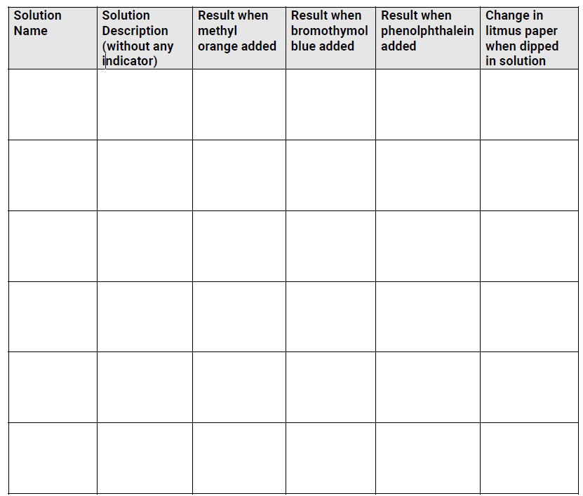

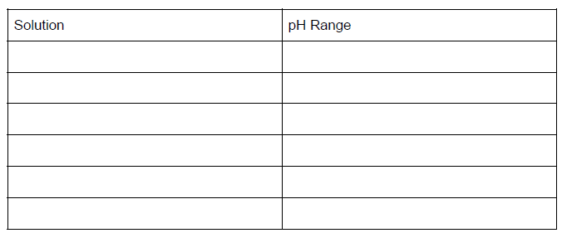Using the pH indicator table, determine the approximate pH range of each solution tested. Be as specific as you are able.

1. Draw a pH scale below and rank the six solutions from most acidic to most basic.
2. When water from a pond is tested by a chemistry class with phenolphthalein, it stays clear. When litmus paper is dipped in the solution, the paper turns blue. What is the approximate pH of the pond water?
3. An unknown solution, solution B, is tested with both bromothymol blue and methyl orange. Both tests give a yellow result. What is the approximate pH of the solution B?
4. Your friend tests a solution and tells you these results. When tested with phenolphthalein, it turned bright pink, and when tested with litmus paper, the paper turned red. What can you conclude from your friend’s results?

**Conclusion:**

1. Briefly summarize experimental results.
2. Discuss any sources of experimental error. What suggestions do you have that would improve this experiment?