**Plasma Membrane**

**Function**

* **physical barrier:**  Separates internal environment from external
* **permeability barrier**: Regulates movement of molecules in and out of cell🡪 maintains homeostasis
* allows **communication between cells** and its environment via membrane
* It **anchors cells** via specialized connections for tissue stability.

**Structure: Fluid-Mosaic Model**

* **fluid** consistency and a **mosaic** pattern of embedded proteins**:**
* **phospholipid bilayer** in which protein molecules are either partially or wholly embedded
* **Integral Proteins** embedded in bilayer
* **Peripheral Proteins** on the outside and inside
* **Cell Recognition Proteins** (Glycoproteins and glycolipids) –*carb chain attached*

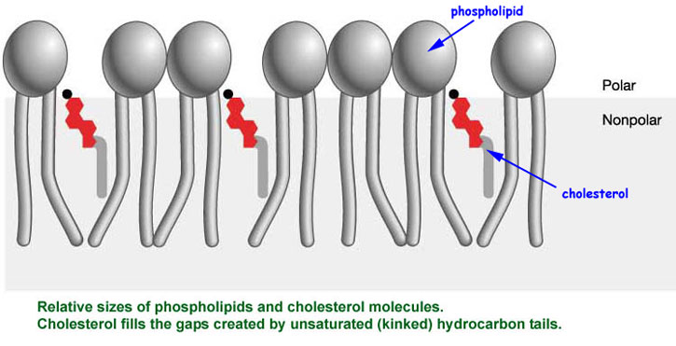**Cholesterol** *–another lipid aside from phospholipids -in animal plasma membranes. Plants have steroids*

* + Cholesterol strengthens the plasma membrane.
  + *reduces the permeability of PM to most biological molecules.*

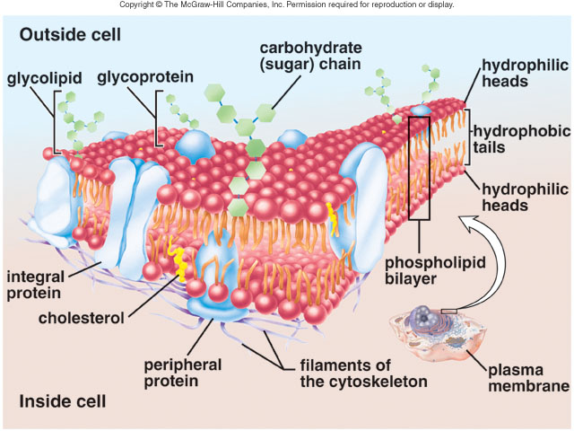

**Membrane Proteins**

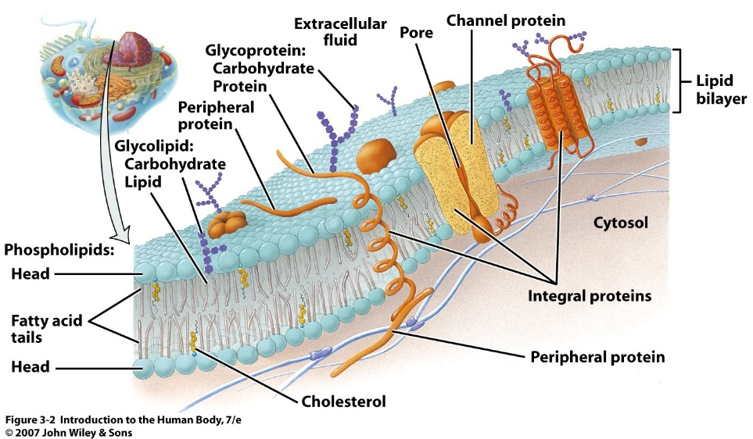

**Peripheral Proteins**

* bound to membrane **surface** (outside or inside).
* provide **structural support – shape and stabililty**

**Integral Transmembrane Proteins**

* **embedded** *in the membrane bilayer*
* determinescell’s **function:**

**Channel Proteins:**

* allow a **particular** substance to cross **freely**.

**Carrier Proteins**

* **selective**

**Cell Recognition Protein**

* + ***glycocalyx*** - carbohydrate chains on cell recognition proteins
    - functions in cell-to-cell recognition, adhesion between cells, and reception of signal molecules.
    - *cellular “fingerprint” due to diversity in carb chains*

**Receptor Protein**

* **specific shape** for **specific molecule**

**Enzymatic Protein**

* 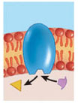catalyze a **metabolic reaction** within the cell. *.*

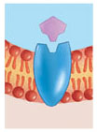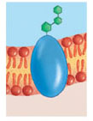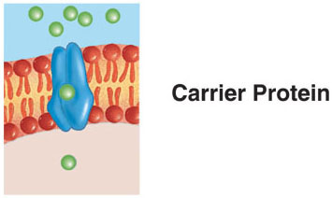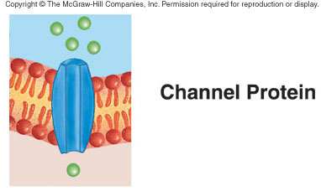

**Plasma Membrane Permeability**

**Plasma Membrane is *selectively* or *differentially* permeable**:

* + 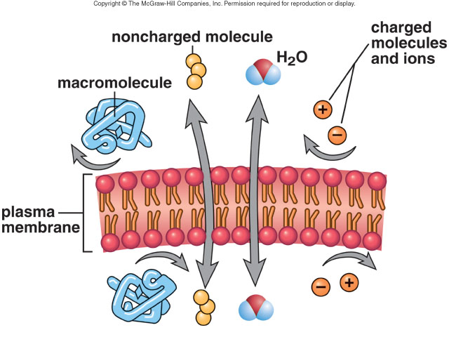**Small, uncharged** molecules **can** pass through the membrane, following their **concentration gradient.**
  + macromolecules cannot pass through because of **size**
  + tiny **charged**molecules **do not** pass through the **nonpolar** interior of the membrane. (lipid solublity)
  + **lipid soluble molecules** 🡒 O2, CO2, fatty acids, steroids, fat-soluble vitamins (A, D, E, K), nicotine via simple diffusion
  + small polar molecules like water can pass through membrane proteins

**Factors that affect Movement of Molecules Across a Membrane**

* **Size** of molecule
* **Charge**
* **Polarity**
* **Concentration** of molecules inside and outside the cell (gradient)
* **Temperature**
* **Available proteins**
* **Distance to travel**

**How Molecules Cross the Plasma Membrane**

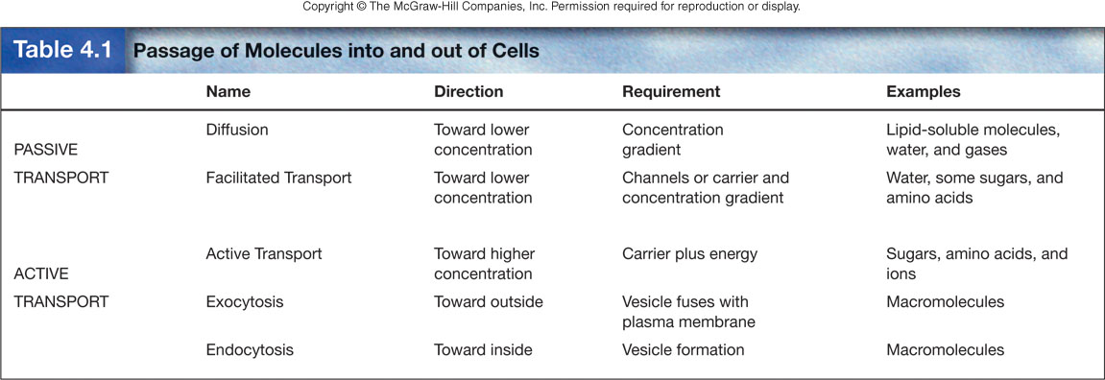Movement of materials across a membrane may be either **Passive** or **Active**

***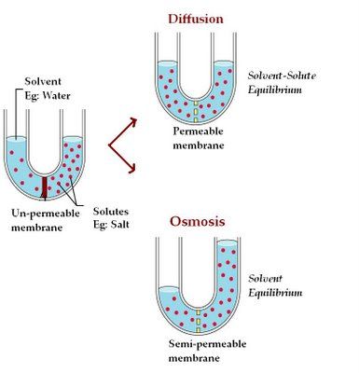*Diffusion**

* movement of molecules from an area of high to lower concentration until equilibrium is reached*.*
* Gases, water, lipid-soluble molecules
* 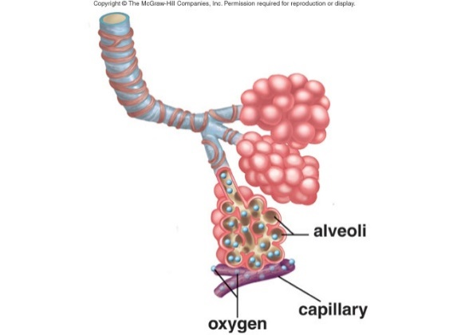eg. Gas Exchange by Lungs by Diffusion

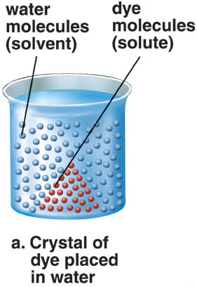

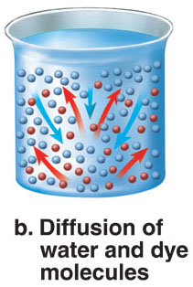

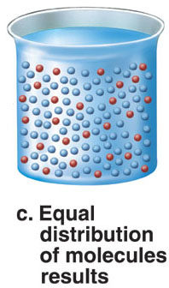

**Osmosis**

* **diffusion of water** across a **differentially permeable membrane** from an area of high concentration to an area of lower concentration
* **Osmosis continues until:**

**Osmotic Pressure = Hydrostatic Pressure**

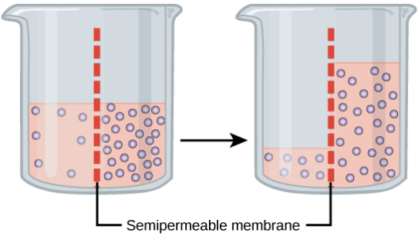

**Types of Solutions (Tonicity)**

* *A* ***solution*** *contains a* ***solute*** *(solid) and a* ***solvent*** *(liquid).*
* **tonocity** is the strength of solution
* refers to concentration as % of solution *Eg. 20% salt solution is 80% water*

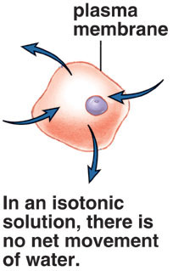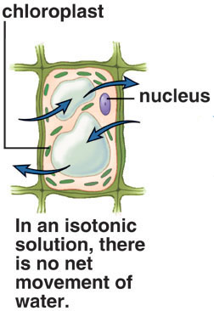**Isotonic Solution**

* “Iso” means the **same**
* the solution (extracellular fluid) has the **same osmolarity** as the cell 🡪no net movement of water into or out of the cell.
* Cells are normally **isotonic** to their surroundings (solute concentration is the same inside and outside of the cell).

**Hypotonic**

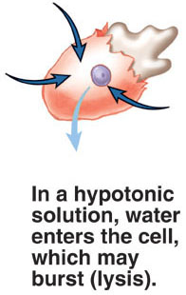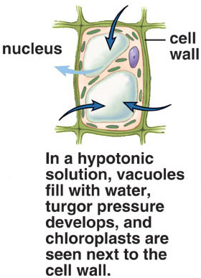

* solution with a **lower** solute concentration (osmolarity) than cell
* **causes cells to gain water**, swell and possibly burst.
* Animal cells undergo ***lysis*** (they burst)
* 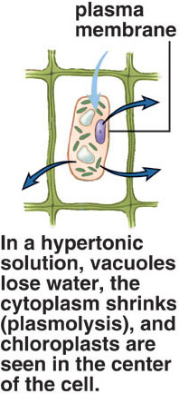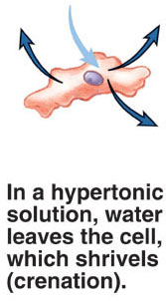Increased ***turgor pressure*** occurs in plant cells in hypotonic solutions.

**Hypertonic**

* extracellular fluid has a **higher** solute concentration  *(osmolarity)* than the cell’s cytoplasm
* Water moves **out** of the cell
* Animal cells shrivel -**crenation**.
* Plant cell vacuoles lose water, the cytoplasm shrinks and cell membrane pulls away from cell wall **(plasmolysis)**

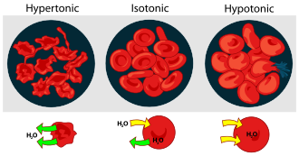

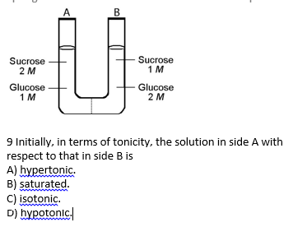

10% protein 5% glucose

20% glucose 95% H2O

70% H2O

Semi permeable membrane

Volume:

Glucose:

Protein:

Hydrostatic Pressure:

**More on Passive Diffusion: Plasma Membrane is Permeable to:**

* 1. lipid soluble molecules 🡒 O2, CO2, fatty acids, steroids, fat-soluble vitamins (A, D, E, K), nictoine
  2. small, polar molecules 🡒 water, urea pass through protein pores

**Other molecules** can’t use pores because: **Too large** or **Carry a charge**

**Transport by Carrier Proteins: Facilitated and Active Transport**

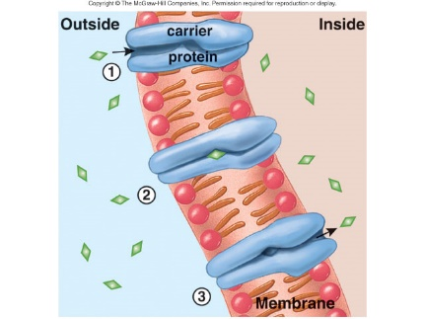**Facilitated Transport: (Passive Transport)**

* movement from **high 🡪 low conc**
* **eg. glucose** and **amino acids** are lipid insoluble
* require **carrier proteins**
* **does not require energy**
* carrier proteins are **specific**

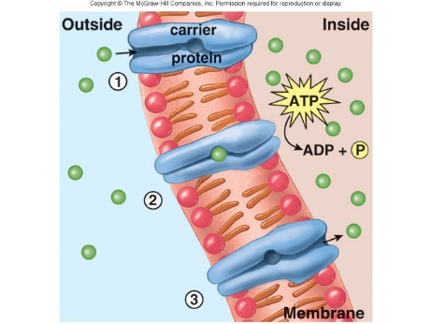**Acitve Transport**

* Moves molecules **against** concentration gradient
* **Requires carrier protein (pumps)**
* **Requires energy** (ATP)
* proteins, fats, starch and glycogen
  + Eg. Iodine collects in thyroid gland
  + Sugar completely absorbed by gut cells
  + Na+ pulled from urine by kidney cells
  + How amino acids absorbed after digestion of protein by cells lining digestive tract
* **sodium-potassium pump** (p75) moves ***sodium ions* out** the cell and *potassium ions* in.
* High concentration of sodium potassium pumps in nerve cells and muscle cells.

**Movement of Macromolecules Too large for Carrier Proteins:**

Eg. Polypeptides, polysaccharides, polynucleotides

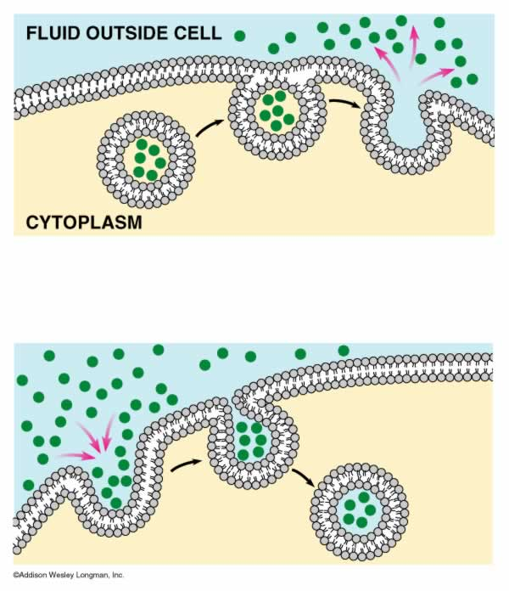**Exocytosis**

* movement of macromolecules **outside** a cell using vesicles *formed by the Golgi (too large for carrier proteins)*
* vesicles fuse with the plasma membrane for secretion
* vesicle formation requires energy
* Neurotransmitters, hormones, and digestive enzymes

**Endocytosis**

* 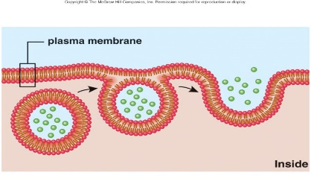take in substances by i**nvaginating** a portion of the plasma membrane, and forming a *vesicle* around the substance.
* **requires energy**
* 2 types: phagocytosis and pinocytosis

**Phagocytosis:**

* cell engulfs a particle and forms a vacuole- “cell eating”
* Large items such as **food particle** or **another cell**
* Ameobas, white blood cells engulf worn-out cellular debris

**Pinocytosis:**

* cell engulfs Liquid or small particles in tiny vesicles- “cell drinking”
* Blood cells, cells that line the kidney tubules or intestinal wall, plant root

**Receptor-mediated endocytosis**  (form of pinocytosis)

* 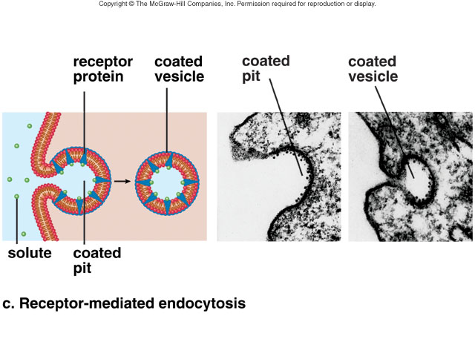substance binds with **specific receptor protein**, migrates to a coated pit
* The resulting vesicle contains the substance and the receptor.
* Eg. low-density lipoprotein (LDL) *when LDL receptors gather in a coated pit*
* Eg. familial hypercholesterolemia, the LDL receptor is unable to properly bind to the coated pit, and cells are unable to take up cholesterol. Cholesterol accumulates in the walls of arterial blood vessels, causing severe health problems.
  1. Explain how each would increase the diffusion rate:
* Increase the concentration gradient
* Increase temperature
* Decrease mass (smaller substances diffuse more quickly than larger ones)
* Increase surface area (alveoli of lungs)
* Decrease diffusion distance
  1. **List 3 things Membrane permeability** depends on.
  2. What type of molecules can cross the membrane easily? What type have difficulty?
  3. Why is selective permeability important?
     + IT REGULATES MOVEMENT ACROSS THE CELL MEMBRANE
     + Allows different concentrations of substances on either side of the membrane ==> SETS MEMBRANE GRADIENTS
     + Allows the localization of cellular processes within certain organelles (I.e. mitochondrial enzymes cannot cross the organelle membrane)