How do the instructions in DNA get delivered outside the cell?
- DNA is the master copy of instructions so it remains protected within the nucleus.
- Instructions on a portion of the DNA template are "read" in two steps: transcription and translation.
  - In transcription, a portion of the double-stranded DNA template gets transcribed by a single-stranded RNA molecule.
  - RNA takes the message out of the nucleus to the ribosomes where the message is translated into protein.

Transcription
- first step of gene expression

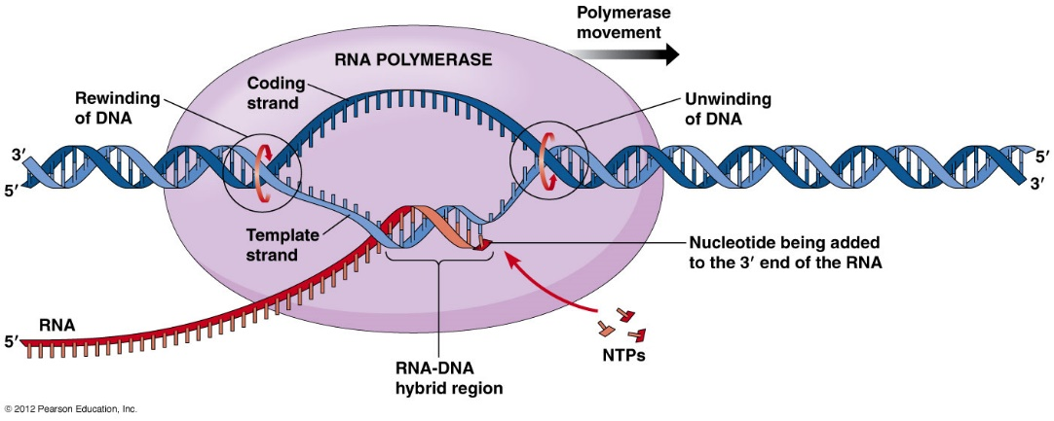
- Initiation: RNA polymerase binds to the DNA strand at a specific sequence of the gene called a promoter.
- Strand Elongation: DNA unwinds and two strands unlink
- Using one of the DNA strands as a guide or template, a strand of mRNA matches new nucleotides with their complements on the DNA strand (G with C, A with U
- The new RNA nucleotides bind together to form a complementary copy of the DNA.
- Termination: Transcript stops when it encounters a termination sequence of bases (stop codon).
  - mRNA strand moves from the nucleus and to ribosomes in the cytoplasm for processing. Where the sequence of bases will be translated into a sequence of amino acids.
How is the protein made?
Translation
genetic code sequence is broken into a series of three-nucleotide units known as codons
- Initiation: the ribosome docks onto the mRNA at a position near the start codon.
Transfer RNA bring amino acids to the ribosome
- Elongation: ribosome shifts to the next codon on the mRNA.
- Each successive tRNA leaves behind an amino acid that links in sequence. The resulting chain of amino acids emerges from the top of the ribosome.
- The polypeptide elongates as the process of tRNA docking and amino acid attachment is repeated.
- Termination
- ribosome comes to a stop codon, which signals the end of the genetic message.
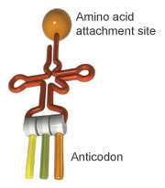
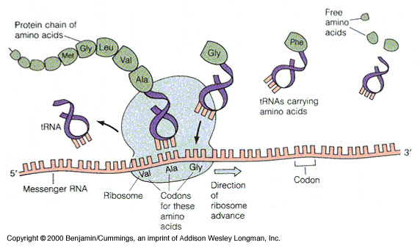
- ribosome detaches from the mRNA and releases the amino acid chain.

Most genes in humans are interrupted by segments of DNA that are not part of the gene.
Introns (intragene segments)
- noncoding sections of an RNA transcript, or the DNA encoding it, that are
- spliced out by enzyme ribozyme before the RNA molecule is translated into a protein.
- Not expressed

Exons - sections of DNA (or RNA) that code for proteins
- expressed

Three types of RNA:
mRNA (messenger RNA) that serve as temporary copies of the information found in DNA;
rRNA, (ribosomal RNA) that serve as structural components of protein-making structures known as ribosomes;
tRNA, (transfer RNA) that ferry amino acids to the ribosome to be assembled
  - single strand doubled back on itself to create regions where complementary baes bond to each other
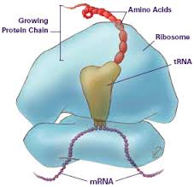
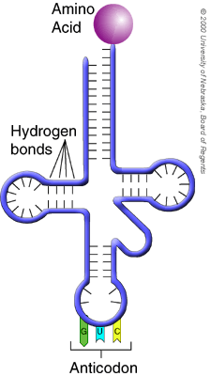
  - attachment requires ATP

DNA Questions

- A nucleotide is made up of:

- Distinguish between purines and pyrimidines.

- What are DNA’s three major functions?

- What is crossing over?

- What are the three steps of DNA replication?

- What are the three types of RNA? What do they do?

- What codons are involved in initiation of protein synthesis? In termination?

- What happens during elongation?

- Here is a segment of DNA: TGA CTT ACG TTT

What would the complementary mRNA strand look like?

What are the possible tRNA anitcodons?

What are the sequence of amino acids in the polypeptide (protein)?
