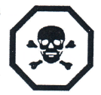
Lab Safety Assignment
You are about to use a household product that has the indicated symbol to the right on its label.

- What does this symbol mean? _____________________________________________________

- Describe the precautions that you should take when using this product.

______________________________________________________________________________
______________________________________________________________________________
______________________________________________________________________________

- A product’s life cycle includes all the steps in making, distributing, selling, using and disposing of the product. Hazardous materials may be used and eventually become waste. Briefly describe three things that consumers can do to help prevent hazardous waste from entering the environment.
______________________________________________________________________________
______________________________________________________________________________
______________________________________________________________________________

- Many homes have hazardous materials. Often people dispose of them by throwing them out in the regular garbage or down drains or toilets. What hazards are associated with these practices?
______________________________________________________________________________
______________________________________________________________________________

- For each WHMIS symbol below, describe what it means and then give on example of a substance that would have it on its label.
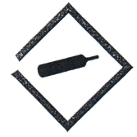
Symbol: __________________________

Example: _________________________

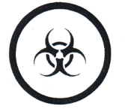
Symbol: __________________________

Example: _________________________

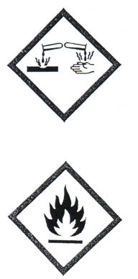

Symbol: __________________________

Example: _________________________

Symbol: __________________________

Example: _________________________

- Why is tying back long hair a safety procedure in the lab?
______________________________________________________________________________
______________________________________________________________________________

- When should a student wear safety glasses?
______________________________________________________________________________
______________________________________________________________________________

- On a separate piece of paper, make a sketch of your science room showing the location of the emergency exits, eyewash station, fire extinguishers and any other emergency equipment.

