•Sci 8 Conservation of Mass Name: Period:
These vividly colored maple leaves were all bright green during the summer. Every fall, leaves of maple trees change to brilliant red, orange, and yellow colors. A change of color is a sign that a chemical change has taken place. Maple leaves change color because of chemical reactions.
Chemical Reactions and Balanced Equations
A chemical reaction occurs when some substances change chemically to other substances. Chemical reactions are represented by chemical equations. Consider a simple chemical reaction, the burning of methane. In this reaction, methane (CH₄) combines with oxygen (O₂) in the air and produces carbon dioxide (CO₂) and water vapor (H₂O). The reaction is represented by the following chemical equation:
CH₄ + 2O₂ → CO₂ + 2H₂O
This equation shows that one molecule of methane combines with two molecules of oxygen to produce one molecule of carbon dioxide and two molecules of water vapor. All chemical equations must be balanced. This means that the same number of each type of atom must appear on both sides of the arrow.
Q: Is the chemical equation for the burning of methane balanced? Count the atoms of each type on both sides of the arrow to find out.
A: Yes, the equation is balanced. There is one carbon atom on both sides of the arrow. There are also four hydrogen atoms and four oxygen atoms on both sides of the arrow.

Following the Law
Why must chemical equations be balanced? It’s the law! Matter cannot be created or destroyed in chemical reactions. This is the law of conservation of mass. In every chemical reaction, the same mass of matter must end up in the products as started in the reactants. Balanced chemical equations show that mass is conserved in chemical reactions.

Lavoisier and Conservation of Mass
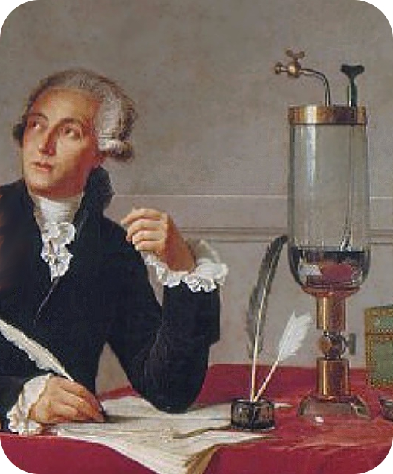
How do scientists know that mass is always conserved in chemical reactions? Careful experiments in the 1700s by a French chemist named Antoine Lavoisier led to this conclusion. Lavoisier carefully measured the mass of reactants and products in many different chemical reactions. He carried out the reactions inside a sealed jar, like the one in the figure. In every case, the total mass of the jar and its contents was the same after the reaction as it was before the reaction took place. This showed that matter was neither created nor destroyed in the reactions.
Antoine Lavoisier.
Q: Lavoisier carried out his experiments inside a sealed glass jar. Why was sealing the jar important for his results? What might his results have been if he hadn’t sealed the jar?
A: Sealing the jar was important so that any gases produced in the reactions were captured and could be measured. If he hadn’t sealed the jar, gases might have escaped detection. Then his results would have shown that there was less mass after the reactions than before. In other words, he would not have been able to conclude that mass is conserved in chemical reactions.

Summary
- A chemical reaction occurs when some substances change chemically to other substances. Chemical reactions are represented by chemical equations.
- All chemical equations must be balanced because matter cannot be created or destroyed in chemical reactions.
- Antoine Lavoisier did careful experiments to discover the law of conservation of mass in chemical reactions.
- law of conservation of mass: Law stating that matter cannot be created or destroyed in chemical reactions.

Sci 8 Conservation of Mass Name:
Period:
- How can you tell that a gas was produced in the vinegar and baking soda reaction?

- How can you tell that the products of the reaction are different from the reactants?

- What evidence shows that mass is conserved in the reaction?

The following questions go with the reading
- Why must all chemical equations be balanced?

- How did Lavoisier demonstrate that mass is conserved in chemical reactions?

