Sci 8 States of Matter Name: _____________
Block: ______________
- What is Kinetic Energy?

- What are the three main points of the Kinetic Molecular Theory?

- Complete the chart below describing states of matter:
 | Solid | Liquid | Gas
Shape |  |  | Not fixed  Takes the shape of the container
Volume |  | Fixed volume
Mass |  |  | Definite
Space is between particles

Attractive forces between particles | strong
Arrangement of particles |  | Randomly arranged  Particles are touching, but able to move past one another
Movement of particles |  |  | Can move freely and quickly in all directions in the container
Example

Draw a picture of the particles

Changes of State
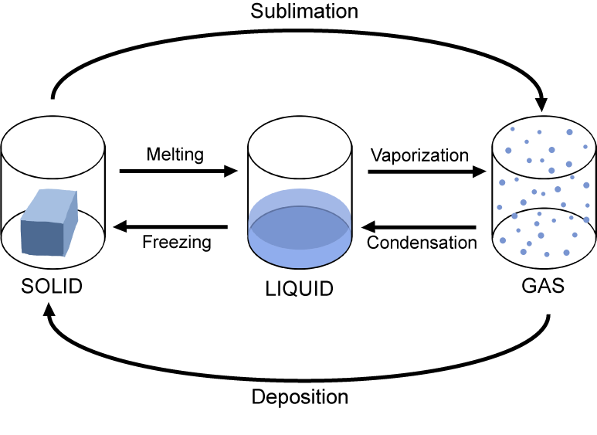
- Label the diagram below using the following terms: condensation, deposition, vaporization, melting , freezing, and sublimation.

- Complete the following table by indicating the initial and final states of matter and whether kinetic energy is added or removed. Give an example of each of the changes of state.
State Change | State of Matter |  | Kinetic Energy Added or Removed | Example
 | Initial State | Final State | Added
Melting
Freezing
Deposition
Sublimation
Vaporization
Condensation | Gas | Liquid |  | Water droplets form on a bathroom mirror after a hot shower

