History of Atomic Theory
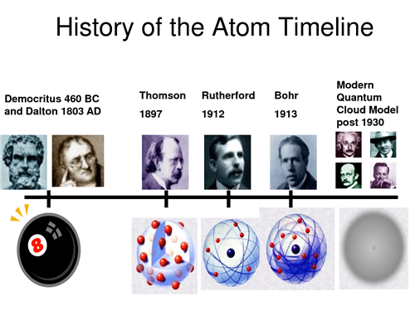Important Scientists in atomic theory:
Researcher | Idea | Model
Ancient Greeks | Democritus 460 BC – matter was made up of atomos- the smallest pieces of matter.  Aristotle - didn’t believe empty space could exist; believed matter was made of different combinations of earth, air, fire, and water. | (n/a)
John Dalton  (1766-1844) | All matter is made of ____________________  Atoms cannot be ____________, ____________, or ________________ into smaller particles.  Atoms of same element are _______________.
J. J. Thomson  (1856-1940) | Atoms contained _______________________.  These particles are found ________________.  The atom is ___________________________.
Ernest  Rutherford (1871-1937) | Atoms is mostly _______________________.  Most of mass __________________________.  Nucleus contains _______________________
Neils Bohr  (1885- 1962) | Electrons surround _____________________ in _______________________________.

What is an atom? ______________________________________________________
Atoms are composed of ________________________________ that are WAY too small for us to see.
Particles with a positive charge are called _____________________.
Particles with a negative charge are called _____________________.
Particles with no charge are called _______________________.
What does an atom look like? Label the diagram below:

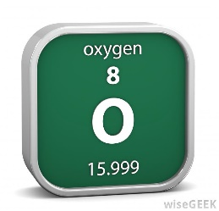
WHAT DOES THE PERIODIC TABLE TELL US ABOUT ELECTRONS PROTONS AND NEUTRONS?
The atomic number of an element = number of _______________in the nucleus
Ex. Atomic number of oxygen: ______________
Number of protons: ___________
PRACTICE:
Element | Symbol | Atomic Number | # of protons
Hydrogen
Beryllium
Carbon
Cobalt
Krypton

The mass number = # of ______________ + # of ______________in the nucleus.
(Since electrons are VERY light and don’t add much to the mass of the atom)
**** So # of electrons = mass number – atomic number
PRACTICE
Element | Symbol | Mass # | # Protons | # Neutrons
Hydrogen
chromium
Carbon
Barium
Iron

The number of electrons in a neutral atom = # of protons (atomic number)
Ex. Carbon has: atomic number= 6 # of protons = 6 # of electrons = 6

ATOMIC STRUCTURE PRACTICE
ELEMENT | ATOMIC # | ATOMIC MASS | # PROTONS | # ELECTRONS | # NEUTRONS
Lithium

Boron

Oxygen

Phosphorous

Argon

Nickel

Bromine

Cobalt

Platinum

Lead

Barium

Iron

Nitrogen

Neon

Sulphur

Magnesium

Potassium

Copper

What kinds of elements are there?
- The Periodic Table groups elements into __________ (vertical groups)
- A chemical family is a group of elements that share similar ________________.
- Most elements are either __________________ (on the left)
- or ___________________ (on the right)
- Some elements called _____________________ that have some similar properties to
- metals and/or non-metals
CHARACTERISTICS OF METALS and Non Metals
Metals | Non-metals
- Are __________ __________ at room temperature (except for mercury, which is a liquid)  - ________________  - ________________  - ________________  - Good __________________ of heat and electricity  - High ____________ (heavy for their size)  - High ____________strength (resist being stretched)  - High Melting points  Eg. Gold, Silver, Copper | - Are gases or brittle solids at room temperature (except bromine, which is a liquid)  - Not shiny  - Not malleable  - Not ductile  - Not good conductors of heat and electricity.  - Eg. Carbon, Oxygen, Sulfur
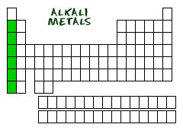
Most Elements are Metals.
ALKALI METALS
- found in the _________________ column (Group _____)
- does not include the element _____________________.
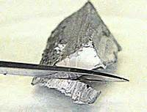
- They all have _______________ in their outer shell,
- shiny, soft (malleable) and have low ________________.
- Not found freely in nature because they all______________________________ ___________________________.
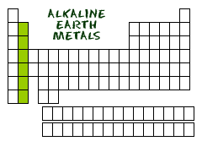
ALKALINE EARTH METALS
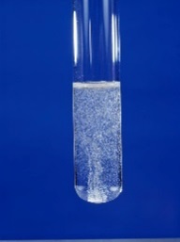
- Group _____ of the Periodic Table.
- They have _____ valence electrons.
- ________________ most reactive family.
- silvery, shiny, and relatively soft metals.
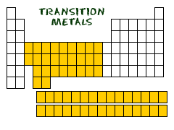
TRANSITION METALS
- Shiny
- high melting and boiling points.
- Eg. Gold, silver, platinum
NON-METALS
- Hydrogen, Halogens, Noble Gases
- Generally, gases or brittle, dull-looking solids

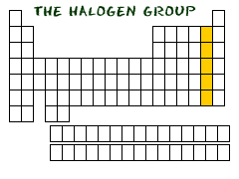
HALOGENS
- Group ______ of the Periodic Table.
-Have _______ electrons in valence shell
-They are not found freely in nature because they are very _______
Typically found in ________________ or ___________
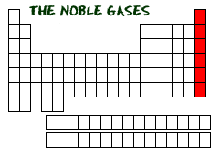
NOBLE GASES
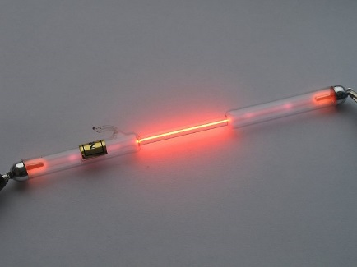
-Group _______
-Valence shell is ___________.
-________________(nonreactive) because they already have a stable octet.
-Colorless, odorless gases
HYDROGEN
- often called a _______________.
- Lightest element,
- Colourless, tasteless, highly _________________ gas
- Most ________________ element in the universe (over 90% of all atoms)
METALLOIDS OR SEMI-METALS
- Act like both metals and non-metals
- Mostly ________________in their physical appearance:
  - Eg _______________ solids at room temperature
- mostly ___________________ in their chemical behavior.
  - Eg. brittle, not ductile
  - Poor conductors or ____________________.
- Examples include: boron, silicon, arsenic.

Modelling Atoms: Bohr Model
- A Bohr Model is a simplified diagram of number of _______________in each of the ________________________ (shells) around an atom.
- Each shell can only hold a certain number of electrons.
- First shell can only hold a maximum of ___ electrons.
- 2nd shell = __, 3rd shell = ______, 4th = _______.
The outermost shell is called the ____________________.
PATTERNS IN THE PERIODIC TABLE REGARDING ELECTRON ARRANGEMENT
- Elements of the same ____________have the same number of ________________________
- Elements that are in the same ________________ have their valence electron in the same shell
- The _______________ number = the number of occupied energy shells.

How do atoms for ions?
- An ion is an atom with an ___________________ because it has gained or lost electrons from its valence shell.
- An atom that ____________ one or more electrons _______________ ion (cation)
- An atom that ___________ one or more electrons ________________ ion (anion)

Why would an atom become an ion?
- Elements are more ____________ when their valence shell is __________ (like the noble gases).
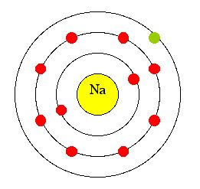
- When this is achieved it is called a __________________.

Periodic Table and Ion Formation:
  - Metals tend to _____________ electrons and become positive ions (cations)
  - Non-metals ___________ electrons and become negative ions (anions)
Representing Ions
- Show the charge on an ion with a ___________________ “+ or –“ to the right of the symbol.
  - Eg Lithium ion = _____________ chlorine ion = _____________
- The charge on the ion is equal to the sum of its _____________ and _______________.
  - Eg. Lithium ion has three protons and two electrons, giving it a charge of “plus one”
  - (3+) protons + (2-) electrons = +1
Bohr Model of an Ion
- Remember, an ion is an atom that has gained a charge (by either losing or gaining one or more electrons)
- The Bohr model indicates the charge with a “+ or –” and ______________.
  - Draw the Bohr model diagram for an aluminium atom and aluminium ion.

