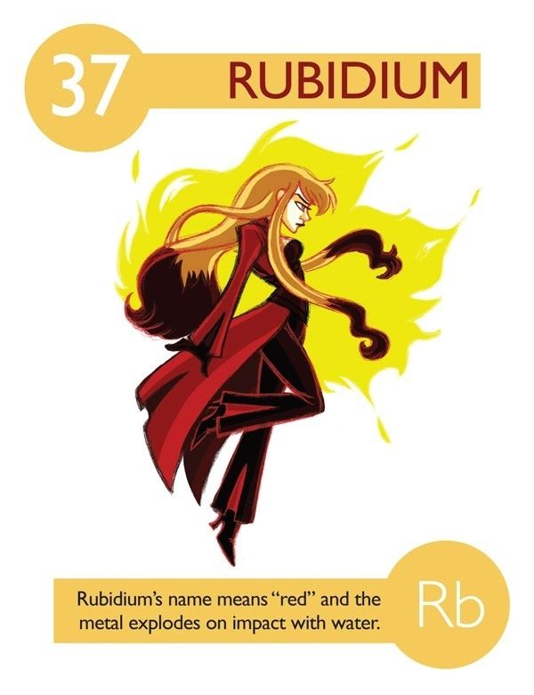
Element Superhero (or Villain) 33pts
Protect our school! Burnaby South Secondary School under attack from an neighbouring school. The fate of the school is in the hands of this class of modern day warriors.

Create an elemental superhero to protect the school (or villain attacking the school) from a list of common elements.

Your assignment should include:
Profile of your superhero (11pt)
- A creative name for your superhero that includes either the name of the element or the chemical symbol
- Identify whether is it a hero or villain
- At least six super powers and how/why your character uses them
  - must be based on the chemical and physical properties of the element
- Some of its main allies (elements with which it forms compounds) and enemies (elements which it cannot/hates forming compounds) – you may want to use the names of your friends’ heroes and villains.
- Create an interesting backstory of how your hero came to be (based on the elements history).
Elemental Information: (10)
  - Elemental name, symbol, atomic number, #protons, electrons, neutrons
  - Characteristics (physical and chemical properties) of element when in its natural state (melting point, boiling point, density, phase at room temperature, colour, texture, hardness or softness, odour, reactivity, conductivity, ductility, etc) –minimum of 6
  - Where on the periodic table is your element found? (Metal, non-metal, metalloid). What family is your element in?
  - What features define your element? (something unique about your element
  - Where it is commonly found in nature?
    - Can it be found pure or is it always in compounds?
    - What types of compounds does it form?
    - How can the element be isolated from its compounds?
  - Importance: How is your element used today? What is the economic importance of the element in Canada or elsewhere in the world? Eg. superconductor, semi-conductor, jewelry, etc)
  - Historical perspective
    - Where/When/Who/How your element was discovered. This could be when your superhero was born, or when they got their powers—any important moment in that superhero’s life

Image of your superhero (10)
  - This section should include an image (in color) of your Element Superhero on a standard sized (8.5x11), clean sheet of WHITE paper.
-Drawing must incorporate at least 3 of the characteristics/properties of the element. You will need to note the properties on the back of the drawing.
-Drawing must correspond to the qualities of your superhero. For example, if sulfur is your chosen element, the superhero’s uniform or hair or skin, etc. could be yellow since sulfur has a characteristic yellow color.
  - Good use of colour and space
  - You can either draw your image or use graphic design (Hero Machine 2.5 or Hero Machine 3.0 are useful resources)
  - Not copied from the internet
References (2pt)
- You must include a WORKS CITED section
- Minimum of three sources (Print or Internet)
- Wiki is not a reliable source

Begin by checking out www.periodicvideos.com to see short videos about different elements and its properties.

Please attach this sheet to the back of your project.
Character’s Name  Villain or Hero? |  | 1
Six super powers  - Six superpowers based on elements’ chemical and physical properties and description of how they are used. |  | 6
Superhero’s allies and enemies  - Other elements with which it forms compounds  - Elements with which it won’t form compounds |  | 2
Portrait  - A portrait that is clear, neat, and demonstrates properties of the element  - Good use of color and space |  | 3  2
Superhero’s story  - In complete sentences  - Incorporates element’s history and some characteristics |  | 5
Element Info (can be in point form)  - Elemental symbol, Atomic number, #protons, electrons, neutrons  - Family  - Characteristics (physical and chemical properties) of element  - Where it is commonly found in nature |  | 1  1  5  1
Overall creativity and effort |  | 4
References  - Cited  - Minimum of 3 reliable sources |  | 2
Total |  | 33

