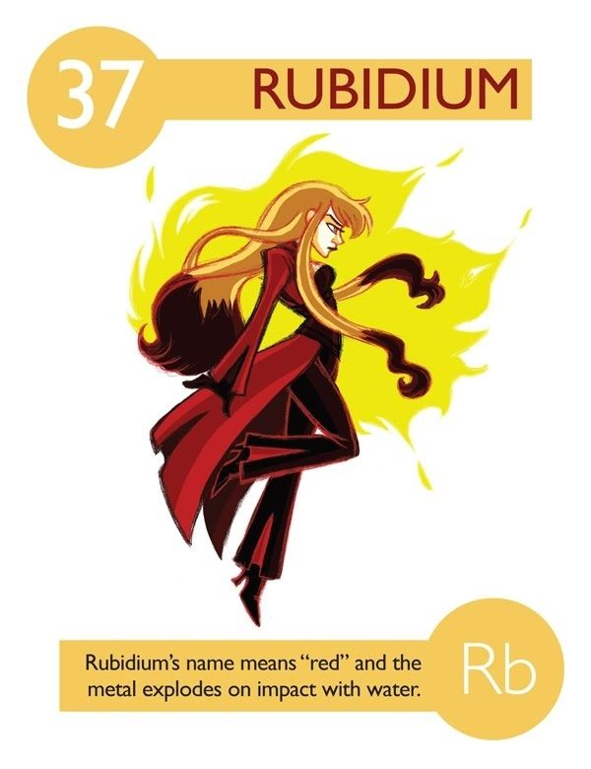
Element Superhero (or Villain) 31pts
Protect our school! Burnaby South Secondary School under attack from an neighbouring school. The fate of the school is in the hands of this class of modern day warriors.

Create an elemental superhero to protect the school (or villain attacking the school) from a list of common elements.

Your assignment should include:
Profile of your superhero (11pt)
- A name for your superhero that includes either the name of the element or the chemical symbol (it should be clear what element you have chosen)
- At least six super powers
  - must be based on the chemical and physical properties of the element
- Some of its main allies (elements with which it forms compounds) and enemies (elements which it cannot/hates forming compounds) – you may want to use the names of your friends’ heroes and villains.
- Create an interesting story of how your hero came to be (based on the elements history).
Elemental Information: (10)
  - Elemental symbol, Atomic number, #protons, electrons, neutrons
  - Characteristics (physical and chemical properties) of element when in its natural state (boiling point, phase, colour, reactivity, ductility, etc)
  - What family is your element in? (Alkali metals? Alkali Earth? Transition Metals? Lanthanides and Actinides? Non-metal? Metalloid? Noble Gas?)
  - Where it is commonly found in nature
  - Historical perspective
    - Where/When/Who/How your element was discovered. This could be when your superhero was born, or when they got their powers—any important moment in that superhero’s life
Image of your superhero (10)
  - This section should include an image (in color) of your Element Superhero on a clean sheet of WHITE paper.
-Drawing must incorporate at least 5 of the characteristics/properties of the element. You will need to note the properties on the back of the drawing.
-Drawing must correspond to the qualities of your superhero. For example, if sulfur is your chosen element, the superhero’s uniform or hair or skin, etc. could be yellow since sulfur has a characteristic yellow color.
  - Good use of colour and space
  - You can either draw your image or use graphic design (Hero Machine 2.5 or Hero Machine 3.0 are useful resources)
  - Not copied from the internet
References (2pt)
- You must include a WORKS CITED section
- Minimum of three sources (Print or Internet)
- Wiki is not a reliable source

Begin by checking out www.periodicvideos.com to see short videos about different elements and its properties.

Superhero name | /1
Six super powers  - Six superpowers based on elements’ chemical and physical properties |  |  | 6
Superhero’s allies and enemies  - Other elements with which it forms compounds  - Elements with which it won’t form compounds |  |  | 2
Superhero’s story |  |  | 2
Element Info  - Elemental symbol, Atomic number, #protons, electrons, neutrons  - Family  - Characteristics (physical and chemical properties) of element when in its natural state (boiling point, phase, colour, reactivity, ductility, etc)  - Where it is commonly found in nature  - Explanation of where, when, who, and how your element was discovered |  |  | 1  1  5  1  2
Portrait  - A portrait that is clear, neat, and demonstrates properties of the element  - Good use of color and space |  |  | 5
Overall creativity and effort  - Demonstrates thought and creativity |  |  | 3
References |  |  | 2

