Sci 9 Human Sexual Reproduction Review
- Label the parts of the male reproductive system:
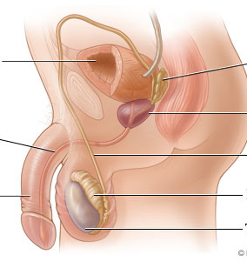

- Label parts 1,2,3,5,7,8 of the female reproductive system:
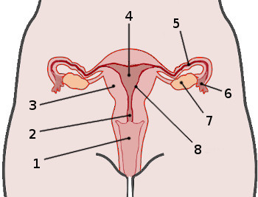

- What is the difference between primary and secondary sex characteristics?

- List two secondary sex characteristics for males and two for females.

- Where are sperm produced?

- List the path the sperm takes from where it is created to where it is released.
- Label structures 1,4, 5 in the production of the egg:

- Where does the egg get fertilized?

- When does a zygote become and embryo?

- When does an embryo become a fetus?

- How does the fetus receive nutrition?

- Complete the chart on menstruation:
Phase | Day | What happens

- Note 2 key points for each trimester of pregnancy.
 | Approximate Size | Event/what is developing?
First trimester
Second trimester
Third trimester
- Define stem cells and differentiation.

