Group Members: (maximum group of 3)
- Project Manager: Adesh
  - Keeps group on task & is the main contact for the teacher.
- Materials Manager: Muhammad
  - Gets the materials required by the group.
- Record Keeper: Victor
  - Takes notes & observations for the group so that they can do their individual reports

Initial Research
Design #1 Link: http://www.kidsciencechallenge.com/pdfs/2010activities/Mud_Battery_Magical_Microbes_2010.pdf
Insert Picture:  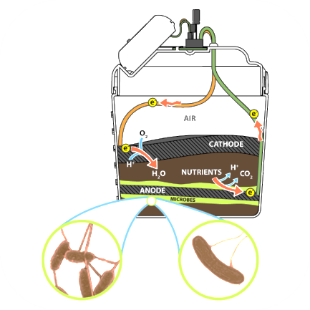 | What part(s) of the design do you like and why?  How the bucket acts as a battery. One easy piece to put your project all together. Easy access to materials.

Design #2 Link: https://www.youtube.com/watch?v=kCWDBju08vA
Insert Picture:  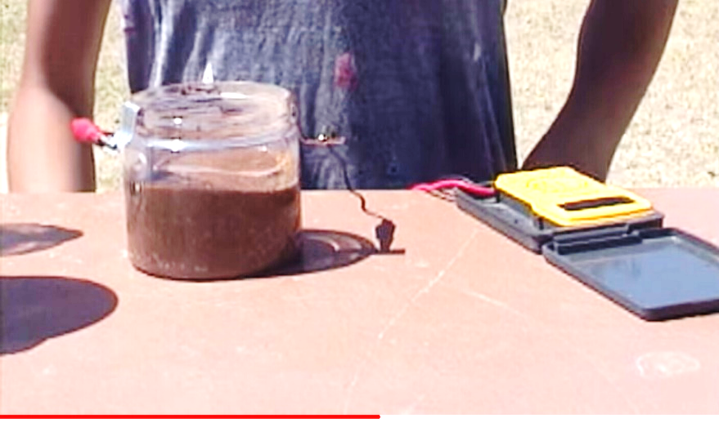 | What part(s) of the design do you like and why?  It doesn't take much time to make and is not messy.The materials are everyday house items that are very easy to get If the mud is kept moist, it keeps producing electricity

(Victor) Design #3 Link:

Insert Picture: | What part(s) of the design do you like and why?  Blah…blah…blah…Mr. Chan is cool

Sketch, Design & Construct
View #1 (Front View)  Full image: | View #2 (Side View) Full image:

What are some of the advantages of the design/construction that you chose? (You need to explain at least two)
I like Pikachu because it is cute…they have a great attack on Mario Smash Brothers

