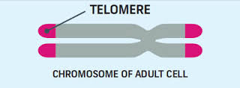
What are telomeres and why are they important?
- Telomeres are DNA caps at the end of chromosomes
- They keep chromosome ends from fraying and sticking to each other which could cause a mutation, malfunction, cancer, or cell death.
- Without telomeres, the ends of chromosomes would look like broken DNA, and the cell would try to fix it cell would stop dividing and eventually die.
Telomeres get shorter each time a cell divides
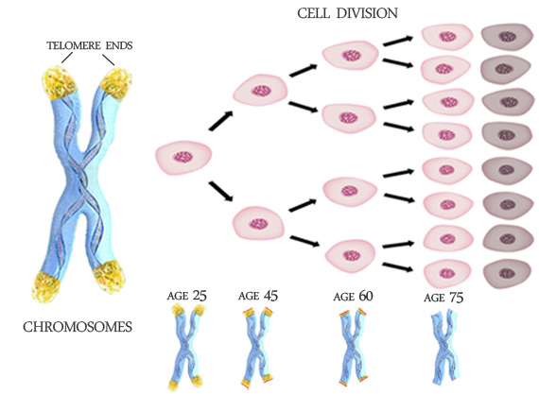
- When they get too short, the cell can no longer divide; it becomes inactive or "senescent" or it dies.
- Cells normally can divide about 50 to 70 times, with telomeres getting progressively shorter until the cells become senescent or die.
Why do telomeres get shorter?
During DNA repliciton, DNA polymerase reads the existing strands to build two new strands, with the help of short pieces of RNA. When each new matching strand is complete, it is a bit shorter than the original strand because of the room needed at the end for this small piece of RNA.

Telomerase counteracts telomere shortening
- Telomerase adds bases to the ends of telomeres. In young cells, telomerase keeps telomeres from wearing down too much. But as cells divide repeatedly, there is not enough telomerase, so the telomeres grow shorter and the cells age.

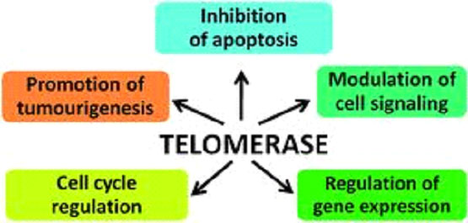
Telomeres and cancer
- cancer cells escape death by making more telomerase enzyme, preventing the telomeres from getting shorter.
