Transcription and Translation Worksheet

- What are the bases in DNA?

- How do the bases pair up?

- What are the bases in RNA?

What RNA nitrogen bases match with the following DNA nitrogen bases?

A T G C

- If this is a sequence of one DNA strand, what is the RNA sequences that would bond with this DNA sequence?

A T T C A G C G A

- How are DNA and mRNA alike?

- How are DNA and mRNA different?

- What is a codon?

- What does a codon code for?

- List three things proteins for us.

- Where in the cell are proteins made?

- If the following were part of a DNA chain, what mRNA bases would pair with it to transcribe the DNA code onto mRNA?
G-G-A-T-C-G-C-C-T-T-A-G-A-A-T-C

Imagine you have the following strand of DNA. Go through the process of transcription and translation and build the correct amino acid chain (protein).

DNA mRNA Amino Acid

C
A
T

G
G
T

C
A
G

G
C
A

T
A
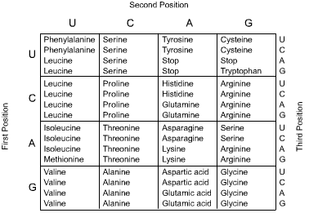
T

