Unit J Review #1 KEY
- Arteries, Arterioles, Capillaries, Venules, Veins.

- 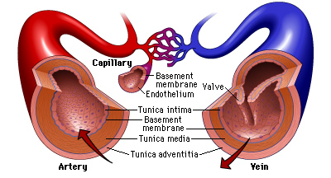

- Arteries carry blood AWAY from the heart, usually this blood is already oxygenated, unless it is an artery that is carrying blood away from the heart toward the lungs.

- Veins carry blood back to the heart, usually deoxygenated blood, unless it is carrying blood back to the heart from the lungs.

- Capillaries allow blood to exchange materials with tissue fluid.

- Arterial structure has a much thicker wall with a thicker layer of smooth muscle. They are more rigid to handle higher blood pressure.

- Veins are not as rigid, they have thinner walls that are not as rigid. They also possess valves to prevent backflow.

- Capillaries have a wall that is only one cell thick. This wall of squamous epithelium is the perfect design for allowing diffusion between blood and tissue fluids.

- Arteries and arterioles have the ability to contract and relax their smooth muscle to dilate and constrict the vessel. During constriction blood pressure goes up, when arteries dilate blood pressure falls.

- Sphincter muscles open or close pathways to certain capillary beds. This allows the circulatory system to direct blood to where the body needs it the most at that time. Ex digestion vs. exercising.
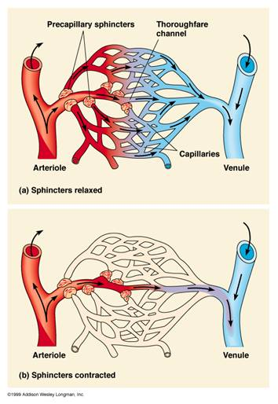
- Blood pressure goes up in areas where more blood volume has been sent. When more capillary beds are opened up at the same time overall blood pressure will go down.

- Blood Vessel Type Blood Pressure
Arteries Highest
Capillaries Moderate
Veins Lowest

- Blood Vessel Type Blood Velocity
Arteries Very Fast
Capillaries Slow
Veins Fast

LO J-2
- Pulmonary Artery
- Renal Artery
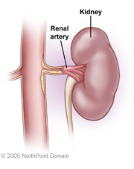
- Femoral Vein and Great Saphenous Iliac Vein

- The AORTA
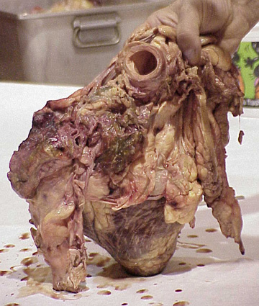
- Most veins carry Deoxygenated blood, the exception to this rule are the PULMONARY Veins which carry Oxygenated blood back to the heart from the lungs.

- Most arteries carry Oxygenated blood, the exception to this rule are the PULMONARY Arteries which carry Deoxygenate blood away from the heart toward the lungs.

- The Superior (Anterior) Vena Cava receives blood from the upper extremities (arms) and head via the Subclavian veins and Jugular veins.

- The Superior (anterior) Vena Cava and the Inferior (Posterior) Vena Cava enter into the Right Atrium.

- Three main Coronary arteries branch off of the Aorta and branch off to supply the Myocardium (Heart Muscle) to keep the cardiac muscle tissue nourished with oxygen and nutrients so that it remains healthy and alive. (see pic below)
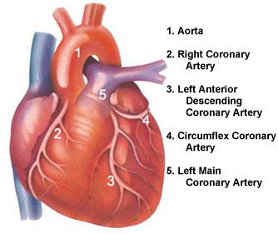
- The Hepatic Portal Vein has a large network of capillaries at one end (associated with the small intestine) and another large network of capillaries at the other end (associated with the liver) so it transports blood from small intestine to the liver where the nutrients are processed.

- A portal system is any vessel that has a network of capillary beds at both ends.

- The Systemic circuit circulates oxygenated blood from the left ventricle out to all the tissues and systems of the body and then it brings deoxygenated blood back from the capillaries and drops it off in the Right Atrium.

The Pulmonary circuit circulates deoxygenated blood from the right ventricle out to the Pulmonary capillaries around the lungs and then it brings this oxygenated blood back from these capillaries and drops it off in the Left Atrium so it can head out into the System Circuit.

Practice Quiz:

- B

- B – This is a vein as it has a valve in it!

- C

- C – The smaller the type of vessel is the more cross-sectional area they add up to have. Capillaries have the most, while venules and arterioles have the second most cross-sectional area.

- D – Blood moves most slowly through capillaries to allow for exchange with tissue fluid.

- A - Blood vessel "X" must be an artery or a decent sized arteriole to have that much pressure.

- A – Veins have the lowest blood pressure and they also have a very small total cross-sectional area.

- D – This vessel is returning blood from lower body and transporting it to the right atrium

- D

- D

- D

