Unit J Rev #2 KEY
LO – J-4
- Pulmonary Circuit

- Systemic Circuit

- Both the Pulmonary Arteries and the Umbilical Arteries carry deoxygenated blood.

- The Left side of the heart drives the Systemic Circuit.

- The right atrium is the collecting chamber for the systemic circuit.

LO – J-5
- The key differences between the circulation systems of fetus and developed human are:
- Arterial Duct – Connects pulmonary trunk right onto Aorta – to help bypass lungs.
- Oval Opening – Opening between right atrium and left atrium to help shunt blood straight from right atrium into left atrium.
- Venous Duct – Connection between Umbilical vein carrying oxygenated blood from placenta and Fetus’s Inferior Vena Cava.
- Umbilical arteries and vein. Blood vessels that connect fetal circulatory system to placenta. Umbilical arteries carry blood AWAY from fetal heart, umbilical vein brings back to fetal heart.

- See diagram
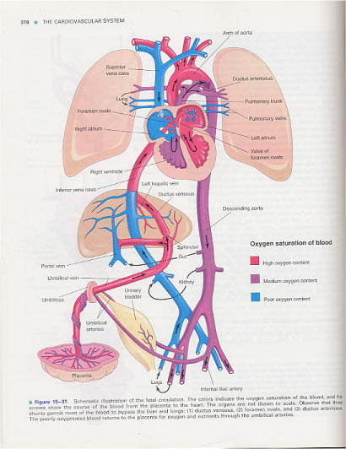
- Both the oval opening and the arterial duct are both structures that help with by-passing the fetus’ lungs.

- As soon as the baby starts breathing the pressure in the thorax helps close off the oval opening. This allows blood to start moving to babies lungs for oxygenation.

- Umbilical Vein

- PLACENTA

- Primarily through DIFFUSION. Baby's blood cells do not exchange with mother’s blood cells.

LO – J-6
- Right Atrium R. Ventricle Pulmonary

Trunk Pulmonary Arteries Pulmonary Capillaries of Lungs Pulmonary Veins Left Atrium Left Ventricle Aorta Abdominal Aorta Common Iliac Artery Femoral Artery Capillary Beds of Toe Femoral Vein or Great Saphenous Vein Common Iliac Vein Inferior Vena Cava Right Atrium.

2. Left Atrium Left Ventricle Aorta Carotid Artery Brain.

- Intestines Hepatic Portal Vein Liver Hepatic Vein Inferior Vena Cava Right Atrium Right Ventricle Pulmonary Trunk Pulmonary Arteries Pulmonary Capillaries of Lungs Pulmonary Veins Left Atrium Left Ventricle Aorta Abdominal Aorta MESENTERIC artery Intestines.

- Superior Vena Cava Right Atrium R. Ventricle Pulmonary Trunk Pulmonary Arteries Pulmonary Capillaries of Lungs Pulmonary Veins Left Atrium Left Ventricle Aorta Subclavian Artery Brachial Artery Capillary Beds of finger

PRACTICE QUIZ:
- C – Hepatic Vein Inferior VC R.A.
R.V. Pulm Trunk Pulm Art Pulm Caps

- B - W = a major artery, X = A Vein, Y = An arteriole, Z = A Capillary.

- C

- D – Hepatic Vein drains blood from small int.

- C

- B

- B

- C - W = Arteries X= Arterioles or Venules, Y= Capillaries, Z = Veins

- A

