Unit J Review #3 Key

- Approximately 55%.

- Approximately 90-92%

- The source for this water is absorbed mostly through the Intestines. So diarrhea could cause the blood to become thicker and the volume would go down (4 L 3.4 L).

- With less blood volume, blood pressure would definitely be lower.

- Plasma proteins have a variety of roles, But collectively they create a hypertonic environment that helps draw tissue fluid back into capillaries. So they help maintain correct blood volume levels.

- If the blood was lacking these proteins, fluid would build up in the tissues around organs.
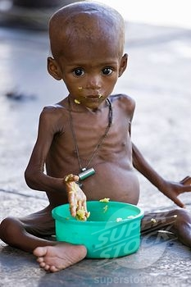
- Nutrients (AA’s, sugars, fats) pass into the blood stream from the small intestine. These nutrients are then dropped off at cells, cells use them for energy and for building materials.

- Plasma carries key metabolic wastes like CO₂, Urea and Uric Acid.
LO – J-8
- A) To pick up excess tissue fluid
B) To absorb the products of Fat Digestion.
C) To filter Lymph and fight infections using lymphocytes.
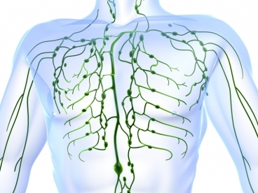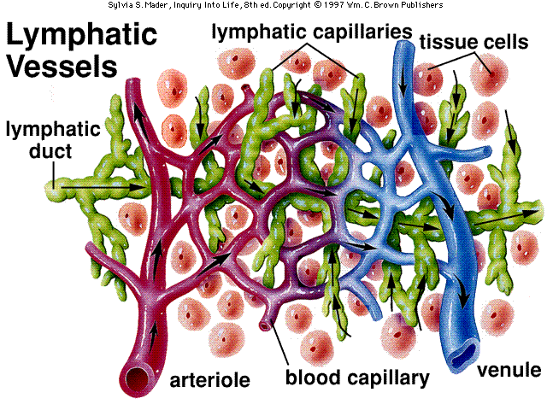
- The Subclavian Veins merge with rt subclavian duct and with thoracic duct.
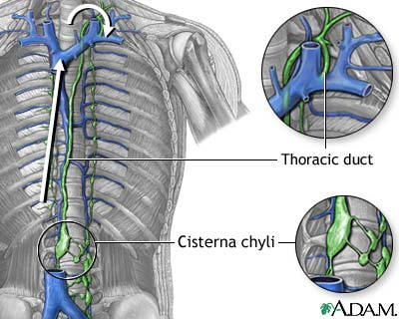
- Lacteals are found in Villi and they absorb the final products of fat digestion.
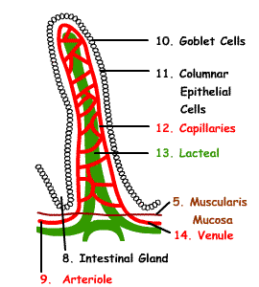
- Lymph nodes house lymphocytes and filter lymph to fight pathogens.

- 6 lymphoid structures are :

- Spleen - Thymus gland
- Lymph Nodes - Red bone Marrow
- Lymphatic vessels - Adenoids/Tonsils
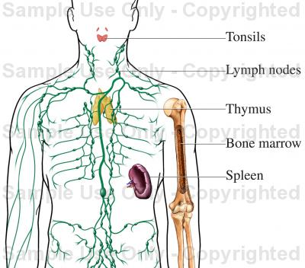

- The Spleen – It filters blood and recycles old red blood cells. It also store blood as a reservoir. Spleen also plays a role in cleaning the blood by fighting pathogens.

- T-Lymphocytes differentiate from some stem cells and reach maturation in the Thymus gland.
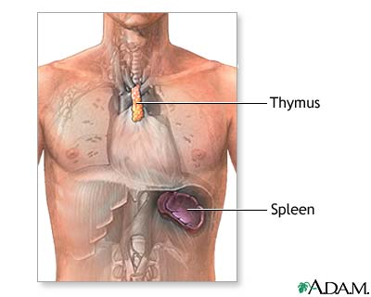
- Tonsils (Palatine Tonsils) and Adenoids (Pharyngeal Tonsils).

- EDEMA – Swelling and poor circulation.
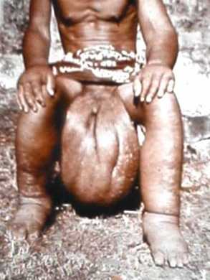
- Lymph fluid is moved in lymphatic vessels when skeletal muscles contract and relax. This muscle movement force the Lymph to move in one direction because lymph vessels contain valves.

- Lymph veins and Cardiovascular Veins both contain valves, they both move fluid back toward the chest/heart. They both rely on skeletal muscle to drive their fluids.
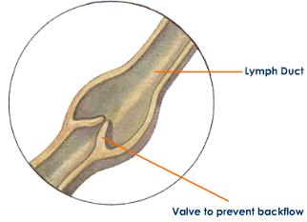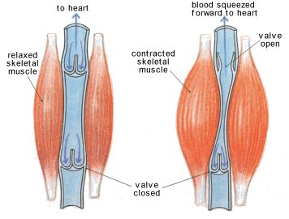
SEE FIGURE – 13.10 for Table Corrections

