Unit N Review #1 KEY
- The central nervous system consists of the BRAIN and SPINAL CORD.
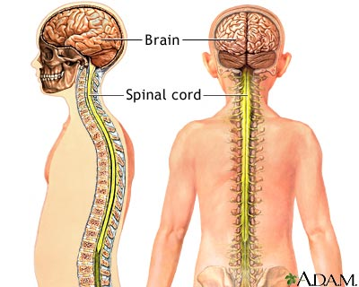
- The central nervous system structures are protected by a) BONE b) MENINGES and c) CEREBROSPINAL FLUID.
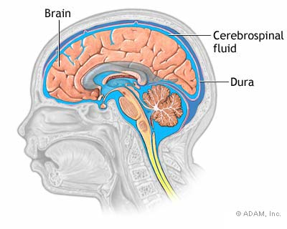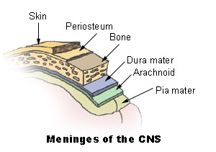
- The spinal cord would consist of three key parts: a) GRAY MATTER (H-shaped) b) WHITE MATTER and c) CENTRAL CANAL.
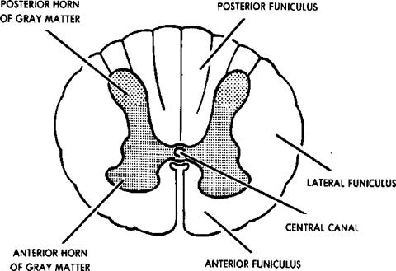
- The gray matter consists of vast amount of non-myelinated interneurons.

- White matter is made up of myelinated nerve fibers forming the tracts that run up and down and in and out of spinal cord and the myelinated nerve fibers in the brain.
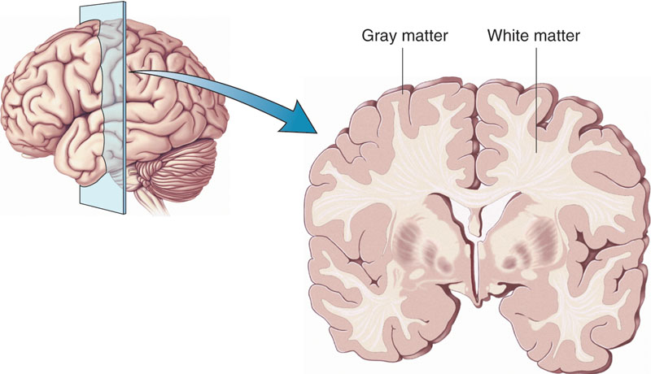
- The spinal cord can be referred to as a divided highway in that its tracts on the left side deal with in-coming and outgoing left side stuff, and its tracts on the right side deal with in-coming and outgoing right side stuff. But these tracts cross over in the brain stem.
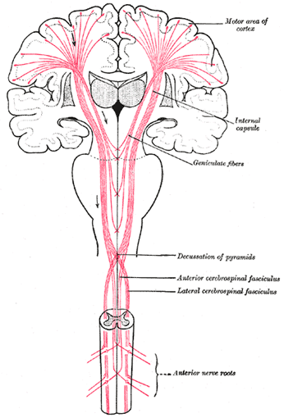
- A ganglion is a cluster/collection of cell bodies from many, many neurons.
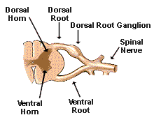
- Sensory (afferent) neurons make up the dorsal portion of the spinal cord.

- The dorsal root ganglion is a swelling found on the dorsal root of a mixed nerve. It consists of many, many afferent cell bodies.
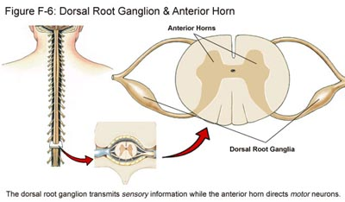
- Ventral roots of a mixed nerve consist of many, many, motor (efferent) neuron axons.

- When the nerve tracts travel up the spinal cord they cross over as they come into the brain stem. Therefore the in-coming and outgoing that deals with the right side of the body is actually dealt with by the left hemisphere of the brain.

PARTS OF BRAIN
- The largest portion of the brain is the CERBRUM (in green)
- It is under conscious control.

- Most SUPERIOR – Above most
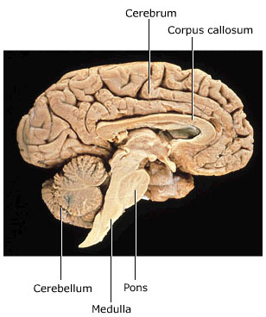
Corpus Callosum
Thalamus
Hypothalamus
Pons
Medulla Oblongata
Most INFERIOR- lowest down

- The Brain Stem connects Brain to Spinal Cord.

- The Medulla Oblongata is responsible for the following: (regulating VITALS) Blood Pressure, Heart Rate, Breathing Rate and (REFLEXES) such as Vomiting, Swallowing, Sneezing, Coughing, Hiccups.

- The CEREBELLUM. Only looks like a butterfly when viewed from behind.
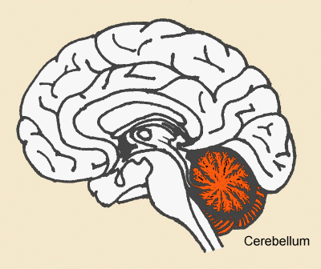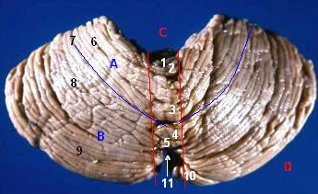
- The Cerebellum is responsible for : Muscle Coordination, Balance and Posture.

- HOMEOSTASIS – Checking and monitoring bodily conditions.

- The Hypothalamus helps monitor the following through neuro-hormonal control: Blood Volume, Hunger, Thirst, Sleep, Body Temperature, Blood Pressure, Sex Hormone levels and Growth.

- The central nervous system (brain) is connected to the endocrine system (hormonal) via the PITUITARY GLAND linked to the HYPOTHALAMUS.

- Pretty much all In-coming impulses are directed through the THALAMUS (Gate Keeper/Operator) out to the CEREBRUM. The Thalamus directs these messages toward the appropriate areas of the Cerebrum.

- Humans possess a very large well-developed region for speech. “Broca’s Area” of the left Frontal Lobe.
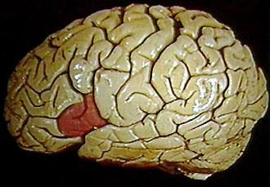
- Cerebral Hemispheres.

- The Corpus Callosum is the structure that integrates the two hemispheres.
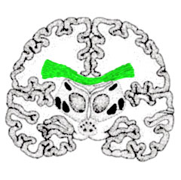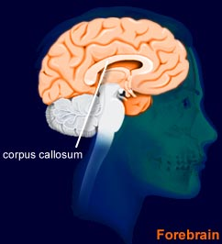
Think
C !
- Each hemisphere contains FOUR lobes:
Frontal Parietal
Temporal Occipital

- 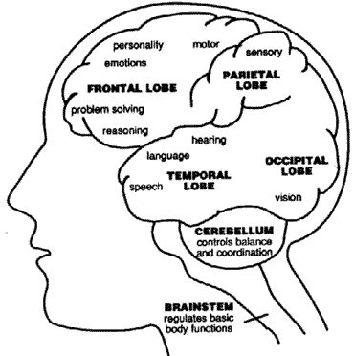
SPEACH

- The outer region of the cerebrum is called the CEREBRAL CORTEX.

- FRONTAL PARIETAL

TEMPORAL OCCIPITAL

- FRONTAL LOBE : Motor Control
- Conscious Thought - Memory, Speach Center, Problem Solving, Emotions.

- PARIETAL LOBE : Somatosensory (from skin) - Touch/Pain/Pressure –
- Incoming Taste

- Salivation and Primary Taste.

- TEMPORAL LOBE – Deals with Hearing (auditory), Smell (olfaction) and speech.

- Temporal Lobe also helps out with language word recognition.

- OCCIPITAL LOBE visual cortex for vision.

DIAGRAMS
Parietal Lobe of
Cerebral Cortex
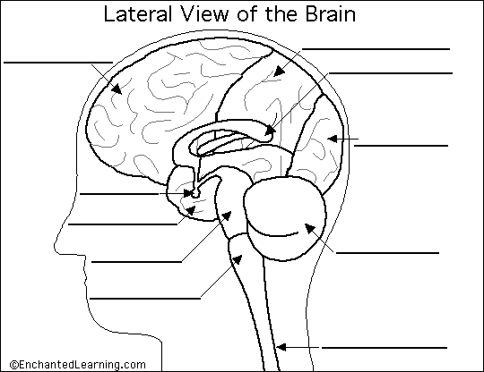
Frontal Lobe of Cerebral Cortex
Pons
Occipital Lobe
Of Cerebral Cortex
Thalamus
Hypothalamus
Right Temporal Lobe
Of Cerebral Cortex
Pituitary Gland
Medulla Oblongata
Spinal Cord to Brain Stem
Cerebellum
Corpus Callosum

REVIEW TABLE:
STRUCTURE | LOCATION | FUNCTION
THALAMUS | Found above midbrain tissue forms walls and roof of third ventricle | Gatekeeper – Integrates incoming sensory and directs them to the appropriate parts of the cerebrum
CEREBELLUM | Just posterior/dorsal to the brain stem. | Receives info from eyes,ears, joints and muscles and uses this info to help send out motor impulses in a coordinated manner. Maintains posture, coordination and balance.
MEDULLA OBLONGATA | In brain stem just below Pons. | Regulates breathing, heart rate and blood pressure. Also houses reflex centers for vomiting, coughing and sneezing.
HYPOTHALAMUS | Part of Diencephalon, just below Thalamus. Forms floor of third ventricle and found just above Pituitary Gland. | Helps maintain Homeostasis by regulating hunger, sleep, thirst, body temperature, water balance. Controls pituitary gland (endocrine)
CORPUS  CALLOSUM | Found just above the Thalamus in the deeper central area of brain. | Consists of a bridge of nerve tracts that connect both hemispheres to allow them to share information

